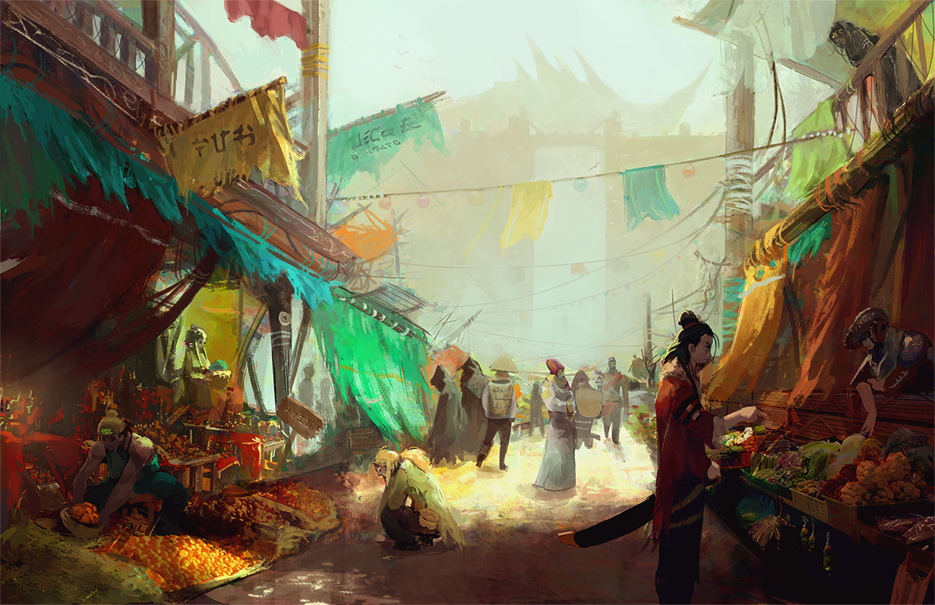
SALT IN WOUNDS
CAMPAIGN SETTING GUIDE

For the 5th Edition of the World’s Oldest RPG
The City of Salt in Wounds
Rough Draft 1st Half Edited, Second Half Rough
Campaign Setting Guide
By J.M. Perkins
Edited by Mike Myler
Layout by Mike Myler
Art by Jeffrey Chen
Cartography by Ryan Hennesey
Additional Writers:
Neal Powel, Brandes Stoddard, Adam Dagna, Austin Matteson, Jesse Brake, Christian J M West, Edward O’Bryan, Matthew Fortune, Nicholas Decostanza, Jon Pio, Paul Steffens, Robert Lesmeister, Salvatore Puma, William Tan, Spenser J Schaffner
Additional Art by Justin Bergo, Big Stock, Jess Stock,

Contents
Fiction: Footfalls 12
INTRODUCTION: BASICS & HOW TO USE THIS GUIDE 14
On Handling Sensitive Topics & Facilitating Fun at Your Table 15
Responsibilities and Conflict Resolution at the Table 16
Salt in Wounds at a Glance 18
Premise & History 18
Prominent Factions 19
Districts and Locations 20
General Information 20
[Special] Navigating Salt in Wounds: Information Every Traveler Needs to Know 21
Approaching the City 21
The City & Its People 22
Timeline 24
Map 26
1. LIFE IN SALT IN WOUNDS 27
Fiction: That Satisfying Crunch 27
Races of Salt in Wounds 29
Human 29
Elf 30
Half-Elf 30
Half-Orc 30
Gnome 31
Halfling 31
Ghouls 31
Tiefling 32
Dragonborn 33
Grippli 33
Agogi 33
Orcs 34
Duergar 34
Mites 34
The Salt in Wounds Calendar 35
Festivals of Salt in Wounds 35
Industry, Work, and the Economy of Salt in Wounds 37
Meat 37
Horn 38
Clearing House for Magical Items & Banking 39
[special] 10 Delicacies of Salt in Wounds 39
Salt in Wounds and Water 42
Special: Water Dens 43
Weather 45
The Salt in Wounds Mindset 46
Colors, Symbols, and Iconography of Salt in Wounds 47
Crime and Punishment 47
[special]Example Crimes and their Punishments 48
Coins of Salt in Wounds 49
Salt in Wounds and Morality 52
2. DISTRICTS & PLACES 53
Fiction: Two Blocks 53
The Fortress Salzinwuun 55
Prime Gate 56
Giant's Gate 56
Butchers Gate 56
The Charnel Sluice Grates 56
12th Gate 57
The Butcher’s Hall 57
Ballistas 57
Lord and Lady’s Pagoda 57
The High Shrine of Macinfex 58
Tail Stones 59
The Guild Hall of the Marrow Miners 59
The Pewter Cup 60
The Rachi 60
Gothmork’s Grub Hub 60
Regga’s Stir Fry 60
Kutu Lampi 61
The Shifting Place 61
Sage’s Row 62
Testing Field 62
Seconds & Bits 62
The Flask of Inspiration 63
The Temple of Reason 63
The Beast Crown District 64
The Chine Hall 64
The Stage Courts 64
The Manor-Towers 65
The Black-Stone Well 65
The Throat 66
The Scales & The Sword 67
Skorn’s Ironworks 67
Herald’s Taven 67
The Unmaimed Man 68
Locations Outside the City 69
The Spillway 69
The Feathered Saddle 69
The Heartsblood Marsh 69
The Capcaps 70
The Laboratory of Dr. Mundacri 70
The Camp of the Mammoth Wardens 71
Shatter Peak Mass Grave 71
The Pool of All Forms 72
High Rock Altar 72
Verdant Fields 72
Special: Salt in Wounds & The Wider World 73
3. PEOPLE & FACTIONS 74
Fiction: The Party 74
13 Meridian Houses 77
House of the 1st Meridian 78
House of the 2nd Meridian 79
House of the 3rd Meridian 80
House of the 4th Meridian 81
House of the 5th Meridian 82
House of the 6th Meridian 84
House of the 7th Meridian 85
House of the 8th Meridian 86
House of the 9th Meridian 88
House of the 10th Meridian 89
House of the 11th Meridian 91
House of the 12th Meridian 92
House of the 13th Meridian 94
The Enders 96
The Process Guild 97
Notable Members of the Process Guild 97
The Marrow Miners 99
Notable Marrow Miners: 99
The House Militias 101
The Order of God-Butchers 102
Notable God-Butchers 104
Sage’s Council 105
Sage’s Council Notables 105
Blood Merchants 107
Notable Blood Merchants 107
Gangs and Organized Crime 108
Notable Organizations 108
Notable Criminals 109
The Circle of Release (Criminal Faction) 110
Notable Former Members of the Circle of Release 110
4. RELIGION 111
Fiction: Gratitude 111
The Church of the Monad 113
Notable Members of the Church of the Monad 115
Macinfex - God of Butchers 116
Notable Members 117
Septum Soletirmus The Holy Writ of Coin Everlasting. 119
Notable Members 120
The Cult of Renesec 122
Notable Members 123
Other Religions 124
5. HISTORY 125
Fiction: Binding 125
Prehistory >50,000 BB (Before Binding) 128
History of the Ronine Valley Before Binding ~50,000-100 BB (Before Binding) 128
117 BB – Tarrasque Reemerges 128
8 BB – The 13 Gather 128
0 AB (After Binding) The Tarrasque is Bound 128
0 AB Construction of the fortress Salzinwuun Begun 129
1 AB – The Loss of the Armies 129
11 AB – 26 AB The Granite Shard War & The Harvest Begins 129
27-49 AB Trade & Population Bloom 131
48 AB Enders Founded 131
50 AB Salzinwuun officially renames itself a Sovereign City with a Charter 131
59 AB Creation of the Clear Water Accords 131
67 AB The Wyren Siege is defeated and the All Consumption Doctrine is Established 131
71 AB Heartsblood Marsh Identified as a Unique Area 132
77AB – 246 AB The Artifact Wars Rage 132
223 AB Circle of Release Founded 132
238 AB Night of Cleavers 133
256 AB 12th Meridian Crisis 133
257 AB 12th House Coup & the Creation of the Marrow Miners 134
277 AB Present day. 134
6. SECRETS & INTRIGUE 135
Fiction: Drums 135
Mammoth Wardens (Secret Faction) 137
Secrets of the Tarrasque 138
Secrets of the Heartsblood Marsh 139
3rd House Secrets 140
5th House Secrets 140
6th House Secrets 140
10th House Secrets 141
12th House Secrets 142
13th House Secrets 143
Secrets of Myrida, the Enders, and the Marrow Miners 144
Secrets of the CapCaps 147
Tuska & the Quest for Divinity 148
The Command Words & Releasing the Tarrasque 150
Secrets of the Circle of Release 154
Alchemist War 155
Secrets of the Oni 156
7. MONSTERS & HAZARDS 157
Fiction: The Arena 157
Animated Objects 160
Ankheg 160
Axe-Beak 160
Ghouls & Ghasts 160
Harpy 161
Otyugh 161
Oni 161
Stirge 161
Yeti 162
Unique Monsters 163
Goblin Wormtongue 163
Ramora Fleas 165
Worm Savant 168
The Worm Mother 170
Kolo Birds 172
Tarrasque Flesh Golem 176
Alchemist Testing Apparatus 179
Ledgerman 182
Red Leech Tide 185
APPENDIX 1: INTRO ADVENTURE 188
GOTHMORK”S GRUB HOUSE 188
Introduction 188
The House Stew: Worm Stew 188
The House Ale: Worm Brew 189
Reasons the PCs might get involved 189
Background 190
The Tavern and Basement 191
1. The Dining Room 192
2. The Kitchen 192
3. The Storeroom 192
4. Basement 192
5. The Worm Chamber 193
Ending the Adventure & Setting Up the Next 193
APPENDIX 2: SALT IN WOUNDS, SYNOMA & THE WIDER WORLD 194
Synoma: The Fantasy Cold War 194
The Great Game: The Role of Adventurers in the Geopolitics of Synoma 195
Salt in Wounds in Synoma 196
APPENDIX 3: RANDOM ENCOUNTERS 197
D6 Encounters for Sage's Row 197
D6 Encounters for the Throat Merchant District 199
D6 Random Encounters for the Tail Stones 200
D6 Encounters for the Beast Crown District 202
OGL Information 204

Fiction: Footfalls
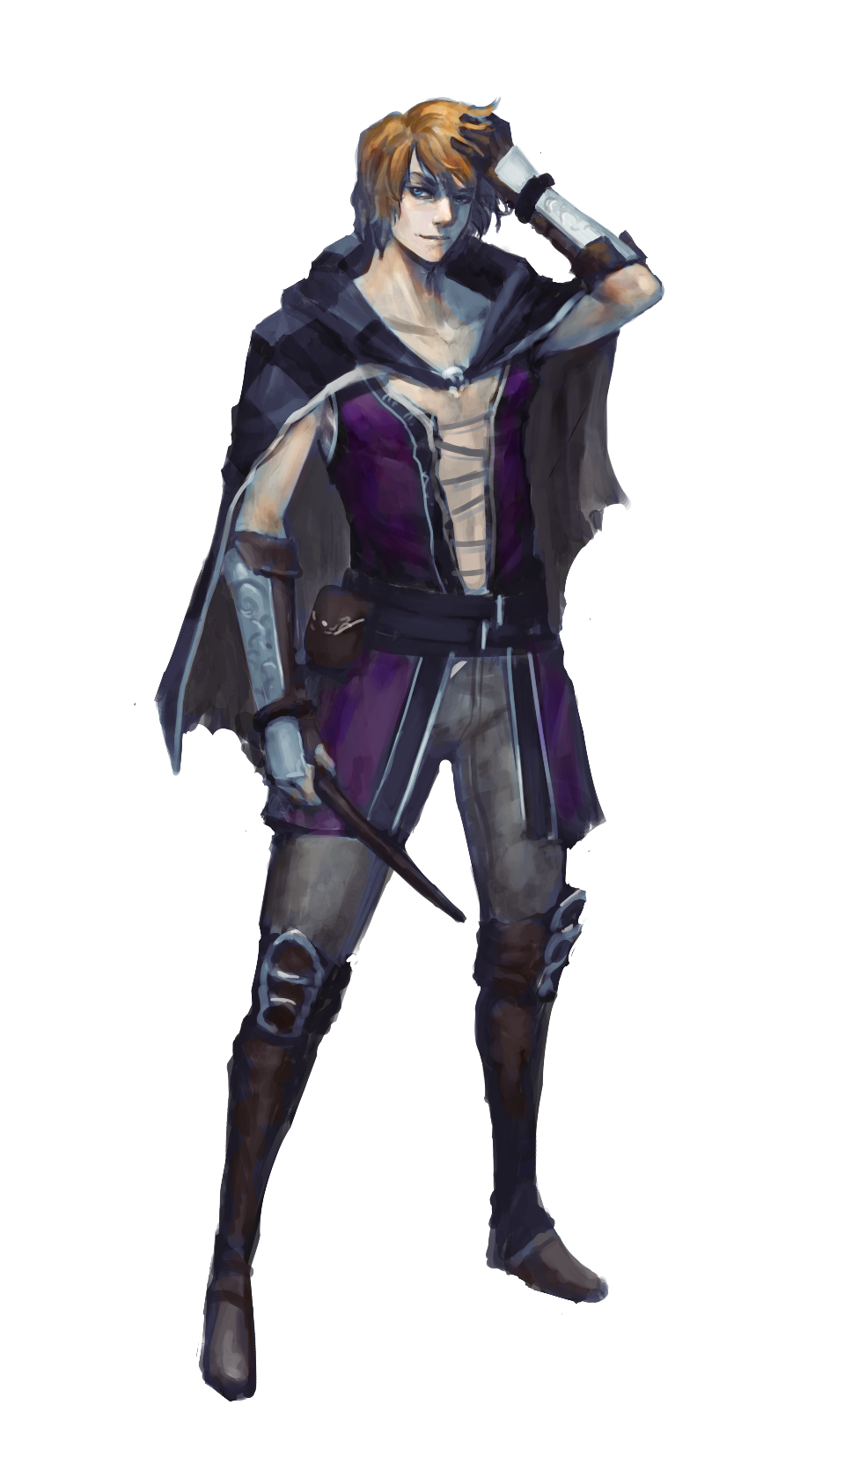
Mayvin ran, his footfalls splashing through the thick red-brown mulch that seemed to cling to every street in this district. His heart raced—what fun! What a delight, to feel the thrum of life and vitality. And to imagine, all it took to know this cascade of sensation was for some abominable horror burrowing below the paving stones to give chase.
One would think that a simple predator would have grown tired by now, dissuaded after its erstwhile meal had burned out five of its eyes and evaded it for so long. So perhaps it was sent by someone? Who exactly? Nearly tripping over the half-rotted skeleton of a barrel, Mayvin decided that may be a question for another time.
Everyone the sorcerer saw fled into some twisting alleyway or through some doorway that was then quickly, audibly barred from within: if not as a reaction to the garishly dressed fop sprinting at full tilt, than in response to the distended bulge of earthworks that betrayed the presence of something hungry and huge just below the surface. Mayvin noted his quickening breath, the distended street (and the thing beneath) gaining on him, and thought, “I wonder how long I can keep this up…”
A quick left brought him face to face with a dead end.
“Well, that answers that…” he spoke aloud, weaving protective magics about himself in anticipation of the creature’s jaws bursting up from below.

INTRODUCTION: BASICS & HOW TO USE THIS GUIDE
This book is a campaign setting guide for the fictional city of Salt in Wounds, primarily designed as an accessory to help you—as a game master—play a role playing game (a game of make-believe with a light drizzle of rules and randomization mechanics) with your friends. While this version is specifically intended to supplement the 5th Edition rules of the world’s oldest RPG, the descriptions of factions, nonplayer characters, maps, history, competing motivations and monsters work well no matter what rules (or lack thereof) you’re playing with. If you’re like the author you’ll read through this book, take inspiration for the adventures you want to run, and you’ll start improvising and making alterations to your Salt in Wounds (occasionally skimming or searching out a section for reference). Alternatively you could play with this guidebook as “cannon”, the absolute truth to your gameworld, and thereby remove much of the need to invent or improvise parts of it as your own. Additionally, you could utilize this book to lift sections, characters, and plots to transplant into other settings, inspire your own fiction, and so on. There is no wrong way to play as long as everyone at the table is enjoying themselves.
What follows broken into self explanatory sections and indexed for ease of navigation.
For Players
While not specifically designed with players in mind, you can—as a player—get a lot out of this guide. In general a well informed or properly motivated player character (or player) would know most of the information held within the book with a few small exceptions. If you’re a player in a Salt in Wounds game you should be fine reading all of the guide, just avoid the Secrets section, appendixes, and mind these two important caveats:
- When in doubt, check with your GM first.
- If and when your GM presents information that contradicts what’s presented in this guide, it is your GM (not the arrangement of pixels or ink you’re staring at) that is the final arbiter of what is or is not true about Salt in Wounds.

On Handling Sensitive Topics & Facilitating Fun at Your Table
Roleplaying games are a fascinating device for people to explore themes of identity, heroism, violence, and more. They can also be used—like all stories—to examine sexism, racism, the nature of evil, and any other concept tale-tellers (which include GMs and their players) put their mind to.
Salt in Wounds is in particular a morally reprehensible place, a city where slavery, torture, and violence are extremely common. The setting increases the likelihood of (but does not necessitate) these issues coming up in game. Players and GMs can take the in-game perspective of generally ignoring these sensitive subjects in pursuit of other goals and things to explore, or they can grapple with (or revel in) the evil of the city to prime importance within their game—there is no wrong approach. That said in order to make sure you’re best facilitating the fun of everyone at the table, keep these things in mind.
- Communicate what you want, get consent from all parties, check in regularly, and return to “communicate” if anything changes. The concept of the Salt in Wounds campaign setting will probably attract a certain type of player, but that doesn’t mean everyone will be equally available to explore the same (potentially troubling) things. And even when they are…
- Understand that people can abide and have fun with variable levels of squick (disturbing sensory details). Even (and especially) if the party agrees to what’s “on the table” with regards to violence and other potentially offensive topics, understand that there is still nuance to how these things are handled. For instance, say the party has captured an enemy and decided to torture them for information. One way to handle this is for the GM to simply say, “Tenie the cleric is tortured…” and describe the consequences. A different method would be to describe how, “Felina the assassin splays out Tenie’s fingers, binds each of them individually. She lets the cool metal of her clamps caress the wrinkled flesh of Tenie’s knuckles, lingering on that moment before she gets to work on the soft pink below his nails and…” (continuing method two would be a bit much for the author if he were at the table, and would probably get in the way of his fun.)
It is not immoral, wrong, or even un-fun to use either fictional or rhetorical devices and both have their uses. What would be improper is to use the setting as a way of dismissing the feelings or concerns of anyone at the table, making arguments along the lines of, “you can’t be upset I spent 15 minutes describing sexual violence because that’s just something that happens in quasi-medieval settings.” If the story the table wants to co-create does involve torture (or violence, or sex, or discrimination, or ______) then it’s important for everyone to be on the same page generally about how these things will be handled, because it is not about the desires/needs/sensitivities of any one party, but the desires/needs/sensitivities of everyone at the table.

Responsibilities and Conflict Resolution at the Table
As a player or GM, if someone’s behavior bothers you, tell them: respectfully and with as deep a care and consideration for them as a person as you can manage. If you’re sitting together do your best to see your fellow players as—if not friends—than at least as collaborators rather than adversaries (even when and if your characters are enemies). A good framework for talking about behavior can resemble this:
Jeff, sometimes your <troubling behavior of nitpicking my character’s actions based on their alignment>, <attempts to play out my character tactically>, <rape jokes>, <strong desire to act out these really horrific scenes> makes me feel <emotion> and if you could do <preferred behavior such as tone it down> instead that would really help me out.
Players should keep in mind that GMs generally act as referees (for rules at least if not for social dynamics at the table) and while whenever possible matters should be resolved personally, it’s smart to go to the GM with with concerns. Voice your concern and ask them for advice about how they’d like to handle the situation. This works a bunch of different ways—if they dismiss your concerns without hearing you then probably you’re at the wrong table, and if they feel like the situation would best be handled on their end they’ll also generally mention it at this point without any feelings of obligation.
GMs have a primary responsibility for the fun and safety of everyone at the table (a responsibility shared with players). If you notice something going on at the table (for example, a player seems uncomfortable with another player) you’re probably better off making time to talk with all the parties individually to create space for them to discuss what’s going on (though you can’t make anyone talk about anything, and it might literally be a nonexistent/unimportant/temporary conflict without any need for action). GMs are not relationship counselors, police officers, or ultimately responsible for the behavior of anyone at the table, but they are in the best position to alleviate tensions and facilitate proper flow at the table as there are a number of tools at their disposal up to and including banning players.
In all things GMs and players alike should try to keep everyone at the table, viewing one another as collaborators—when sitting across from adversaries, very little can be done to create peace.

Salt in Wounds at a Glance

Premise & History
Problem Unkillable, regenerating kaiju Tarrasque rampaging through the countryside.
Solution Several kingdoms launch a combined army led by 13 heroes, each equipped with ballistas armed with immovable harpoons to bind and slay the beast. Despite heavy losses the army is successful and the mighty creature is bound in a high mountain valley—yet still cannot be killed. Defenders start disbanding, low on food, and to feed the populace the newly built fortresses turns to butchering and eating the Tarrasque for rations. War with native stone giants ends with enslaving the tribe and their labor is used to upgrade the fortification, building the city of Salt in Wounds.
The heroic Binder-Lords of days old left behind 13 aristocratic houses to control the city, the symbol of their power laying in their knowledge of the command words that can unleash the harpoons holding the beast. Waves of immigrants fleeing famine have made the city one of the most populous in the world, and alchemists experimenting with Tarrasque-derived reagents have further driven its economy to thrive. Only the 12th Meridian crisis—where the titanic monstrosity’s tail briefly became unstuck and caused destruction of a section of the city the Tail Stones—has caused major catastrophe in the settlement’s recent history and in the current year of 277 AB (After Binding), the city of Salt in Wounds has blossomed into a weird, evil metropolis built around the perpetual butchery of the Tarrasque.

Prominent Factions
Meridian Houses. Decadent aristocrats who control the city and constantly vie for power.
God-Butchers. Ceremonial order of knight-butchers who carve up the Tarrasque
Marrow Miners. New organization that works on the Tarrasque, founded after 12th Meridian Crisis, rivalry with God-Butchers, and rumored ties with organized crime.
Enders. Extinct faction intended to kill the beast
House Militias. “Law Enforcement” broken up into 13 distinct groups each loyal to a different aristocratic house and frequently in conflict with one another.
Circle of Release. Druidic insurgency attempting to free the Tarrasque.
Church of Macinfex. Worships the God of Butchers.
Church of the Monad. Academics and alchemists who believe in the supreme unity of all things.
Solidia Septermus. Religion that believes wealth is God.
Faith of Renesec. Worship the God of Mutations.

Districts and Locations
Beast Crown. Aristocratic District.
Sage’s Row. Home to the world’s finest alchemists.
The Throat. One of the biggest markets in the world, everything is for sale.
Tail Stones. Crime ridden slums still in ruins following the 12th Meridian Crisis.
Salzinwuun. Fortress core that holds the Tarrasque, inaccessible by the public.
Heartsblood Marsh. Mutant fungal swamp crafted from twisted druidic magic that processes Tarrasque runoff like it was chemical waste.

General Information
- Food is cheap to free but (clean) water is expensive.
- Horrifying drugs, mutations, monsters, crime, and torture are all common; law enforcement is not.
- Weather is an idiosyncratic nearly tropical climate amongst snow covered mountains.
- Most “normal” water drinking animals are considered luxuries—axebeaks and other birds or lizards take their place.
- Ghoulification is legal and ghouls are citizens (eating a prodigious amount of rotting Tarrasque flesh to stay sane).
- Paladins, rangers, and druids are generally unwelcome in the city, often operating covertly.

[Special] Navigating Salt in Wounds: Information Every Traveler Needs to Know
By Regga Thistlethorn noted Mercenary, Vermin Removal Engineer, and Fry Cook

Approaching the City
For travelers who have not visited the Salt in Wounds in person, it is hard to conceive of the scale of the place. It is even harder for outsiders to understand how wholly the economic engine of butchering the bound Tarrasque has transformed the society of the still swelling metropolis. Upon approach to the city, the first thing a traveler will note is the sounds of the monster screaming. Its roar echoes for dozens of leagues and the ground occasionally trembles as the creature at the core of Salt in Wounds thrashes. Most times the God-Butchers and Marrow Miners keep the monstrosity unconscious but even they claim that—despite toiling night and day—they can not extract enough to keep the creature down every hour. Appearing concerned about these sounds and movements is a surefire way locals (colloquially known as the “salted”) notice out of towners (“tenderloins”) and a traveler would do well to appear unperturbed to avoid being designated as an easy target for criminal elements.
Drawing closer, the next oddity most people notice is the shift in ecology and weather; the coniferous forest with its seasonal snows gives way to a humid, almost tropical zone. The temperature for the surrounding area keeps steady at warm or even hot, sometimes stiflingly so even in the dead of what would otherwise be winter. However the tropical plants here are unique, twisted and changed from ground soaked in red. Travelers should be aware that from this point on, the water is no longer safe to drink—Salt in Wounds is provided with imported water carried into the city at great expense (see the other side of this pamphlet for recommended, honest water merchants).
By the time the traveler can see the walls they’ll also see the beast’s horns peaking up above even the tallest manor-towers built by the Binder-Lords. The air above the city is often blackened with a swarm of stirges and hungry gulls cawing to swoop down for scraps from the never-ending butchery. Salt in Wound’s famous marketplace extends far beyond its gates and even a mile outside of the metropolis passerby are assaulted by innumerable merchants hawking their wares. This anarchic bazaar and endless swirls of tents, caravans, and other temporary accommodations that exist beyond the walls is a city unto itself known as The Spillway.

The City & Its People
Entering through the main gate, visitors must press through the rich market to gain access to the rest of the city. The vendors of The Throat are only slightly more settled and permanent than those outside and the district is complete with shops, lodgings, places of work, and all else which continues almost to the processing core of Salt in Wounds itself; the fortress Salzinwuun around which the rest of city was built. While a large number of merchants are involved in the selling and buying of water or Tarrasque byproducts, nearly anything can be bought or sold in Salt in Wounds: slaves, drugs, all manner of vice, and even the rare goods that are technically illegal are generally tolerated if the sellers and buyers can learn to behave themselves and pay off the right House Militia Captains.
To the north the section of Salt in Wounds known as the Beast Crown District holds the manor-towers of the Binder-Lords. Most of these hereditary oligarchs can trace their lineage back to the original adventurer heroes who bound the Tarrasque—their authority an ordained and sacred trust emanating from their possession of one of the 13 Command Words that can release an immovable harpoon keeping the Tarrasque bound—and all wish that their reign never end. It would be wise for travelers to ignore (and certainly never repeat) rumors of the decadent excesses of these aristocrats even though such untruths run rampant throughout the settlement and the world beyond…falsehoods made more attractive by salacious details like the secret orgies fueled by blood wine where biting, cutting, and feral bloodletting intermingle with the carnal merging of bodies in a cacophony of violence, hunger, and lust that can last for as long as the sanguine spirits continue to flow. Of course this is a horrendous slander of the good and just rulers of the city that the humble author of this simple tract would never suggest, only noting that it is something that other people say and merely wishing to better dissuade you—dear traveler—of believing such libelous blasphemy.
The core of the city is dedicated to the eternal harvest itself. Scattered about the Tarrasque are hundreds of workers cutting at the beast, clearing the massive charnel sluices of obstructions, operating cranes to move the larger pieces, or extracting small pearl like granules, subtle glands, and tiny excretions of alchemical reagent. Overseeing it all are the God-Butchers, hulking figures with huge adamantine or Tarrasque bone greatswords strapped to their backs, screaming orders with mouths stained red by skin-chaw. Even the Binder-Lords give these workmen respect as anyone that does not might see that the vicious skills they’ve gained carving the monstrosity can be just as useful in flensing humanoids. Care is needed around Salzinwuun as bloated ramora fleas—parasites turned predator from long gorging on the Tarrasque—sometimes spill out into the city. These creatures range from merely dog-sized to something akin to a draft horse yet are far from the most dangerous hazard of the city.
Everywhere is the stink of meat cooking, piss being boiled in huge vats, fat being rendered into its base components. When not drowned out by the calls of the beast, the city is loud with the hungry cries of men and other carrion eaters. These are the sounds and smells of my beloved home, the finest city of the world. In all of this traveler, above all act natural—do not gawk, do not wrinkle your nose lest you be marked as one of the tenders.
Depending on what section of the city a traveler finds themselves in, roughly 1 in every 10 citizens may be horrifically mutated or disfigured. The southeastern section of Salt in Wounds is currently referred to as the Tail Stones district, mostly in ruins since the 12th Meridian Crisis when the beast managed to briefly free its tail to whip at the earth, stones, and machinery behind itself and send projectiles hurtling through the air to smash innumerable city blocks like the work of a thousand catapults. While now “safe”, only the desperate and impoverished reside in the Tail Stones (and one would be much better off finding lodgings elsewhere; see the other side of this pamphlet for my recommendations for food and lodging).
Among Salt in Wounds’ other environs is the notable Sage’s Row, dedicated (primarily) to alchemical research, along with small districts dedicated to particular classes, professions, or even races. Each one of these contains secrets and intrigue well beyond the scope of this slim guide.

Timeline
~50,000-100 BB (Before Binding): Stone giants and orcs make their home in the Ronine Valley.
117 BB: Tarrasque reemerges after a period of hibernation, proceeds to rampage for over a century, all attempts at stopping it fail.
8 BB: The 13 Heroes gather, pledging to stop the Tarrasque. They plan to magically bind it in place so a permanent method of slaying the monster can be discovered.
8BB-0BB: The 13 Heroes gather a pan-national army to bind the Tarrasque.
0 AB (After Binding): Sustaining massive casualties and at great cost, the Army of the 13 binds the Tarrasque but are unable to kill the monstrosity. Construction begins on Fortress Salzinwuun to protect the defenders as they develop a permanent solution.
1 AB: The Army of the 13 disbands, gradually called back by their various rulers or the needs of home and leaving only a skeleton force to continue researching the Tarrasque and defend it until such a time that a permanent means to kill it can be found.
11 AB–26 AB: The Granite Shard War is fought between the Binders (as they are now called) and the local orc and stone giant tribes.
18 AB: Due to lack of supplies the harvest and consumption of Tarrasque flesh officially begins.
27–49 AB: Trade and population boom.
34 AB: The God-Butchers are founded.
44 AB: First documented case of a Tarrasque-Corrupted mutation.
48 AB: The Enders are founded.
50 AB: Salzinwuun officially renames itself as a Sovereign City with a Charter.
59 AB: Creation of the Clear Water Accords.
67 AB: The Wyren Siege is defeated and the All Consumption Doctrine is established.
71 AB: Afridini begins growing the Heartsblood Marsh.
77 AB–206 AB: The Artifact Wars rage.
166 AB: Afridini merges with the “fungal sieve”.
223 AB: The Circle of Release are founded.
238 AB: Night of Cleavers.
256 AB: 12th Meridian Crisis.
257 AB: 12th House Coup.
257 AB: The Marrow Miners are founded.
277 AB: Present day.

Map
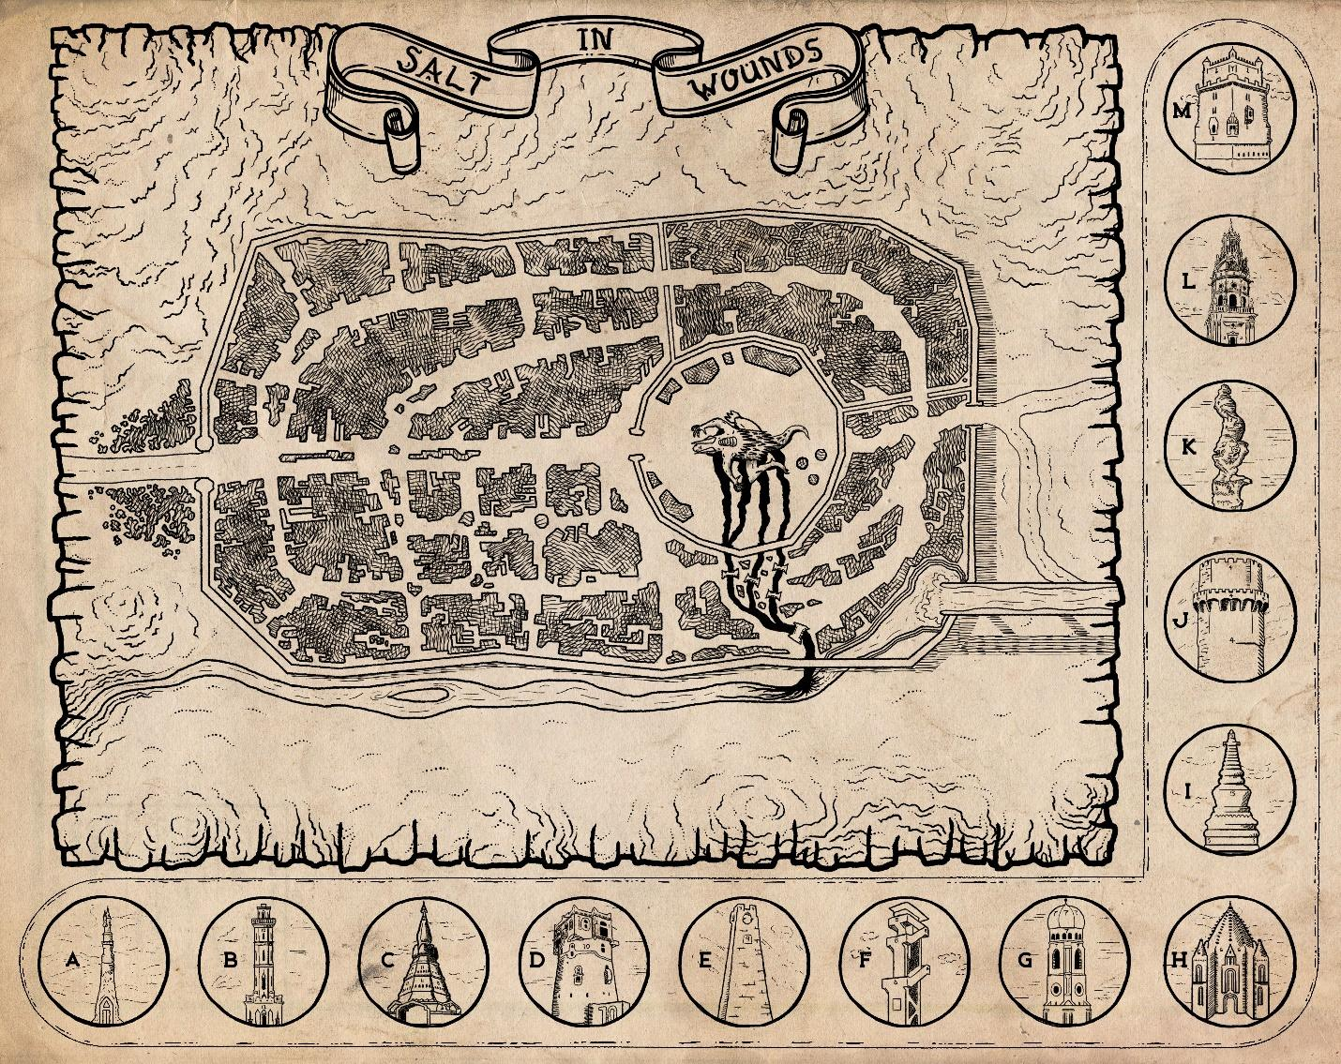

1. LIFE IN SALT IN WOUNDS

Fiction: That Satisfying Crunch
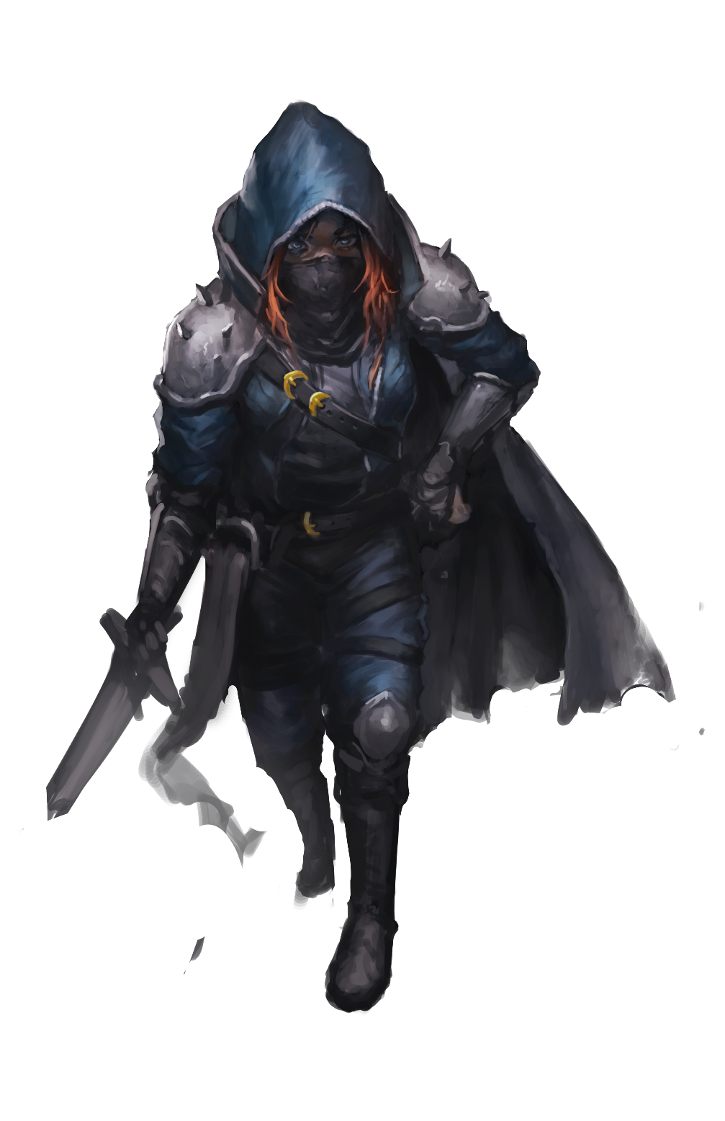
Toman always enjoyed the feel of cracking a tender’s nose. A lot of places you hit a face and you can break your own knuckles if you ain’t careful, but catching them just right—unsuspecting like—in the snoz, you always get a satisfying crunch and the give of cartilage as you flatten that bulge below their eyes. Then it’s all blood and blurbing and disorientation; this time was no different. A hit like that, a smack just right, catches them off guard and makes them unsteady on their feet….which is doubly ‘portant if they’re properly salted and further persuading is called for. Toman didn’t think this scrap of a bully was the sort but she hadn’t lasted this long by thinking nobody was nothing short of a killer in waiting.
She bent a bit and in a smooth motion that happens before the broken nosed duergar can react she draws one of her daggers—Chastity—and lets it sink past the coarse, bushy beard and nip into the soft flesh below the nape of his neck. Pushing gently, she uses his natural inclination not to have his throat slit to drive his back against the filthy walls of the alley and up on his tiptoes in such a way that her body shields the scene from onlookers; her steady and stable on her feet, him further off balance.
“Now, my friend,” she whispers. “We’re gonna have a nice, friendly chat about your dealings with 4th House…”

Races of Salt in Wounds
Salt in Wounds is home to a dizzying array of peoples and it’s commonly said within the city that it’s home to every sentient race on the planet…even those that haven’t been born yet. Representatives and sometimes entire communities of the various races come to the metropolis for a wide variety of reasons, from economic opportunity to food security, various plots and adventures, the spectacle of pain, alchemical wonders, or (most commonly) the markets. Of particular note are normally monstrous races which have a recognized legal status within Salt in Wounds. Countless thousands have eked out a place in the human-dominated society in roles that they would be completely unable to capitalize upon in any other civilized city, and these beings are usually found in the employ of the Marrow Miners.
What follows is a description of the social place and temperament of the most common races.

Human
Humans are the most common race of Salt in Wounds and dominate most power structures. Given the incredible diversity of the city however it is important to note that they are not the majority, merely the largest minority. Notably humans of dozens upon dozens of ethnicities live and work in the settlement. Common wisdom holds that human (and demi-human) residents will lose most of their individual culture as they are integrated into Salt in Wounds in a process generally referred to as becoming properly salted. How salted an individual is (accent, manner of dress, indifference to Tarrasque noises and movements) is the most important discriminator for class status as most other human racial features (hair, skin, eye color, and so on) are usually ignored. The average human in the city is dark brown skinned, with slightly curly thick black hair, weighing an average of 200 pounds and standing 6 feet or taller. It should be noted that numerous ethnic enclaves exist within the city (largely populated by more recent waves of émigrés) that hold onto their own values and cultural identity in opposition to those held by Salt in Wounds at large.

Elf
Occasionally, adventuring elves can be found within the city but currently there are no “true” elves living as long term residents—most find the reality of Salt in Wounds to be extremely distasteful.

Half-Elf
Half-elves (that is, individuals with both human and elven ancestors retaining noticeable phenotypic features of each) are a significant ethnic minority. Many work as brokers and agents for their immortal elven progenitors (who by and large refuse to live or even draw close to the metropolis) and 8th House was founded by a female half-elf named Virtan Berkuyin. The still living Binder-Lady has sired hundreds of offspring (technically “quarter” elves) in the centuries of her reign; she is almost always pregnant, with usually each pregnancy begun by a different male who caught her eye and resulting in the birth of twins, triplets, or even septuplets.
Dwarf
Dwarves are rare in Salt in Wounds in large part because of the significant presence of duergar. As a population they tend to be quite well-to-do, excelling as skilled hornsmiths and prosperous blood-merchants in addition to comprising 6th House.

Half-Orc
Half-orcs are a major demographic component of the population of Salt in Wounds and the most common racial group after humans. Complicating matters however, there is a widely varied percentage of orcine blood as—again—this racial designation is commonly used to describe mixed ancestry individuals who bear both human and orc features. In the early days of the fortress the human defenders of the Tarrasque hunted down and exterminated the male orcs of the nearby Seven-Talon clan, enslaving the juveniles and claiming the females as “spoils of victory” (concubines and sex-slaves). From their rapine beginnings the half-orc children of these unions have become a dominant force in Salt in Wounds and the city's acceptance of these individuals drives a lot of immigration by non-native half-orcs, though this population has come into increasing conflict with the “true” orc immigrants recruited by the Marrow Miners. This is especially ironic given that no genuine division exists, with mixing of the blood producing a gradient of individuals with various human to orc racial features, each afforded different privileges afforded to them based on which they most closely resemble (either mixed, human, or orc).

Gnome
Gnomes are well represented particularly amongst alchemists. This is largely a result of Tonagree Bumblezaz (an early, prominent gnomish alchemist and first teacher of the famed Bakal Filligreen) sending invitation letters and offering to help with the resettling of every one of his thousand and eight cousins in addition to their families. Not surprisingly; most Salt in Wounds gnomes are related to the long gone Bumblezaz. The gnomes of Salt in Wounds are known for a playfulness that runs into overt sadism—whether this is some effect of the city or a selection bias of the sorts of gnomes who choose to live in Salt in Wounds is a subject of much barroom speculation.

Halfling
Halflings were mostly servants, aides de campe, and slaves of the army that originally bound the Tarrasque—most of their descendants fit in a similar caste in the present day. This is so often the case that it isn’t uncommon for people to simply assume every halfling they meet is a slave. This is especially troubling for Halfling courtiers of 13th House (the so-called “people's house”) which was founded by Rexaney Bramblethumb, a teenage halfling servant who stepped into place to accurately fire the final immoveable harpoon when her master fled.

Ghouls
Despite the more poetically minded chroniclers claiming that the entire city is comprised of ghouls and parasites, literal ghouls make up only a small percentage of the population of Salt in Wounds. While the statecraft of 5th House has gained them begrudging legal acceptance by the legislators (the other meridian houses) they are still largely despised and feared by the general population.
The primary legal argument that 5th House presented to justify the sanctioned creation of ghouls is that issues of ghoul attacks and violence are driven by unsated hunger for flesh, which they posited would never be a problem in Salt in Wounds. While this isn’t necessarily true, in general by eating twice their own body weight in meat each day (usually spoiled Tarrasque flesh) the undead are able to function more or less as any other demi-human (though many choose to supplement their diet with meats of all kinds, including that of sentient creatures). Ghoul citizens employed by 5th House have now largely replaced otyughs as the primary disposal mechanisms for the tons upon tons of rotting meat produced by Salt in Wounds each week.
5th House offers ghoul contracts, legally binding arrangements wherein the alchemist-necromancers of 5th House guarantee to resurrect individuals as ghouls. To enter into the contract the would-be undead must either pay a hefty fee or pledge to serve 5th house tirelessly for a century. This resurrection is usually handled by implantation of a small alchemical device filled with specially modified ghoul fever that bursts when its owner’s life functions have ended (5th House vehemently deny any rumor that the implant can burst upon non-deadly impact.)
While open to individuals of all walks of life, this offer (unsurprisingly) has largely been taken up by the desperate and damned. The ghoul contract is viewed as an insurance policy against a less desirable after-life destination or (perhaps more worryingly) the equivalent of an ethical blank-check to live life however one wishes without supernatural consequence. The process of ghoulification—as well as the resulting creatures—have some distinct though not always predictable differences. Traditional ghouls wrought by the 5th House undead creation process are not animated or victims of unholy plague but a marriage of traditional ghoul fever infection and Tarrasque-derived alchemy.

Tiefling
Tieflings make up a significant portion of the city’s population yet almost none are born within the metropolis. They suffer (or enjoy) stereotypes which position them as ruthless and cunningly efficient, unburdened by squeamish morality. Many guilds and organizations try to enlist tieflings as faces or ambassadors of their institution due to these (often untrue) notions and competition in the settlement exists to hire fiend folk for their visage (and the prestige attached to it) alone. Regardless of their other qualities due to these cultural distortions a number of the most effective operatives looking to reform Salt in Wounds—trying to bring an end to cruelty and championing other causes of good—are tieflings that rely on the biases of the city to cloak their true intentions.

Dragonborn
Dragonborn are somewhat uncommon in Salt in Wounds but the famous Teeth of Srithie mercenary company is wholly comprised of the scalykind. Their kind are so renowned (and otherwise rare) that citizens frequently assume that any dragonborn encountered is a member of the Teeth and available for immediate hire.

Grippli
Grippli—4 and a half feet tall, 120 pound frog-people—are a regular sight within the Tail Stones district, almost universally associated with poverty. Most are emigres from Heartsblood Marsh either driven out for fear of violence or by wanting something better, greater than anything they could accomplish in the shadow of the fungal sieve. As a population many of them are slaves and those that are free tend to find themselves in the most servile positions.

Agogi
Easily weighing over three stones and towering over humans, agogi are veritable mountains of muscle covered in leathery reptilian skin and often possessed of a seemingly gruff personality. Unfortunately this means they are often dismissed as monstrous brutes by the ignorant, a perception that belies a race notable for an extremely altruistic society. Rather than extolling the virtues of benevolence or having a secret agenda of ingratiation, the agogi almost universally believe that helping others and being useful to their community strengthens themselves as much as their neighbors, eventually raising them all up to be equals among other races. Even evil agogi can see this communitarianism as a way to raise their social ranking among others that might look down on their monstrous self, and by taking advantage of the training and resources offered by the community the poor will eventually contribute more themselves as well.
With immigrant waves beginning 50 years ago the agogi have thrived in Salt in Wounds particularly due to their ability to eat carrion, derive water from meat, and extremely supportive kinship networks.

Orcs
Often employed by Marrow Miners, these are large, green-gray-skinned, tusked, powerfully built humanoids with “poor impulse control” when compared to a human standard. As more tribes across the globe lose in their wars to humans and other settled races, orcs increasingly choose to reside in Salt in Wounds. The distinction between orcs and half-orcs are blurry, often influenced by culture, language, manner, and dress over more objective standards (although generally the more “human featured” an individual is deemed, the more and greater the privileges afforded to them).

Duergar
These so called “deep dwarves” are squat, short, gray-skinned humanoids who experience sensitivity to sunlight, affirming a culture that celebrates oppressive work and brutal hierarchies for their own sake. Since a few hundred emigrated to Salt in Wounds they have found the city much to their liking, amassing massive power and influence.

Mites
Considered odd (and unusually spiteful) by other races, these bone-white halfling-sized fey breed quickly and generally don’t learn much beyond some simple language and the most pressing skills or concerns to get through the day. They are typically used for the worst and most dangerous working jobs in Salt in Wounds which for them is preferable to most other lives in the wider world—mites tend to be predicated upon monstrous elements and are often eliminated by the other races without much consideration.

The Salt in Wounds Calendar
Salt in Wounds uses a simplified calendar based on seasons rather than months. The annual tracking of the calendar begins with the binding of the Tarrasque, hence the current year is 277 AB (After Binding). While the nature of the city’s unique weather removes most of the markers of traditional seasons, the citizenry still count by them. Each is broken up into a dozen seven day weeks for a total of 84 days per season. A date might read “74 AB – Summer – 37” for the 37th day of summer, 74 years after the binding of the Tarrasque. One quirk of this calendar is that since a year of Synoma is 337 days long, a single “gone day” separates one year from the next, celebrated between last year’s winter and the next year’s spring.

Festivals of Salt in Wounds
The city of Salt in Wounds features hundreds of celebrations, block parties, and feast days ranging from local neighborhood affairs to events put on by obscure religious sects to bacchanalias that surge through the municipality sweeping up young and old alike. What follows are three of the largest and most significant festivals of the city.

Binder’s Glory
Celebrated Fall – 10th–13th each year, this festival is held to commemorate the binding of the Tarrasque. Binder’s Glory is the largest celebration in the metropolis and almost all laborers take up to three days off of work to drink, dress in garish costumes, and revel. The massive festival draws wealthy visitors from hundreds of miles away and features a large parade where floats and performers reenact the now near mythical imprisonment of the monstrosity. It is customary for each of these reenactments to be expected to be bigger and better than the year before, and no small amount of intrigue goes into the festivities as they are used to shape the narrative about Salt in Wound’s history (and thus plays into the politics of today).

Gone Day
Celebrated on the calendar’s “gone day” between Winter and Spring, Gone Day is a traditionally light-hearted affair in the usually dour Salt in Wounds. Numerous minor laws (anti-defamation statutes, trade restrictions, and so on) are temporarily rescinded as citizens are encouraged to act out of character. Gone Day is also a popular time to make overtures of romance, friendship, business, or any other category of offer where one might fear rejection. When these offers are accepted much the better, and should such advances be unwelcome or rebuffed, it is customary for all parties to act as though nothing ever happened in the spirit of the holiday (quite literally as if the interaction happened during a day that doesn’t actually exist).

Unity Day
Celebrated in the middle of Winter, the Church of Monad convinced the city elite decades ago to set aside a single day to officially honor learning, quiet contemplation, and “the unifying principle(s) that connect all things.” What was intended to be a somber day of reflection has largely morphed into a cross between a tradeshow and a session of one upmanship between the city’s many alchemists wishing to demonstrate their skills. Unity Day also tends to attract visitors from the world over journeying to see what the famous Salt in Wounds alchemists have come up with, culminating at midnight when the city unleashes a stream of fireworks that rivals any display found elsewhere in the world.

Industry, Work, and the Economy of Salt in Wounds
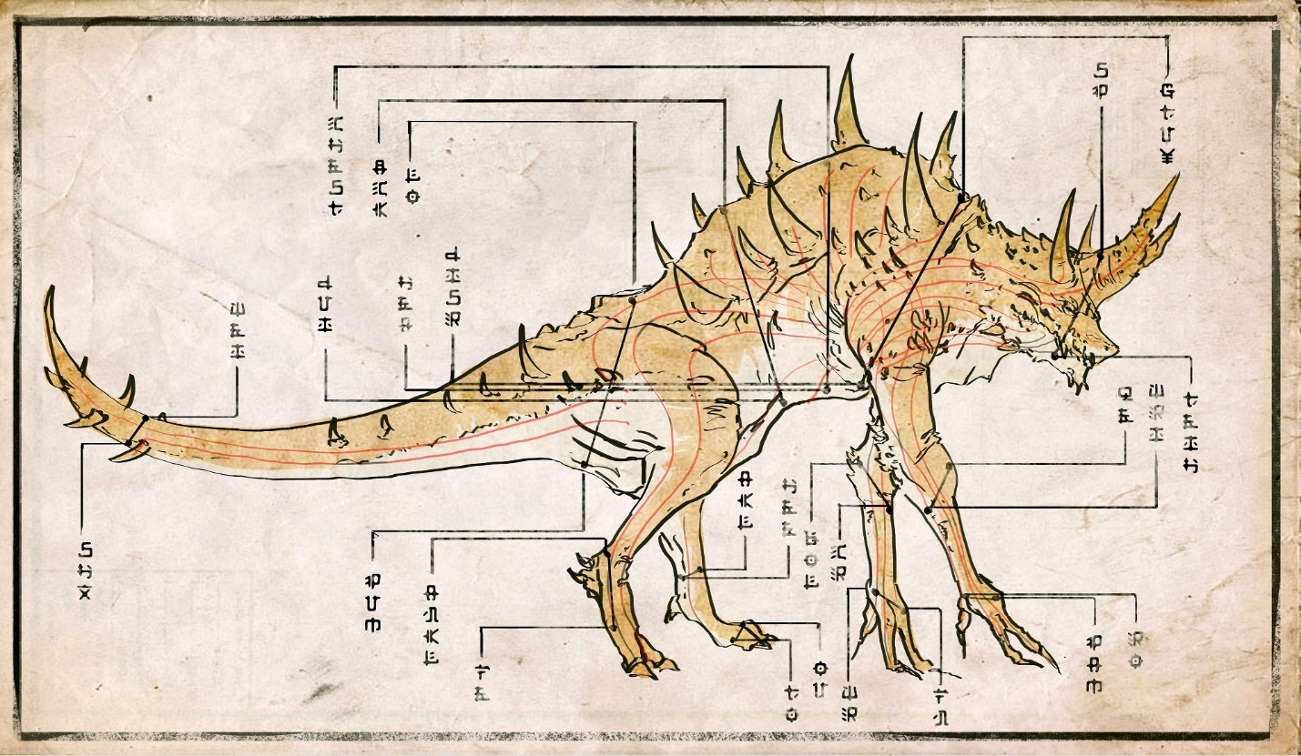
The Tarrasque is utilized in a number of different ways to feed the populace and grow the economy of Salt in Wounds, and in recent decades the city has developed method and uses never anticipated. What follows is an overview and common knowledge of some of the most common Tarrasque-derived products, industrial, and trade activity typical in the metropolis.

Meat
The most commonly used part of the Tarrasque is the meat—muscle and fat tissue cut out for consumption. Meat comes in many forms the most common of which is stringy basale boiled in bulk and practically (or in some cases literally) given away. As such it is considered the lowest class foodstuff of Salt in Wounds. Beyond that are a range of cuts to satisfy every palate and prices vary widely between the almost fishy osseous to prime, red flank to all the most rarefied plates of pith. Cuts of the tongue are valued above all others and officially served only to high ranking God-Butchers or honored guests following a successful Rite of Mutual-Recognition. There are however numerous black-marketers which claim to sell tongue for exorbitant prices (and at least one who actually does).
Salt in Wounds is a huge exporter of heavily salted jerky which can remain edible for months or even years and—depending on region—will be the most common component of long lasting trail rations.
Horn
Low grade Tarrasque horn can be shaped by specialized bone smiths for nearly any application that would commonly call for steel—as a material it exhibits similar hardness, ability to keep an edge, and other functionalities. As such armor, weaponry, and tools in Salt in Wounds and the region beyond are commonly made from pieces of bone taken off the monstrosity. These items have an advantage over steel in being relatively inexpensive, but conversely when they are damaged or suffering from wear they’re impossible to repair and must instead be replaced.
High grade Tarrasque scale or horn has properties similar to adamantine and is extensively used by God-Butchers to cut into the Tarrasque and by horn smiths whose craft tools are made of the substance. Such tools and weaponry must be specially cared for and occasionally “fed” or they cease approximating adamantine and instead degenerate into “low grade” status ( akin in hardness and utility to steel). Feeding involves heating the item in question in a forge or open flame, then quenching it in a small quantity of fresh Tarrasque blood mixed with water or tens of gallons of other blood which is absorbed into the item.
Scale
Scale is harvested in massive quantities, crushed, reconstituted and used as a type of concrete-like building material.
Alchemy & Medicine
Alchemy derived from Tarrasque extracts is the metropolis’ second most important industry. Such palliatives, aids, weapons, and boons come in a dizzying array and have been known to provide functions as disparate as regeneration, induction of rage, allow diners to eat near limitless quantities, avoid fear, and so on. Of special note are the so called blood tokens—thin, coin sized wafers made via alchemical distillation that double as a secondary, de facto currency of Salt in Wounds. These tokens are actually comprised primarily of blood which is processed with small, alchemically active amounts of other, rarer reagents. Those skilled in the art (and possessing the proper equipment) can extract one of any number of alchemical functions from these bits, or use a sufficient quantity of specially treated blood tokens in substitution for an otherwise unobtainable reagent.

Clearing House for Magical Items & Banking
Beyond its industry derived from the Tarrasque, Salt in Wounds has developed in recent years into a central merchant and banking hub. Its status as an independent power with low taxes and trade surpluses has made it especially attractive to those who wish to trade magical items and devices. The presence of these high value items serves as the collateral for much lending and finance, often used to provide capital adventuring or merchant expeditions which in turn further feed the booming financial industry. Especially canny, financially minded individuals believe that this industry may well one day supersede Tarrasque-derived manufacture and food production as the prime driver of Salt in Wound’s economy (with the city’s security enshrining it as a truly neutral power where even enemy states can conduct business).

[special] 10 Delicacies of Salt in Wounds
All-Color Pudding. There are very few orchards in Salt in Wounds and fruit is generally an expensively imported item. Early on, merchants would disguise their rotten apples, pears, and more by mashing the barely edible fruit and boiling it into a pudding. Over time tastes evolved to the point that this is now the preferred way for citizens to consume this manner of foodstuff—even perfectly preserved fruit is usually mashed and boiled together. The traditional recipe for all-color pudding is one part grape to one part apple to one part pear to one part squash liberally seasoned with cloves and tributary leaf.
Ambergris. Tarrasque ambergris is worth its weight in gold due to its use amongst perfumers and its reputations as being an aphrodisiac. The extremely wealthy eat it basted, sometimes served with eggs or thin slices of imported celery and rice.
Bladed Bakeup. A bake of Axebeak eggs, Tarrasque bacon, peppers, tomatoes, and (for those who can afford it) pig eye is traditional fair for a late, rest-day breakfast and is colloquially known as an excellent hangover cure.
Bread. Unadorned bread is considered a delicacy within Salt in Wounds as flour is four times the normal cost due to the city’s extreme distance from any fields and an endemic yeast quickly rots stores of the stuff. As such, bread is not a staple as it is for the rest of the world. The city’s bakers are rare and tend to be extremely skilled in their craft (so as not to waste flour) and visitors often describe the bread of Salt in Wounds—which ranges from light, fluffy blanch bread to heart almost loamy black bread—as perfect.
Five-Roast. Five-roast is a stirge stuffed in a singing house-lizard stuffed in a hatchet beak stuffed in a juvenile ramora flea stuffed in an axe beak. Before encasing it in the next layer, each animal is cleaned, skinned, plucked, coated in an individualized rub meant to compliment its unique flavor, then wrapped in thin strips of Tarrasque flank. Five-roasts are then cooked on a spit for no less than 20 hours, the skin crackling and caramelizing, before being served as part of feast day celebrations.
Marsh Stew. Despite the unappetizing name, this hearty soup comprised of half a dozen varieties of mushroom and delicately seasoned has been all the culinary rage of late. The gastronomically adventurous search high and low through the Tail Stones for the best, most authentic gripple-run street stalls to cook this meal. Gathering ingredients for the stew has sent many adventurers to the Heartsblood Marsh—not all of whom return.
Master’s Tongue. This rarefied cut of Tarrasque tongue is only ever served at the celebratory feast when a Journeyman God-Butcher completes their rite of mutual recognition to become a Master God-Butcher. It’s usually paired with pickled vegetables and brine soup. Being invited to such a feast is considered recognition of an individual’s status among the elite.
Rat Crunch. Rats are not a common pest in Salt in Wounds (due to the general absence of water, singing house lizards seem to better serve that urban ecological niche) but are not wholly unknown and often stow away in caravans. Enterprising trappers obsessively seek to hunt for these creatures as their skeletons are considered an appetizing way to add a pleasant crunchy texture to casseroles of Tarrasque pseudo-liver and imported potato.
Sweatmeat Jerky. Tarrasque fat coated with honey and root spice then smoked for days, this chew is favored by workers who often gnaw on the taffy-like confection for hours. Sweatmeat jerky can hold its pleasant flavor for hours upon end and supposedly chewing on the substance can sustain one for days, making it a favorite alike for harried laborers without time to sit down for a meal and aristocratic dandies trying to watch their figure.
Tarrasque Sash. Custom and common sense hold that Tarrasque flesh should be served well-done, but raw or lightly-pickled Tarrasque flesh (called sash) can be served with vinegar and garlic paste. There are different notions about how to do this while minimizing the risk of being corrupted by the monstrosity’s meat, but Tarrasque Sash is usually only consumed by the extremely decadent or fool-hardy.

Salt in Wounds and Water
When the Tarrasque was first bound a large, sweet stream—almost a river in its own right—ran nearby the encampment that would become the fortress Salzinwuun. Along with several wells the watch drug, the denizens of the fortress and early binders felt that they would always be well-supplied with ample water to sustain the animals and soldiers.
The spreading of the Tarrasque’s essence into the stream, the soil, and the surrounding water tables proved this early optimism unfounded.
Within months of the Tarrasque’s binding the water downstream of the beast became fouled for dozens of miles. It looked and tasted of blood, and any who drank of it were sickened (or worse). Efforts were made to rely more heavily on the wells until they too were corrupted with the red essence of the perpetually slaughtered Tarrasque. During this time the volume of the stream’s flow increased—some alchemists theorize that the spilled blood of the Tarrasque itself continues to regenerate—and so the flow off from Salt in Wounds was renamed the Red River.
Daily, haulers would travel upstream to fetch water for the soldiers and beasts of burden. As time passed however, water further and further upriver was corrupted until there was despair over whether or not Salt in Wounds could survive. This crisis occurred right around the ascendancy of the nascent city’s economic viability however, and funds were provided for a massive engineering project: the Clear Water Aqueduct.
The Clear Water Aqueduct
Hundreds of miles upstream, far from the corruption of Tarrasque essence, the Halcon River was diverted onto a massive aqueduct which carries water safely to the city. Water is drawn off of this vital piece of infrastructure and carted to market to be sold by the Water Hauler’s Guild. There is worry that eventually even the distant headwaters that feed the raised aqueduct will become corrupted—the Tarrasque’s essence slowly creeps uphill, claiming ever more acres to its twisted nature—but at the current rate of ecological change the city still has several decades before that becomes an issue.
When allowing the Red River to flow unchecked was deemed to be an environmental crisis of the most devastating kind, the mad Gnome Druid Afrindi Gunterhix diverted the waters as well as importing and modifying hundreds of organisms to create Heartsblood Marsh.
Food & Water Prices
Food—at least food that can be obtained from the Tarrasque—is significantly less expensive (1/10th normal cost) however due to the cost of water, daily ration costs are identical to what one would find in any other large city.
Water is generally affordable to all but the poorest residents and the increased cost of hydration generally counterbalances the decreased cost in food to create a cost of living basically in keeping with (or even significantly lower than) other cities. One large exception however is that the keeping of traditional animals (horses, dogs, etc.) is seen as prohibitively expensive by all but the wealthiest, and individuals who own, ride, or otherwise use such animals are automatically assumed to be extremely wealthy. Every such animal kept costs the same in upkeep as an average person. Most Salt in Wounds residents favor Axe Beaks (as a replacement mount or draft beast) or hatchet beaks (rather than a dog) who—like many other birds of prey—draw their water from the meat they consume.
Types of Water
- Snow Melt. hauled from the local mountains, this is usually seen as a prestige purchase (although sourcing water this way has the added benefit of preventing a complete monopoly capture by the Water Hauler’s Guild).
- Aqueduct. This is the main source of water for Salt in Wounds—clear, safe, and affordable (for now) to all but the absolutely poorest residents.
- Rain. Neither common nor uncommon, rain is always appreciated and directed into thirsty barrels for use later.
- Riverfall. Where the aqueduct terminates on the northwest corner of Salt in Wounds, any water not already drawn out of it simply spills into the ancient path of the stream. From here it meets runoff of the Tarrasque’s butchering and soaks up corruption from the very earth. The extremely poor and desperate try to draw this water (cost free) before it is irrevocably fouled by the monstrosity’s blood.

Special: Water Dens
In a city like Salt in Wounds companionship can be as vital as water. Water dens are billed as social huqqa smoking dens, staffed by gorgeous hosts who handle everything from serving drinks, tobacco selection, entertainment, pointed conversation and—of course—water.
The quality of a water den is judged not only by the hosts and menu, but what isn't available as well. Higher end establishments don't offer sex or even touching as part of their services, with some existing simply as a tavern for successful merchants and adventurers that is constantly filled with beautiful people. These hosts rarely interact with the patrons, simply existing as eye candy in a city filled with mutations and hard people. Foreign travelers with coin often use these higher end Water Dens as a place to practice local dialects in relative quiet, with specially built walls absorbing outside sound and the rumble of the Tarrasque.
A majority of high-end establishments are under the purview of House Impertabo, its most famous Water Den being The Library. More information about this location can be found in the Beast Crown District section of this book on page @@.

Weather
Salt in Wounds is surrounded by freezing mountains but ranges in temperature akin to what one would find in a humid jungle. Rains occasionally fall on the metropolis but is more likely to experience “slurries” (named for the liquid or partially melted snow or hail that rarely falls on the settlement). The city also experiences unique effects (like the terrifying “black sun” days) more information about which can be found in the Hazards section on page @@.

The Salt in Wounds Mindset
The culture and common mindset of Salt in Wounds is quite unique to the city. As one of (if not the most) populous places on the planet, the metropolis’ society as a whole is extremely insular and individuals tend to be focused on their own affairs. While traders come from the world over to buy alchemical and magical goods derived from the Tarrasque (and sell to the huge domestic market) the city’s relative isolation ensures that only the most dedicated and skilled visit (although fortunes are made in such ways). Most who reach Salt in Wounds never leave and absorbing several waves of emigres (most often in the form of peoples often fleeing famine) has kept the settlement a polyglot society with individuals at various levels of being naturalized or, more colloquially, salted.
The masses tend to be extremely industrious with lives that are regularly punctuated by extreme binges of revelatory or even criminal behavior. The aristocracy meanwhile is largely obsessed with their own pleasures or the greater glory of their house at the expense of the city at large. Uniquely, Salt in Wounds tends to be comparatively under-militarized ever since 3rd House Binder-Lord Huzawai turned back the Wyren Siege by threatening to release the Tarrasque—and the city has been largely unmolested by traditional military forces ever since.
The people of Salt in Wounds think and care little for the outside world. With the exception of some luxury goods (most especially spices, intoxicants, and varieties of food) or as a chance to make their fortunes (either through mercantile or adventuring schemes) most assume that the Tarrasque will provide for any need—and in this they have historically been proven more right than wrong. This makes important projects like securing possible water supplies difficult to organize for and usually means that Salt in Wounds is susceptible to price gouging by organizations like the Water Hauler’s Guild.
Salt in Wounds’ citizens are largely inured to pain, death, and mutilation—legal torture, bar fights that maim or even kill, and industrial maiming of workers are all seen as normal (if not desirable) by the majority. Even as mutation plagues sweep through much of the city, most salted people are smugly proud that even the poorest among them don’t go hungry.

Colors, Symbols, and Iconography of Salt in Wounds
As a polyglot metropolis Salt in Wounds is awash with color, symbols, and imagery imported from dozens of ethnicities and cultures. However, certain motifs carry over into the sigils, seals, and other identifying marks of the aristocratic houses, merchant guilds, and those belonging to high profile individuals.
Imagery featuring the Tarrasque (usually heavily stylized) reigns supreme and such designs often place special emphasis on the creature’s jaws. Icons of the Tarrasque are usually shown pierced by a harpoon (the placement of which is suggestive of Meridian house loyalty or kinship) or wrapped in chain. Images of axebeaks, ghouls, alchemical glassware, and the oversized swords of God-Butchers are also regularly included. The metropolis’ official colors are dark red (for blood), parchment tan (for flesh), and blue-purple (for the notion that every man is a king, every woman a queen, and that all are independent in Salt in Wounds).
The official flag of Salt in Wounds is the bowing head of the Tarrasque bleeding from the contact points where a crown of thirteen harpoons pierce it over a blue-bordered white background. The official motto of the city is “Bind the Savage, Honor the Deal, Feed the People.”

Crime and Punishment
The city of Salt in Wounds tends to have extremely harsh penalties for infractions although imprisonment is almost unheard of. The most common punishments are fines (even for serious crimes for those who can afford it), forced labor, flogging, branding, a variable number of points maiming, execution, and finally truncation.
Points of maiming follow a regular (cumulative) order and thus the relative disfigurement of an individual often provides information about the severity of their crimes. This maiming is in the following order: the extraction of an eye, the loss of five toes (across both feet), the loss of five fingers (across both hands), the loss of a hand, the loss of an arm, the loss of a foot, the loss of a leg. This order was selected as it was deemed to give the guilty the best chance to continue contributing economically. If a criminal ever reaches eight points of maiming, they are given the choice between truncation (amputation of both legs, both arms, tongue, and gouging of both eyes) or execution (though the most serious offenders are truncated). Parts taken by these punishments are usually actioned to alchemist constructing flesh (or Tarrasque flesh) golems. As an unfortunate corollary of the city’s legal practices, adventurers, veterans, and even laborers who have lost limbs are usually assumed to be former or current criminals.

[special]Example Crimes and their Punishments
Conspiring to End the Tarrasque's Binding. Truncation or Execution
Magical Creation or Unauthorized Import of Water. Fines up to double the water's value and up to 3 Points Maiming
Maiming or Assault. Branding and up to 2 Points Maiming
Murder. Execution
Propagandizing. Special Case - “propagandizing” is any speech deemed to “threaten the economic, social, or cultural well-being of the city” and is a charge which can only be brought by a Binder-Lord. After conviction, the accusing Binder-Lord determines punishment which can range from a single copper fine to truncation, depending on the Binder-Lord’s recommendation.
Runaway Slave. Branding, Flogging, and 1 Point Maiming
Smuggling. Fines up to five times value, Branding and/or up to 3 Points Maiming
Theft. 1 point Maiming
Unlicensed Ghoulification. Destruction of ghoul and 1 Point Maiming for the practitioner (if applicable)
Use of a Command Word by any Non Binder-Lord. Truncation
Use of Magic or Alchemy to Remedy Court Ordered Maiming. Maiming equal to what was healed or proposed to be healed.

Coins of Salt in Wounds
While awash with foreign money, as a point of pride Salt in Wounds mints their own coinage. The currency of the city features several distinct features. First, the copper, silver, gold and platinum tokens do not sport portraits but instead are pressed with famous phrases, maxims, and laws spouted by the aristocracy. Which phrase is selected for placement on this year’s platinum (and to a lesser degree other metals) is a source of much competition and political maneuvering by the Binder-Lords.
In addition, the center of each coin features a small conical point on one side with a tiny hollow that can accommodate another coin’s point on the reverse face. These are referred to as the “tip” and “divet” respectively. This construction makes Salt in Wounds coins easy to stack securely on top of one another (useful for quick counting and pushing stacks of coin back and forth across a table without risk of toppling). Coins are usually kept in neat rows within pouches with reinforced corners. Out of towners can often be identified by how they improperly shove coins into their pockets or bags where they are liable to jut uncomfortably into flesh (or poke out of fabric). Some especially cautious merchants (and devotees of Solidia Septermus) are known to deliberately keep the tips of their coin stacks pressing into their skin to be aware if there’s a change in weight resulting from a visit by one of the metropolis’ notorious pickpockets or as part of a religious practice known as the Merchant’s Penance.
To “know the pain of their stack” refers to an individual with business acumen or is otherwise good with money. When discussing transactions or jobs commerce can be described as “tip” which means above board or legal and can be spoken of openly, or as “divet” dealings if secretive, under the table, and of dubious legality (if not wholly black market).
Slang Terms for the Denominations of Coin
Copper Spike
Silver Scale
Gold Bone
Platinum Horn

Language and Slang
More or less any resident of Salt in Wounds speaks Common and small enclaves of speakers of every language can be found within city limits. All the same, citizens are proud of their slang.
Salt in Wounds Slang
- Agogi in an Apothecary Used similarly to “bull in a china shop” but with more of an implication that someone made an incredibly stupid mistake
- Burke A hard man or woman well suited to life in Salt in Wounds
- Bone Sap A term for success or ease
- By the 13 (Meridians) Curse akin to taking a god’s name in vain
- Divet Job Criminal (or at least dubiously legal) activity
- Know the Pain of One’s Stack Generally used to describe individuals with financial acumen or great wealth
- Last Cuts or Last Wednesday's Cuts Term for trash, garbage, shit; exceptionally low quality and undesirable; often used to sexually demean a person
- Salted An individual normalized to Salt in Wounds peculiarities
- Scraper/Skav Slang for a low class person or scavenger, especially used for people who seem to have no regular employment and are most likely criminals
- Tip Job Legitimate business
- Tenderloin or Tender The opposite of a burke; a rube, out of towner, or the target of crime or a con
- Twelfey or Twelfth man Insult used to denote someone or something as idiotic

Salt in Wounds and Morality
Salt in Wounds is an evil place. While the binding of the Tarrasque is perhaps necessary, the city has been built upon its callous torture with no current legitimate efforts to minimize its suffering. The evils of slavery are regarded as commonplace with regular arguments as to the rightness of owning slaves or how it can even be better for them. Numerous historical and ongoing atrocities—the literal and cultural genocide of the local orcs and stone giants, the dictatorial powers of the Binder-Lords, incredible corruption at all levels of society, and the economic collusion and abuse by the various merchant organizations—are regularly excused when they are not actively celebrated. More or less everyone in the city is party to this and while that does not mean that every individual is evil, it does tend to engender a general disregard to inflicting pain and suffering. As such a significant minority (and most of the leadership of the city) can be considered to be evil. Like every population however the majority should be considered to be neutral, primarily motivated by their own self interests though usually disinterested in hurting others in the pursuit of their own ends and when doing evil typically acting out of a place of ignorance or cultural inertia rather than special malice. Though it should be pointed out that this neutral percentage is the majority by a smaller margin than can be found elsewhere.
There are exceptional good individuals too—out of town adventurers or travelers, idiosyncratic individuals or families, most of the Agogi, or even those rare creatures working for one of the secret factions laboring to wholly overturn the horrifying status quo.
Due to its strictly hierarchical and legalistic government the city as a whole can be considered lawful, though chaotic individuals can easily thrive in the settlement as rampant corruption affords many opportunities to act freely for oneself.

2. DISTRICTS & PLACES

Fiction: Two Blocks
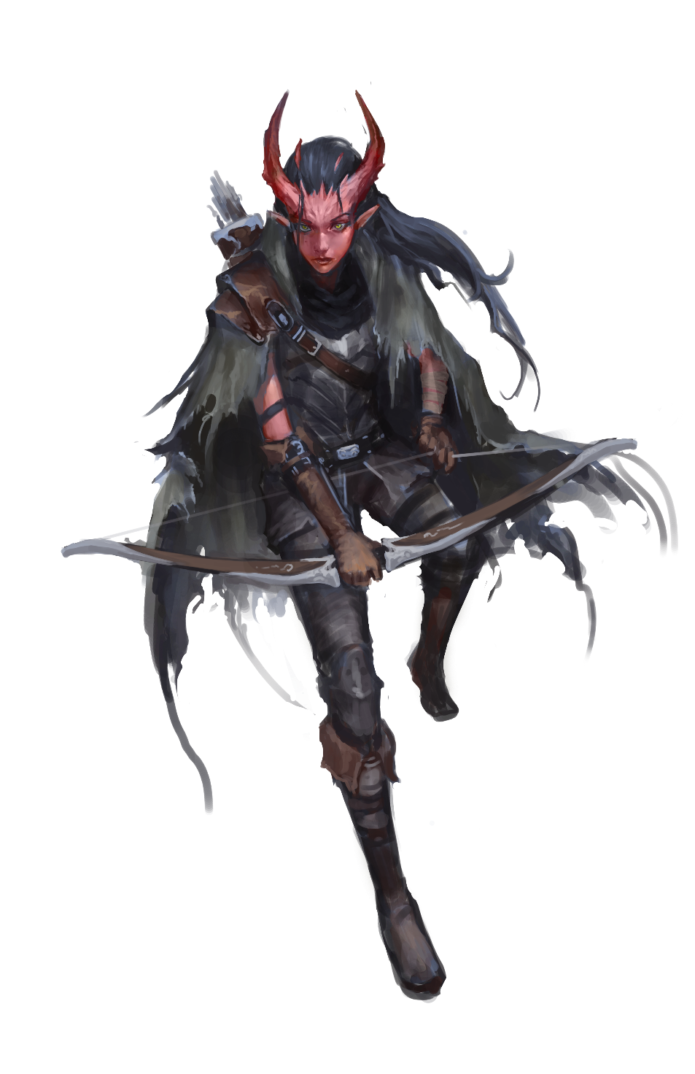
What a difference two blocks makes, Karyna Dontier muses as they notch another arrow. Two blocks from here—where Sage’s Row kisses High Throat—might as well be a different world. There, the black fox hasn’t been raised so most everyone was likely asleep, safe and sound in their beds. Two blocks from here, there wasn’t some armored maniac, face obscured by a purple mask, trying to break down the door Karyna had just finished barricading.
Of course two blocks from here Karyna wouldn’t have had a job, not that such a thing seemed so bad at the moment. They’d always preferred the man-hunting to man-saving but sometimes you took the work available even if you suspected you’d regret it later. Which Karyna did, now.
The only reason they were quite certain the—man, orc, whoever—wasn’t a golem (because no person has any right to be that big) was due to his incredibly loquaciousness. He just wouldn’t shut up. Not even after Karyna had put four arrows in his body…which should have killed him a dozen times over but only seemed to piss him off.
From beyond the failing door, Karyna heard him talking, “The night masks want your turf and your head Pipilo…and tonight we’re taking both.” This latest threat was punctuated by a greataxe blow that caved in the top third of the barricaded door.
“Sir Pipilo, as your duly contracted guard I must strenuously suggest that we discuss our strategy for egress.” Karyna said before firing their arrow, catching the bruiser in the eye slot of his mask. It must have been considered the height of comedy where the psycho came from because it only made him laugh as he drew back the axe for another blow, one Karyna suspected would finally cave the door completely.
The client stammered something about roof access before the hatch he was gesturing towards crashed down with a black cloaked figure wearing a purple mask landing atop it like a dancer. This new black cloaked arrival smoothly drew two daggers, just as axe-psycho landed another blow that shattered the door in earnest.
“Well, I guess I’ll be earning my per diem tonight.” Karyna thought, dropping their bow and drawing their blade.

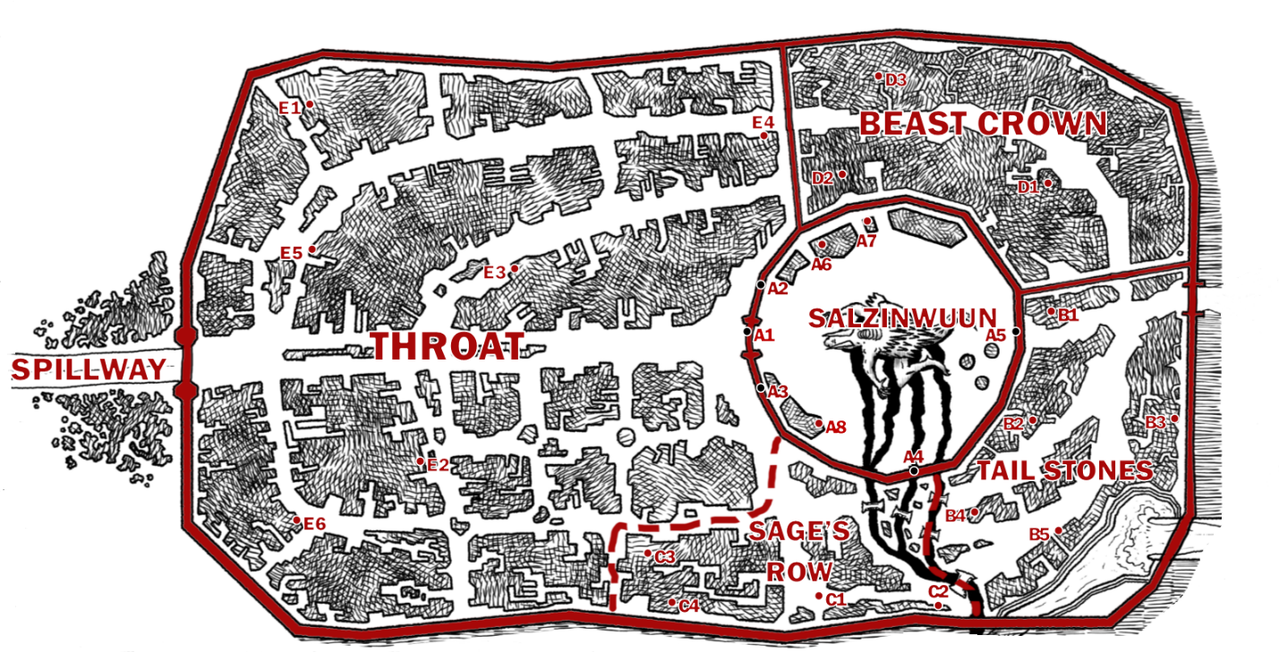

The Fortress Salzinwuun
Even the most strident critics of the Tarrasque’s binding—those who preach endlessly about how the creature must be released or slain—must admit that Salzinwuun is a wonder. The modern day fortress walls are over a hundred feet high, constructed of smooth black granite. The skill and craft of the stone giant builders has left barely an inch of space between the seer-mortared blocks; only the most skilled climbers could hope to find toe or finger holds. A faint discoloration betrays where the east facing wall was repaired following the 12th Meridian crisis and otherwise its magnificence is unblemished.
Still referred to as a fortress, Salzinwuun dwarfs most of the continent's castles. Where one would normally expect a keep lays the living, howling Tarrasque. Whereas most similar structures have defensive options aimed outward, Salzinwuun has numerous offensive emplacements aimed both in as well as out: arrow slits and parapets to keep the rest of the city and any would be invaders out, massive ballistas (their bolts affixed to massive chains sunk into the foundation) pointed towards the Tarrasque to keep it in. First time visitors often confuse the emergency weaponry (of which the wall mounted ballistas are the most prominent) with the weapon-like cutting tools—belly lifts, extraction screws, scalpel-rams—tat the God-Butchers and Marrow Miners utilize to run their operations.
Besides the gates, extraction tools, and last ditch weaponry the interior of Salzinwuun also sports first stage processing infrastructure from house sized vats and kettles for rendering fat or the boiling of piss and other liquids, to sieves and sifters the size of alleyways for doing rough sorting before export to the various member establishments of the Process Guild. Salzinwuun also features numerous roof stacks (covered, elevated platforms) where large scale exports are held for up to two days while awaiting sale or contracted pickup—usually, anything extracted from the Tarrasque not claimed and transported out the fortress gets dumped into the drains which lead to the Red River.
The largest structure inside Salzinwuun is the God-Butcher’s mess hall, a looming if simple building usually echoing with the sounds of rough, raucous laughter and filled with endless tables and kitchen facilities to feed workers (though this is off limits to Marrow Miners).
Notable Locations & Gates of Salzinwuun

Prime Gate A1
Prime Gate is set in the west and serves as the main thoroughfare. This is almost always a snarl of traffic as merchants and others seek to move under the double raised portcullis and the looming murder-holes between. God-Butchers man checkpoints just without and within to verify bills of lading, inspect cargoes, and do what they can to facilitate the currents of citizens and meat (while enforcing or carefully circumventing the law).

Giant's Gate A2
Giant’s Gate is almost impossible to spot when closed but can be found north of the west facing Prime Gate. This exit appears simply as another section of wall with curious, faint tracks of wheel ruts emanating from the fortress.When the massive interior cranks are turned (with superhuman strength) what looks like an ordinary stretch of wall shifts lifts to allow egress by massive, rune-inscribed stone giants hauling huge carts filled with meat, lard, bone, and other ephemera delivered in bulk to various Process Guild contacts. No entry is allowed through Giant’s Gate—the carts are hauled easily through Prime Gate at the end of the day—and anyone attempting to enter here would likely be trampled by exiting giants or their carts. The unwary that manage to survive those hazards would be slain by well-armed God-Butchers who jealously guard this gate.

Butchers Gate A3
Butcher’s Gate is a small entrance (the size of a double-wide door) south of Prime Gate, utilized by God-Butchers and the extremely well connected (Binder-Lords, the wealthiest Blood Merchants, etc.) to avoid the chaos of Prime Gate and quickly get into and out of Salzinwuun.

The Charnel Sluice Grates A4
Embedded into the southside of Salzinwuun are utilitarian gates unusedby sentient beings. Around the Tarrasque are deep channels dug to direct the flow of excess blood and slurry ground waste out of Salzinwuun, crossed by bridges at regular intervals and through massive steel grates out into the Red River. The grates and the channels that feed into and out of them must be regularly cleaned, a common punishment for God-Butchers who have angered their superiors in some way (although something that has in recent years often been subcontracted to Marrow Miners or other laborers). While the defenders of Salzinwuun doubt any would brave the foulness of the outflow to try and gain access, they still diligently patrol this feature.

12th Gate A5
Sometimes referred to as the Gate of the Marrow Miners, this an entryway is built into the east facing section of wall that was damaged during the 12th Meridian Crisis, constructed by the Marrow Miners in exchange for extraction and binding services. While not as impressive as Prime Gate, 12th Gate is still a heavily-utilized entrance and exit though delays to use it are much more pronounced as the God-Butchers who defend it regularly stop travelers or traffic altogether to conduct (sometimes justified, often punitive) searches of the Marrow Miners and their haul. God-Butchers claim that all contraband is smuggled via 12th Gate—while this isn’t entirely accurate, numerous criminal elements do make extensive use of the Gate of the Marrow Miners (in addition to making use the Guild of Marrow Miners themselves).

The Butcher’s Hall A6
These combination offices, mess hall, and barracks are available for all God-Butchers and their guests, though many choose to reside elsewhere. The meat served here—usually cooked on huge barbeques—is considered the best in the city.

Ballistas
Thirteen of these huge siege weapons are set into the parapets of Salt in Wounds, massive ballistas that are rebuilt and maintained after first being used to bind the Tarrasque. While not currently loaded with immoveable harpoons, they still maintain that capacity (should the need arise to again fire an enchanted bolt) though their regular ammunition is capable of causing massive damage and (hopefully) overwhelm the Tarrasque’s ability to regenerate should the need arise.

Lord and Lady’s Pagoda A7
A raised platform set near the south side wall, this structure was built to entertain visiting Binder-Lords (or other honored gates) so they could “inspect” work while being somewhat isolated from it. A small cadre of servants maintain a supply of delicious potables, perfumed handkerchiefs, and other luxuries nearby to supply for any visitors.

The High Shrine of Macinfex A8
A statue of Macinfex, Lord of Butchers sits southeast of the Tarrasque, and daily high priests of the Lord of Butchers give blessings to God-Butchers, Marrow Miners, and any who ask.

Tail Stones
The Tail Stones District is the area northeast of the fortress Salzinwuun, the central core of Salt in Wounds. Massively damaged during the 12th Meridian Crisis, the Hind Quarter (its formal name) was the stage for the death of thousands and saw many more wounded. The underfunded repair efforts for the homes, businesses, and critical infrastructure in this area is still underway (where it has not been completely abandoned).
By far the poorest district of the city, the Tail Stones is only marginally patrolled by the House Militias with control largely ceded to half a dozen gangs that pay dues to the Binder-Lords and their militia captains.
While the still evident destruction, criminal control, and rampant poverty here keep many with alternatives living elsewhere, the Tail Stones are still a bustling hub of cottage industry. Proprietors of these businesses favor their mean streets for the relative inexpense of setting up shop—and find that paying a gang protection fee for security is simpler than lax law enforcement and paying one of the roaming tax and trade enforcers that are all too common in the rest of the city (who often decide the risk-reward ratio for attempting to collect in the district reason enough to avoid the area).
At night the Tail Stones fill with the smells of cooking that waft from the hundreds of homes and street stalls of dozens of immigrant ethnic groups. It is said that those who know their way around can find better cuisine in the Tail Stones than even the best posh and polished eateries of Beast Crown.
Notable Locations in the Tail Stones

Guild Hall of the Marrow Miners B1
Built several years ago, this large building is the grandest structure in the Tail Stones, seen as a symbol of hope for many of residents and always a bustling hub of activity.

The Rachi B2
Largely if somewhat miraculously untouched by the 12th Meridian Crisis, this decades old gladiatorial arena is the most popular entertainment destination in the city, regularly attracting visitors from all walks of life. Adventurers are the stadium’s favored recruits, their foreign magics and martial skills making for captivating battles that always draw huge crowds and profitable speculator bets. In these fights anything goes save mind-affecting magic (as it’s not considered to be exciting enough to please the crowd). Rumors of the arena staff sabotaging or paying off combatants in order to beat the odds are roundly dismissed.

Gothmork’s Grub Hub B3
Goblinoids and the desperately poor frequent this tavern. Word on the street is that any kind of criminal service can be purchased here for rock bottom prices (for more information see Appendix 1 on page @@).

Regga’s Stir Fry B4
The sign above this street stall reads “Regga Thistlethorn: Extermination + Security Services & Best Street Chow This Side of the Beast!” Below it is a small storefront ringed with counters and eaves heavy with various roast carcasses of dog sized lizards, young axe-beaks, and some unidentifiable species of giant insect. The stall is manned by a cheerful, thoroughly scarred and dagger-laden halfling usually busy cracking the shell of some squirming thing into a wok filled with delicious smelling stir fry. Regga is knowledgeable about the various threats one can face in Salt in Wounds and happy to chat with customers.

The Shifting Place B5
The Temple of Renesec, Lord of Mutation is a converted apartment building on which the mutated faithful constantly add new layers of twisting, strange architecture while welcoming any and all who pause even for a moment to look at the strangeness.

Sage’s Row
Sage's Row is a series of interlocking streets famed for its preponderance of alchemists and other researchers of the arcane and mundane alike. The district is found south of Salzinwuun between the Tail Stones and the Throat. By city edict every other building sports tall smoke stacks—venting clouds of colored fog and ash of variable toxicity. At most times a breeze takes the offending miasma and disperses it “harmlessly” though if the skies are still the noxious air settles onto the avenues. Residents quickly get a sense of what color and kinds of smoke should be avoided, instincts that are usually cross-referenced to the active times of the alchemists with reputations for producing the most caustic substances.
Alchemical innovations pioneered in Sage's Row are exported the world over. Inhabitants are notoriously absent minded to the point that it's joked that the average Sage Rower wouldn't notice that the Tarrasque had escaped and leveled half the city till a week later when they failed to receive one of their regularly scheduled deliveries.
Notable Locations

Testing Field C1
After a number of incidents that resulted in property damage and death, a barren field was left open for alchemists and other inventors to test new devices, magics, and even mutagenic effects. This testing area is surrounded by high fences and eagerly watched over by 5th House Militia and curious gawkers alike. At least once a day, something brought here explodes, transforms into a rampaging monster, or otherwise gets dangerously out of control though the genius of the Testing Field is that the problem can easily be contained (with perhaps only the creator slain by their hubris instead of injuring valuable buildings).

Seconds & Bits C2
Run by a dour ghoul named Bling Gerpie (who in fact can see quite well) and found at the boundary between Sage's Row and the Tail Stones, Seconds & Bits is a sprawling emporium that sells junk, castoffs, and the reclaimed “treasures” of laboratories that burst into flame or other, more esoteric disasters. A little of everything can be found here at an incredible price...though no warranties are offered and all is expected to work not quite as advertised.

Flask of Inspiration C3
The most famous bar in Sage’s Row, this business is differentiated by its own working in-house apothecary. A three story tavern serves alcohol and assorted depressants on the first floor, hallucinogenic (or otherwise unknown connotations) on the second, and stimulants from coffee to spiced tea and beyond on the third level. The selections also increase in potency from the southside (where the door and stairs are) to the northside. The young and foolhardy are known to dare one another to take a drink from each floor, racing from one loor to the next as quickly as possible. The Flask of Inspiration is owned by a retired bard gnome adventurer named Grizanaline Decan who can usually be found singing or poring over her books amidst light cursing.

Temple of Reason C4
This Monadist temple—the most prominent in the world—looks roughly akin and functions much like a university with housing for followers and various educational classes available to the public on a sliding scale. Courses in alchemy, astrology, and aether theory are costly but often regarded as the most advanced in the known world. It has specifically become the de facto alchemical teaching facility for the city (though opinions differ whether the best learning can be found here or at the personal instructions of master alchemists who have hoarded private knowledge and developed their craft for decades or even centuries).
The church sponsors promising minds who could otherwise not afford their advanced teachings, requiring a demonstration of personal research in their field of expertise in a quarterly qualification event.

The Beast Crown District
The posh district located in the northwest corner of the city is the Beast Crown, bound to the north by Salt in Wound’s walls, to the south by Salzinwuun, in the southwest by the Throat and the south east by the Tail Stones. This part of the metropolis is further divided into “house neighborhoods” populated by members and those favored by the Meridian Houses. Each neighborhood is presided over by a manor-tower, a looming structure intended by its owners to display the wealth and power of their respective noble owners. Most of these towers, intentionally or not, also reflect the character of its house in addition to featuring repeated instances of the house number. Even those unfamiliar with the district can fairly easily find their way around.
The streets here are clean and jealously patrolled. While any may freely access the district, individuals who lack an aristocratic bearing (or fail to produce a token of a Meridian House) face a veritable inquisition by the resident House Militias, a process repeated every few blocks as a traveler passes through different house neighborhoods. In addition to serving the sprawling Meridian House families, the Beast Crown district is also home to numerous boutique shops, pricey entertainments, and diversions—of which the world famous Salt in Wounds Opera is the most prominent—and most of the metropolis’ official administration buildings including the courts, tax centers, trade offices, House Militia barracks and more.
Notable Locations

The Chine Hall D1
Owned and operated by 8th House, this Salt in Wounds opera house is known to attract skilled players from around the globe who perform to the haunting accompaniment of a custom built organ constructed from hollowed out Tarrasque finger bones.

Stage Courts D2
Constructed in the style of covered amphitheaters, each of the dozens of courts features seating for hundreds yet even so they’ve been known to overflow during particularly captivating trials. When in session, each of these courts have a sitting judge who listens to arguments of accuser and accused before passing judgement (for particularly prominent and important cases, a counsel of five or even thirteen judges is assembled). Such courts process scores of cases a day with judgment decided and punishment (usually some form of amputation, mutilation, flogging, branding, or even execution) immediately dispatched in front of the excited crowd. Watching trials is a popular pastime of Salt in Wound residents from all walks of life with most judges relishing their secondary role as entertainers.

Manor-Towers
Each Binder-Lord or lady has a fabulous manor-tower that serves as residence, office, playground, and even place of business for the house. More information of the notable manor-towers of the Binder-Lords can be found in the Factions section on page @@.

Black-Stone Well D3
The most famous (or infamous) of Salt in Wound’s myriad Water Dens, this locale is a whisper-enforced property rumored to be controlled by 10th House. At the Black-Stone Well the masked owner—known only by his title of Precisi—whispers orders to their lovely attendants. The library keeps numerous notebooks with many pages of entries recording details of customer birthdays, personal history, relationship status, business trip schedules, children's profiles, and more which will all be recalled and used to create ever more pleasing visits. Reservations are placed months in advance and it is considered a great honor to receive an invitation (and thus skip all the waiting).
The Black-Stone Well contains an expansive arched hall which consists of a reading room, stack room, and a rotunda for lectures. Rumor holds that the Precisi and the rest of the staff of the library can link up relevant parties (adventurers and scheming merchants say) in serendipitous encounters that result in new bargains or accords being reached to forward the interests of all parties (including—presumably—the Black-Stone Well itself and its unknown masters).

The Throat

Home to merchants, shops, and much of the economic activity that sustains Salt in Wounds, the Throat is the name for the (mainly commercial) district extending roughly from the outer portcullis of the fortress Salzinwuun to the main gate of Salt in Wounds proper (though of course commerce extends and pushes ever outward into the spillway). The Throat can further be divided into three main sections:
- High Throat. The first segment (located directly outside Salzinwuun) is where the freshest cuts of meat are supposed to be had. High Throat also serves as home to a number of mid-list merchants.
- Core Throat. Numerous high-end merchants, jewelers, slavers, and a scattering of alchemists and wizards reside here though many of these can be found in Sage’s Row or clustered around 5th House’s manor-tower. This section is sandwiched west of High Throat towards the front gate but spreads out further into the city as many vendors prefer not to conduct business along the main thoroughfare.
- Low Throat. The area around the front gates and is home to merchants who are infamously aggressive with visitors and travelers. This more chaotic section houses sellers of everything else—a little of everything.
Merchants are further organized into clusters; multiple blacksmiths opting to work near to one another, or multiple bakers, or coopers. Hence while giving directions, a citizen might describe their second floor apartment as “Brown Building, Confectioner’s Row, Core Throat.”
Supposedly the name for this section of the city comes from a joke told by one of the first dozen merchants to encamp around Salzinwuun. Between the intermittent roars of the Tarrasque, the constant sounds of work, and the barking of other sellers; the merchant quipped that, “success here has less to due with business acumen and more to do with the strength of one’s throat.”

Notable Locations

The Scales & The Sword E1
A rowdy, roaring gambling and vice den, this is a place where most illicit substances can be bought and consumed but the main attraction is a rotating assortment of beast-beast or beast-man fights. While all manner of creature battle here, owner Lady Gloriana Heatherton’s tastes favor reptilian or amphibian combatants and she is known to pay incredible bounties for any new or exotic creatures that fit the bill (and offers to pay well for the participation of any patron that fits her proclivities regardless of their interest or prowess). Small fortunes can be made in enthusiastic betting and Lady Heatherton has a profitable side-business selling monster parts to alchemists (claiming any corpses or loose parts as spoils for the house).

Skorn’s Ironworks E2
This renowned if somewhat unique forge does steady business in the city. Skorn—the dwarven proprietor—and his staff specialize in the sale, repair, and occasional production of metal weapons, armor, and various other implements. While metal is largely replaced in Salt in Wounds by bone, horn, and scale as a production material, Skorn’s (in addition to half a dozen other smaller shops) carved out a niche for itself focusing on customers who for whatever reason prefer wielding steel. Various individuals seeking to hire out of town adventurers or mercenaries frequently use the bulletin boards (or in person greetings) around Skorn’s Ironworks as the majority of his customers are out of towners.

Herald’s Taven E3
Run by a former half-orc ghoul named Grendar Hitten, this otherwise nondescript slinger of libations is notable for employing several heralds who deliver speeches summarizing news of the day. Different hours of the day have a different focus, from economic happenings to local politics, the world at large, and even fashion and entertainment. In recent months sensing the ongoing rise of literacy and publications of broadsheets, Herald’s Tavern has been experimenting with utilizing puppets and vellum dolls to act out key stories.
The establishment has been regularly frequented by agents of the various Meridian Houses in order to keep close eye for any hint of sedition or propaganda. They’ve largely been unable to gain access to the invite-only backroom where politics can be discussed freely—and information unfavorable to the Binder-Lords can be exchanged without fear of consequence.

The Unmaimed Man E4
This tavern located in the shadow of the Beast Crown District in the Throat District features a sign of a smiling man with broken shackles hanging over the door. It is favored by many who work for the Stage Courts and offers a free drink to anyone tried and either been acquitted, found not-guilty, or sentenced to any punishment less than 1 point Maiming. The half-elven tavernkeep Quoni Deradax’s ability to maintain peace between accusers, witnesses, victims, and criminals (at least while they’re drinking in her bar) is legendary and seen as nigh supernatural.

Kutu Lampi E5
This one of a kind business resembles a spa or public bath but instead provides spawning opportunities to Salt in Wound’s grippli population. Securing a small fortune’s worth of fresh water, the business provides a place for fertilization, gestation, and the winnowing (ritualized family consumption of most tadpoles) necessary for the grippli reproductive cycle. Currently only the wealthiest of the city’s grippli residents can afford the Kutu Lampi’s services, though its owner—a purple spotted and remarkably tall grippli named Tinkinie—is endlessly scheming on how to secure a larger supply of affordable fresh water even as ever more thieves scheme how to steal or syphon off the impressive (and well-fortified) reservoir that sustains the breeding pool.

The Pewter Cup E6
This lower middle-class ale house is known for its pewter cups—imported at some expense to limit their effectiveness as bludgeoning weapons. Halvan Rine is a large one-eyed man usually found sucking on some piece of imported candy and the tavern he runs is clean, generally safe, and favored by many Process Guild members.

Locations Outside the City
Numerous locations are utilized, frequented, or avoided by citizens and visitors of Salt in Wounds alike. What follows is a small sample of them.

The Spillway
Not technically within the walls, the Spillway is still considered by most to be part of the city. This series of tents and other temporary structures is a sprawling, chaotic marketplace that serves as a functional extension of the Throat. Prices are generally seen as better (as merchants here don’t pay a gate fee for entrance into Salt in Wounds) but the goods on offer are generally known to be of lower quality and the merchants less scrupulous—it’s not uncommon for tents to be set up on Monday only to disappear Tuesday.

The Feathered Saddle
This stable just beyond the city gates southeast of the Spillway is known as the best seller of axebeaks, hatchetbeaks, and (occasionally) other draft animals with a breeding program and pedigree that stretches back to Before Binding. The business is now in the seventh generation of its family owners though the sisters Daddle and Daphnie Knackie (the two primary owners) are often at odds about the future of the ranch—business minded Daddle pushes for more profit (generally through lowered standards of breeding and training) while Daphnie believes in upholding the family tradition by resisting any proposed change in the way things are handled.

Heartsblood Marsh
Located dozens of leagues south of the city, Heartsblood Marsh is a bizarre swamp where the tips of the mushroom forest climb hundreds of feet into the sky, and the air is alternately thick with clouds of spores or buzzing insects. Disease is rampant and for that reason alone most travelers avoid it. Huge roaming insects are forever feasting on the blood rich fungus, one another, and the unwary while savage grippli “rule” the swamp, many empowered by weird magic—with rumors of other, worse things at its core.

Capcaps
Almost everyone has heard about the tunnels and passageways that riddle the earth below the city of Salt in Wounds—the so called Capcaps. Unfortunately much of what is known is incorrect, the product of speculation, hearsay, and unsubstantiated rumor liable to get a would-be explorer hopelessly lost.
The Capcaps are an odd mix of ever-changing ankheg hunting-tunnels, the ruined vaults and halls of the sepulchral duergar city of CarDouf as well as the mishmash of (more recent) excavations by sentient creatures that connect and build off the other two. These range from meter wide tubes which can only be crawled through to cavernous amphitheaters which seat hundreds. None of these are sewers although some waste and refuse of various kinds do seep into them as—instead—most sewage is generally dumped into the Red River.
God-Butchers dig testing wells straight down in order to make seasonal forays into these tunnels with the specific aim of securing and destroying any underground access to Salzinwuun in order to slay or drive out the ankhegs that dig their way to the prone Tarrasque to feed. Otherwise the Capcaps are left unpatrolled and as such are favored haunts of smugglers, monsters, and other secret forces drawn to the city but unable to operate in the open.

Dr. Mundacri’s Laboratory
Located three dozen blocks northeast of the Tail Stones district, this complex of houses, worker lodgings, workshops, and more was established by Dr. Mundacri and her staff several years ago. Dr. Mundacri is (possibly was) one of the finest alchemists of the age who left Salt in Wounds to pursue research outside of the city’s environs (and in a more controlled environment) by setting up in a derelict manor and orchard that had been abandoned when the taint of the Tarrasque soured the land. Rumored to be granted a king’s ransom worth of laborers, material, and funding by unknown backers, the brilliant researcher vivisected dozens of mutated vagrants and hundreds of exotic beasts to divine their secrets. Before their correspondence with some fellows based in Sage’s Row stopped, Mundacri claimed to have mastered controlled mutations, spliced together numerous chimeric creatures, and “‘seizing command the fundamental vital force present in the blood of all to create life itself.” That however was several months ago and no one has heard from Mundacri since—neither her friends or her increasingly impatient financial backers. The laboratory of Dr. Mundacri is comprised of a main house, servant house, and guest house along with tens of subterranean chambers dug to house experiments, supplies, and staff.

Camp of the Mammoth Wardens
The Mammoth Wardens are the remaining faction of the tribe of stone giants who escaped enslavement and now eke out an existence amongst the mountains that ring Salt in Wounds, their numbers increased somewhat by inducted members—mostly small folk druids and rangers with ties to the Circle of Release. The camp moves monthly (on moonless nights) and the tents that comprise are continually re-painted to blend into the surrounding environment. Extreme fire discipline is exercised here to eliminate or hide any smoke making regular use of the hidden caves amongst the crags. It is to this mobile camp that runaway slaves and others fleeing Salt in Wounds often flee, although most die of exposure before ever locating it.

Shatter Peak Mass Grave
The binding armies first made battle against the Tarrasque forty miles east of Salt in Wounds. Adopting a fighting retreat, thousands died in the long valley to make a trail of slain that stretched leagues until the monstrosity was finally bound. In the chaos following the battle (where the binders struggled with what to do after failing to find a way to permanently kill the beast) uncountable corpses were left to rot where they lay or became buried, lost in the snow and frost. Clerics and adventurers have managed to cleanse much of the area surrounding the city but there are vast fields where the dead were never granted proper rest, sewing the land with all manner of haunting undead including many powerful disembodied spirits forever raging at the glut of a wicked city whose very existence mocks their sacrifice. Shatter Peak is claimed to be where the battle began after the Tarrasque unexpectedly knocked over a mountain top and caused its greatest carnage of the day in the resultant landslide. Witches and necromancers make crude, temporary dwellings all throughout the area, plying their trade with the living and sentient undead alike.

Pool of All Forms
Fifteen miles southeast of city in a hidden cave past an area of stalagmites (jutting forth like teeth where a man can scarcely squeeze by) is a perfect pool of what at first glance appears to be water. A visitor staring at the pool can—by focusing on a single image—coax the liquid to float in the air and take any form they visualize. Any attempt to remove the liquid fails (it grows increasingly heavy when it moves away from its source), and distraction (or the visitor leaving) causes the liquid to sink back into its pool.

High Rock Altar
Ten miles west of Salt in Wounds in a secluded plateau that offers an incredible view of the city is a seemingly primitive altar of basalt, teeth, and thorns from an unknown plant. This shrine to an unknown entity (see Secrets on page @@) is usually undefended but is inevitably rebuilt or restored by the local flocks of harpies when destroyed or otherwise defiled. Different beings have been glimpsed meeting here regularly and use the altar—it is filled with carefully encoded scrolls devotees sometimes use to send messages back and forth.

Verdant Fields
An extravagance of a Third Meridian house aristocrat, the Verdant Fields are a pastoral manor built into the side of a mountain where the wealthy of Salt in Wounds can live in an imitation of a more traditional life. Incredibly powerful (and costly) magics that must be continually refreshed keep the local climate for the few acres of farm impossibly pleasant, and all manner of luxury fruits and vegetables are grown here.

Special: Salt in Wounds & The Wider World
Note that Salt in Wounds is designed to be largely standalone, isolated “campaign city” with the ability to support a whole campaign without adventurers journeying beyond its environs. The metropolis is also designed to be modular and with relative ease GMs should be able to be place the metropolis right into their favored game world. A good rule of thumb is to simply select an out of the way valley amidst the mountains—preferably somewhere one might imagine daring heroes trying to lure and ambush the Tarrasque—and Salt in Wounds can easily fit there. The city’s unique features make it able to function more or less anywhere with minimal or extreme socio-economic influence on the wider world (it can even be a semi-legendary “bubble city” widely believed to be a fantasy). All the same, Salt in Wounds is officially part of Synoma, a fantasy setting in the midst of a cold war. For more information, see Appendix 3: Salt in Wounds and Synoma on page @@.

3. PEOPLE & FACTIONS
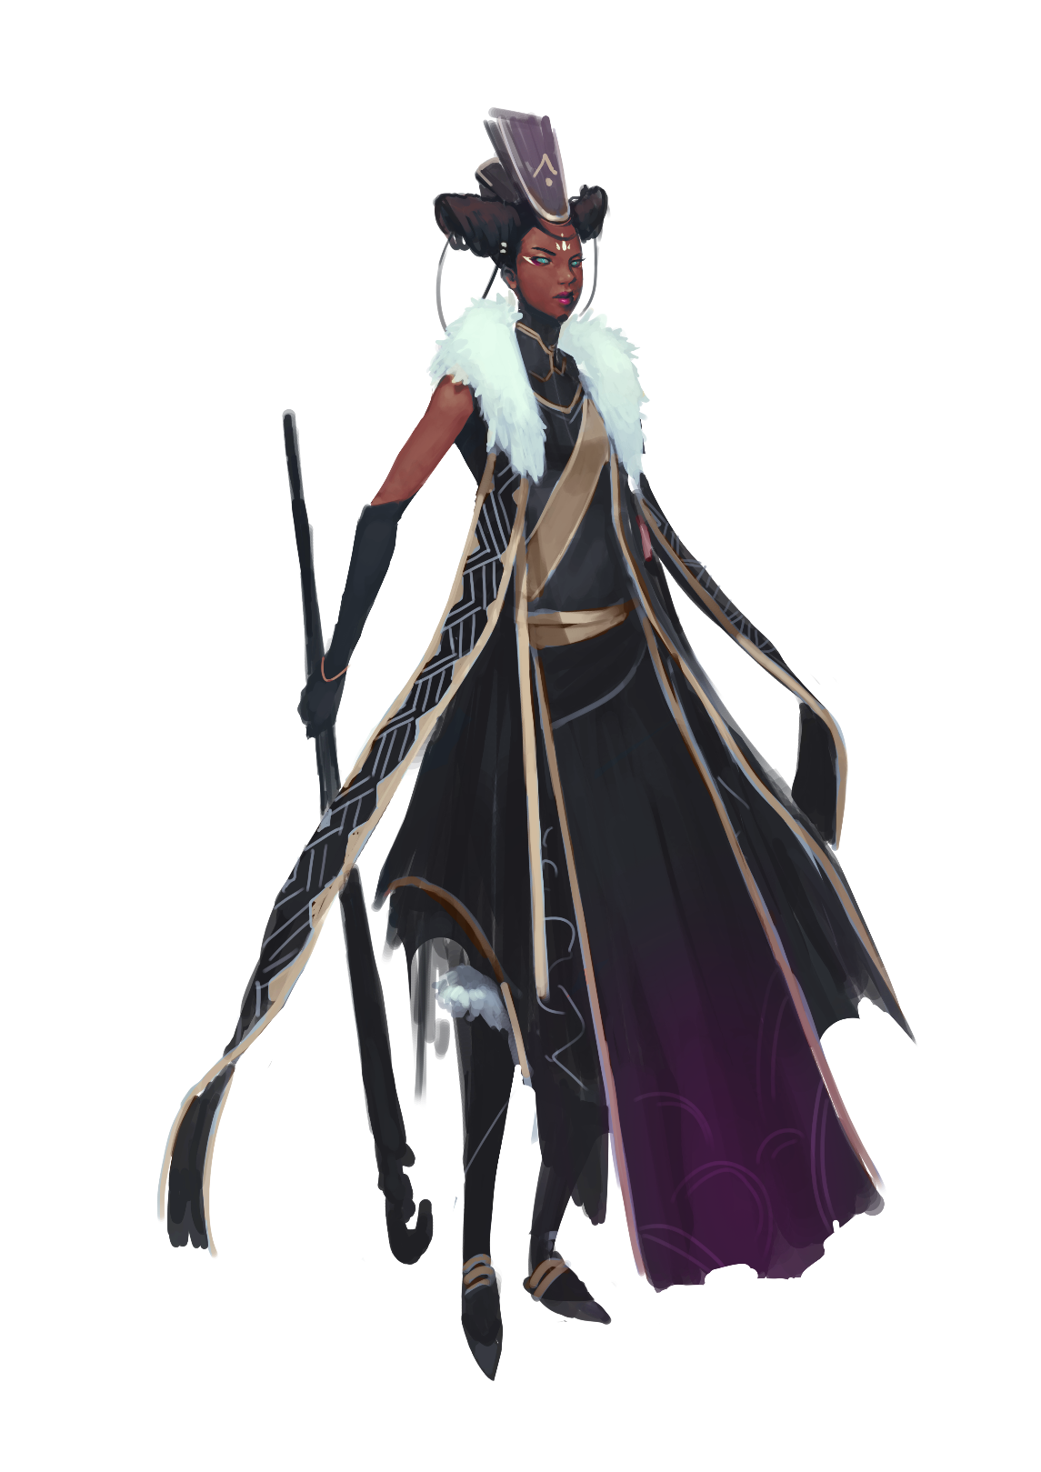

Fiction: The Party

Rebina Maripova woke from her midday nap and—as she did after every sleep—used the full length mirror to check her body for wounds. As usual, they were kept close to her navel and ribs, long gashing scratches like something with talons had raked her skin while she dreamt comforting nightmares she couldn’t recall. As usual, her patron had been kind…ensured that Rebina would be able to hide the marks of patronage with a minimum amount of effort and thus do what was needful. She bandanged herself, her expression something between a wince and a smile as the gauze touched the aching wounds and triggered small fireworks of pain. After, she wrapped the gauze with fine linens to blot any blood that got through before slinking into the fine dress—a beautiful purple number which had to be Pinnay’s finest work yet.
Only after she was dressed did she summon the servants, one to work the tight curls of her hair into elaborate braids, one to apply just the right colors to her face and lips and cheeks; her weapons and armor for this sort of battle (though she much preferred the work where she’d rip apart some trollop with a word). After they’d finished her work it was off to the party.
Arriving at a fashionably late hour, Rebina entered the gated compound and exchanged pleasantries—complimenting Frindini’s wife to distract from her sagging chin, laughing uproariously at Crouxa Adame’s joke that didn’t warrant a titter, and otherwise playing the game as she’d been taught to from childhood on. Through it all she did as she’d done so many times: soaked in the gossip, sowed seeds of discord, and made mental notes of half a dozen opportunities she wished to explore for the greater glory of 10th House, herself, or her Lord (which she ranked in that order).
Finally, the man of the hour appeared: The Honorable Merchant Gaeuv. Rebina waited for the appropriate moment to say, “Gaeuv dear, if I could have a moment of your time.”
She smiled at him, held the smile even as he took a long moment to stare down her neckline before finally returning his eyes to hers, and with an intake of breath she called up into his imagination his most painful memory—plucked like a bit of meat from a bowl of stew. Inside she laughed at his sudden squirming from obvious discomfort, not knowing why he was remembering the betrayal of his first love, that most agonizing moment of his life.
But now Rebina knew just a little more that she was ever supposed to, and that made what was to come next all the easier.
“Sir Gaeuv, I have a proposition for you…” she said, baiting the hook that would lead to this man’s doom.

Thirteen Meridian Houses

Thirteen Meridian Houses
When the Tarrasque was first subdued thirteen immovable harpoons were sunk deep into its body, each with a long, thick chain running to an iron anchor sunk into stones. As the founders built the fortress Salzinwuun they recognized 13 guardians, each a hero in the binding of the enormous monstrosity. All were personally responsible for ensuring that the harpoon in their charge held fast in addition to making arrangements to deal with unforeseen changes. In recent history (the past two odd centuries) the status of these guardians has changed. Their descendants (or in some cases, the original hero) are now referred to as Binder-Lords or Binder-Ladies, each still responsible for ensuring that their harpoon remains secure and keeping the beast chained with the caveat that they all claim the area around their harpoon as their charge to exploit and utilize as they deem fit. These sections of control and responsibility are generally referred to as meridians—hence the Binder-Lords and the houses they lead each owning one of the thirteen meridians (and each house has become incredibly wealthy due to being paid via the work of the God-Butchers and now Marrow Miners selling to the various Blood Merchants and Process Guild Shops). Legal authority is transferred via legal possession of one of the magical command words that can unlock their respective meridian harpoon.
In recent decades all of the Houses have built manor-towers, a glorious palace or even series of buildings that loom over the rest of the city. It has also become customary for each of the houses to use the spire of their manor-tower as their house insignia, reasoning that even the illiterate are able to see the high peaks of their works and know wherefrom edicts, orders, and sealed contracts emanate.
Decisions that impact the whole city are made by the council of Binders and enforced by the various House Militias. Basic publicly understood knowledge about the houses is written in the following pages while house secrets may be found in the Secrets sections.

House of the 1st Meridian


Conservative diplomats who believe they’re holding the city together
1st House—founded by human soldier and diplomat Hyberean Timult—is known for being conservative. The house is notoriously risk averse and only invests in “sure things” with an eye towards maintaining as much diversification as possible; they seek to have a finger in every pie which means that they have direct business interests to nearly everything that happens in Salt in Wounds. In addition to their business interests they often serve openly as brokers and negotiators for other houses, claiming that having something to gain in both sides of a commercial dispute makes them impartial (or at least that’s the theory they trot out in contrast to 10th House which is often utilized for more back alley dealings) and that their House Militia is known to be the most interested in traditional law enforcement.
1st House Manor-Tower District
Done in classic coastal style, 1st House Manor-Tower is a comfortable expansive complex with accommodations for the sprawling family and their business ventures.
Notable 1st House Members
Current Binder-Lord: Amanthia Timult, a handsome human woman in her forties usually dressed well but not ostentatiously.
Founding Binder-Lord (Deceased): Hyberean Timult was instrumental at keeping the Army of the 13 from falling to infighting and his descendants have played similar roles for Salt in Wounds.
1st House Sergeant-at-Arms: Yuranthea Timult, a human woman in her late twenties with a prominent scar over her cheek, is uniquely interested in training and managing her House Militia and keeping the peace through whatever means necessary.

House of the 2nd Meridian


Eclectic pragmatists inducting hypercompetitive members on merit
Founded by Quinnay Fredding, 2nd House is unique in that its membership (and succession) are not a matter of blood, but competence and honor. These traditions have proved to be a double-edged sword for the house as its members tend to be competent, confident, and extremely ready to sabotage their rivals—both without and more commonly within their house—even by the standards of the notoriously intrigue-prone Meridian Houses. Rank is generally determined by the amount of value one has added to 2nd House (which is usually but not always measured in gold) and proudly worn as medals by its members (counting down from 10; 1st Rank is Binder-Lord). As a secondary effect of this practice the house is incredibly diverse and current gnomish Binder-Lord Hatarang Indleprompt-Fredding presides over annual house entrance exams (summed up in the challenge “Impress Us”) to admit new members with entrants that include the recently matured children of current members.

2nd House Manor-Tower District
This area of the city is an eclectic assortment of styles and clashing visions, as each Binder-Lord or aristocrat demanded their section be built to their specifications. Somehow, it all works together.
Notable 2nd House Members
Current Binder-Lord: Hatarang Indleprompt-Fredding is a devilishly clever gnome who enjoys prospecting and developing talent while ensuring the ambitions of his underlings ultimately thwart each other.
Founding Binder-Lord (Deceased): Quinnay Fredding was a half-elf known for his exceptional shrewdness and disdain for those he felt had not earned their position.
2nd House Sergeant-at-Arms: The tiefling wizard Kindine Drade (formerly a lesser, lesser cousin of 11th House) won her position in 2nd House through a show of magical competence and has been steadily climbing the ranks, striving to find some way to advance from Sergeant-at-Arms to named 2nd House heir.

House of the 3rd Meridian


Shrewd lords of spice and water
Founded by Roman DuFaine—a human commoner and cook turned valet and eventual heir of a noted warlord—3rd House has a reputation as shrewd, sensible lords of food, spice, and water. DuFaine was notable for his focus on practical education for his descendants and early investments in the spice trade, but his infrastructure around the transport of water has seen 3rd House fortunes rise steadily since implementation.

3rd House Manor-Tower District
The manor-house of the 3rd Meridian is a large, sprawling estate that favors function over form. Inside the tower proper is a vast dining hall, elegant in its sheer simplicity. To service this hall is an equally vast kitchen staffed by what are claimed to be the best chefs in the world each aided by a huge throng of slaves. Guest quarters are unusually sparse for a manor of its size. Only the most important or influential guests are invited to stay at the manor beyond meals and entertainment.

Notable 3rd House Members
Current Binder-Lord: Gerard DuFaine is a male human in his early thirties known for his energy and head for business, wielding the wealth and power of 3rd House in ways that only increase its capacity.
Founding Binder-Lord (Deceased): Roman DuFaine was a human of common origin who used his head for business (as well as being named heir to a slain aristocrat) to succeed far beyond his wildest dreams.
3rd House Sergeant-at-Arms: Drummond Carter is a sixty year old human who often acts as counter to Gerald’s brashness. The two are very close, with Drummond acting as a surrogate father.
Head Chef: Thoma Cetcham is a half-orc who often employs adventurers and mercenaries to bring him ingredients of the more lethal variety, serving dishes available nowhere else in the world due to how dangerous their constituent parts are to harvest.

House of the 4th Meridian

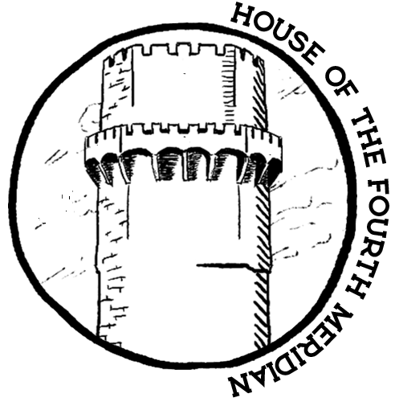
Indebted former adventuring house yearning for the glory days
Founding Binder-Lord Attaxia Ginderhold was a famed human adventurer beloved by many who died still doing her utmost to find a way to kill the Tarrasque. Unfortunately, her legacy—the House of the 4th Meridian—is known today as a house in decline and largely agreed to be the least of the houses. Throughout its history adventuring parties sponsored by the house were a source of wealth and prestige, shifting from their original purpose of uncovering a weapon or process to kill the Tarrasque to bringing in funds and artifacts that led to 4th House’s expansion and establishment of its famed museum. Unfortunately the last few decades have seen multiple extremely costly failures. Coupled with the lavish lifestyle of a large (and largely wastrel) clan, rumors now swirl of outstanding debts to Blood Merchants now in default and rampant mismanagement, signifying that even their regular income from the flow of viscera is not enough to staunch financial wounds caused by that most terrible of injuries: interest.

4th House Manor-Tower District
A sprawling complex showing signs of disrepair, much of it appears like a decrepit museum filled with artifacts and wonders from better days.

Notable 4th House Members
Current Binder-Lord: Trundle Ginderhold is a handsome fellow in his late forties with a reputation as a decadent hedonist, appearing to be supremely confident as he brushes away any and all concerns in the wake of the lavish parties he is known to regularly host.
Founding Binder-Lord (Deceased): Easily one of the most honored and favored of the thirteen, the human Attaxia Ginderhold never abandoned her crusade to finally kill the Tarrasque.
4th House Sergeant-at-Arms: Youvin 9 Fingers is a dragonborn that formerly served as a mercenary and adventurer in the employ of 4th House—she is known to have a lot of experience and a nasty temper.

House of the 5th Meridian

Powerful alchemist house with control of rare reagents and ghoulification
Founder Anton Dolfen was a mysterious human (though some suspect him of being a tiefling) in the Army of the 13, able to wield great magics but cagey about his own background and history. After binding, the aged human drew up a number of seemingly innocuous long-term contracts with the other houses that granted a near monopoly on important alchemical reagents which in time became incredibly valuable—coupled with control of the ghoulification process, 5th House’s rise has been meteoric.

5th House Manor-Tower District
A wonder of design (much of which was said to be drafted by Anton Dolfen), the Manor-Tower incorporates iconography and shapes from Anton’s southern homeland with architectural possibilities that only came about when building from Tarrasque-derived material. Multiple alchemical labs and offices are woven into the structure which include the so called Ghoul’s Bank (the office in charge of creating and collecting terms of ghoul contracts) sitting alongside luxury quarters for aristocrats and visiting nobles. Rumors hold that a secret workforce of ghouls has dug deep below to create dungeons, hidden labs where horrid research happens with access to the rest of the city via the Cap-Caps.

Notable 5th House Members
Current Binder-Lord: Kuolemita Dolfen is a tall middle aged human usually dressed in incredible finery. She is viewed as being extremely shrewd, unfailingly polite, and fair enough (albeit with the edge of ruthlessness to be expected as one of Salt in Wound's oligarchs).
Founding Binder-Lord (Deceased): Anton Dolfen is legendary even amongst the thirteen, his legacy being the stuff of epics and what most Binder-Lords hope to match.
First Consort: Merrin Chyn is the non-aristocratic human spouse of Kuolemita. He is of middling height with gray hair and tan skin, usually found in soiled, ill-fitting clothing wherever drink is served. Unlike his wife, Merrin is viewed by the town as a drunken fool, infamous for his philandering ways.
Head Alchemist: Fidreo Twice-Born is a scheming ghoul known for his intense loyalty to the house and a desire to bring to heel the alchemists of Salt in Wounds.

House of the 6th Meridian

Militant warriors with expansionist dreams and internal schisms
Founded by Dradeth Bolgath, a renowned dwarven fighter considered a hero of both the War of Binding and the Granite Shard War, 6th House is known as the war house. Dradeth died extremely young for a dwarf and his successor Duradin has done his utmost to honor the martial traditions of his progenitor (though without nearly as much success) and regularly (unsuccessfully) lobbies for Salt in Wounds to expand its territory. The house guards and house militia members of 6th House have a reputation for being incredible sticklers for the laws right down to the letter, utilizing taxes and fines whenever possible to help fund ever more recruitment.

6th House Manor-Tower District
The 6th House Manor-Tower has walls covered with weapons and armor alternating with tapestries depicting battle, or standards both used and won. The entirety of the central tower is ringed around a large training and parade field.

Notable 6th House Members
Current Binder-Lord: Duradin Bolgath is an older dwarf grown too fat, often dressed in an ill-fitting suit of armor or uniform and considered to be a poor imitation of his legendary father.
Founding Binder-Lord (Deceased): Dradeth Bolgath was a legendary fighter instrumental at the binding of the Tarrasque and considered hero of the Granie-Shard war.
Named Heir: Thaim Bolgath is a young dwarf with a reputation as a gambler and lover of vice.

House of the 7th Meridian
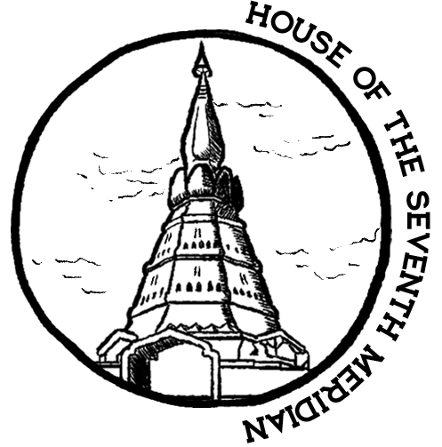
Religiously devout house invested in the church
Founding Binder-Lady Genevo Thrice-Blessed was once a cleric devoted to the God of Healing, converted to the worship of Macinfex after the binding. Since then 7th House has become near synonymous with the church of Macinfex with four generations of Binder-Lords and ladies all serving as high ranking clergy in addition to their official duties. House finances have been frayed of late as 7th House is deeply invested in relief and rebuilding the Tail Stones, a project that’s been ongoing for years but yet to show any profit—a situation current Binder-Lord Harken Knife-Beloved blames on his predecessor.
7th House Manor-Tower
The 7th House Manor-Tower is a mixture of decadent aristocratic living otherwise mundane save for its oversized chapel and many shrines (its importance nearly rivaling the Temple of Macinfex in the Throat).

Notable Members
Current Binder-Lord: Harken Knife-Beloved is a weathered man in his fifties with a nigh-permanent scowl on his face.
Founding Binder-Lord (Deceased): Genovo Thrice-Blessed is remembered as a beatific grande dame and has become a virtual saint in the Church of Macinfex.
7th House Sergeant-at-Arms: The halfling Bixbine Billingsford has been known to keep militiamen in the Tail Stones investigating crime (and supposedly harassing any worshippers of Renesec).

House of the 8th Meridian

Bardic inheritors with interests in entertainment and story
Founded and still led by half-elven bard-adventurer Virtan Berkuyin, 8th House is known for its innumerable half-elf members and as a patron of the arts, sponsoring various entertainers, and eventually building the Salt in Wounds Opera and gladiatorial arena. While now of advanced years, Virtan sponsors ongoing competitions to see who will be her next paramour—she takes the winner of such competitions as a lover who she lavishes attention, praise, and the utmost fidelity upon until she conceives and births children by them. At that point, her former lover is respectfully told to leave at which point she initiates a new competition and begins the cycle again. The city is littered with former lovers, heartbroken from the loss of love and the sensuous decadence of 8th House (though almost everyone believes that they were fools to think that they alone would escape the cycle).

8th House Manor-Tower District
A cluster of buildings all with expansive windows to prism light through colored glass, the 8th House Manor-Tower proper sports hundreds of art works, frescos, and performance spaces incorporated into the living quarters. Events held here are usually incredible selective and invitations are hard to come by even for other members of the aristocracy.
Notable Members of 8th House
Current & Founding Binder-Lord: Virtan Berkutin is known for her love of the arts and as the mother of a significant portion of the city’s half elf population.
8th House Mistress of Song Delanie: This brown-skinned, black-haired immigrant to Salt in Wounds has a reputation for incredible ruthlessness barely hidden by tremendous charm. Despite not being a blood relation to Virtan, she is heir apparent and subject to much envy and plots from Virtan’s sprawling brood.
8th House Sergeant-at-Arms: Dewaltor Husksire is a pale-skinned human in his early forties, a longtime companion of Delanie handpicked after her ascension—he regularly thwarts threats against her life and rule.

House of the 9th Meridian
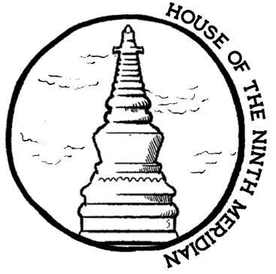

Hereditary sorcerers with an interest in ancient power
Founded by the human sorcerer Xantha Eldurach, 9th House is remarkable for its high degree of sorcerous blood as many of its founding members were born with powers and through the years they have sought to broker marriages with aristocracy able to access similar magics. The house espouses a view that “blood will tell” and believe that the landed nobility are first amongst the people (and 9th House first amongst them). They’ve sponsored innumerable attempts at archeology and adventuring (though they no longer do so in partnership with 4th House) with particular interest to justify and expand their sense of lineage.

9th House Manor-Tower
Rough buildings for servants and slaves ring an ornate tower of delicate scaffolding and elaborate glass windows which manage to express all the haughtiness and gilt for which 9th House is (in)famous.

Notable NPCs
Current Binder-Lord: Garberlin Terratark a human sorcerer known for her command over flames.
Founding Binder-Lord (Deceased): Xantha Eldurach was a light brown-skinned sorcerer and is always depicted with a smirk on her face.
9th House Sergeant-at-Arms: Korth Argelian-Tarratark is a foreign born sorcerer that married into 9th House and has been leading its armed forces ever since.

House of the 10th Meridian
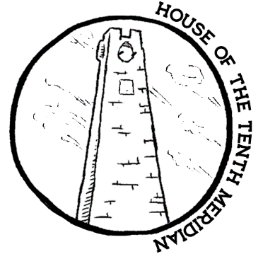
Secretive house growing rich from brokering information and deals
Of all the houses, 10th House induces perhaps the most awe, wonder, and speculation. Its members are divided between low ranking fuori (numerous and usually younger members known for bawdiness, dueling, and revelry) or high ranking elder presci who are rarely seen outside their Manor-Tower district (and then only to conduct high level business or political maneuvering) and never known without their robes of offices and ornate masks. Like all Meridian Houses, House Impertabo has its fingers in many a Tarrasque meat pie but 10th House has made its future by serving as advisors and legal consultants, heavy investments in Water Dens, and (the not secret but also not commonly known) production of a variety of medical and vanity drugs. Whereas 1st House acts as negotiators by making their connections known, 10th House’s businesses (and sources of information) are as secretive and labyrinthine as they can make them. Everyone who is anyone has attended a 10th House party though their memories of the events (and distinct flavor of revelry) can be a little hazy.

10th House Manor-Tower District
The entire district is walled and the otherwise unassuming outward appearance belies an interior with innumerable Water Dens, flesh pits, and space for volumes upon volumes of books—including the so called Black Library. It’s common knowledge that 10th House has dug extensively under its Manor-Tower (which is also believed for many other houses) but what happens below the luxurious environs is unknown to outsiders.

Notable NPCs
Current Binder-Lord: Primi Precisi Baldomero Impertabo (known as a rake in his younger days) is now commonly held to be the master of secrets for much of the city though he hasn’t been seen in public in years.
Founding Binder-Lord (Deceased): Piorvani Impertabo was a mustachioed dandy known for his love of wine and other, stronger intoxicants.
Keeper of the Black Ledgers: Altopar Menzogna-Impertabo is a human in his fifties, the highest ranking and most powerful fuori.

House of the 11th Meridian
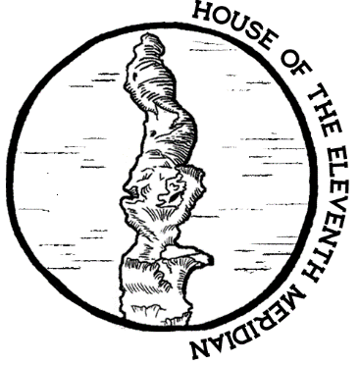
Eccentric wizards trying to change the world with magic
11th House is an enigma to outsiders and even sometimes to those within, their eccentric nature leading to some of the most innovative spells and devices the world has ever seen in countless iterations of a development process that ranges from intriguing to useless. The house of the 11th Meridian has only the scantest formalized militia but is protected and flexes its muscle by magically-empowered members—in order to have formal status within the house relatives must prove their ability to cast spells. Most of the other houses are dependent on the magical creations of the 11th House. Currently, four factions (each led by a different apprentice of Founding Binder-Lord Olgorn) vie for dominance with Kaphressk Arcafor being the fifth apprentice who elevated herself to power by pitting her peers’ sprawling apprentice lines coupled with ruthless displays of raw magical might.

11th House Manor-Tower District
The Manor-Tower of 11th House stands tall, a shimmering decadence of glass and iron that is the central focus for the ever-changing area surrounding it. Due to the magical machinations of its members the area is modular and shifts around depending on the needs of the whole house. The sights and sounds are as varied in this area as the world over.

11th House NPCs
Current Binder-Lord: Kaphressk is an arch-mage, gnome genius, former apprentice to Olgorn (who named her heir), and known to be first in power and standing. She has officially confirmed rumors that she is looking for apprentices—one of which she will (presumably) name her heir.
Founding Binder-Lord (Deceased): Olgorn Arcafor was a slender dwarf who saw the benefit of working magic into everything, even in place of technology. He was ostracized from his clan and took on a new name; mistrustful of blood ties, Olgorn set up a familial structure in 11th House where no lineages are recognized save for those of apprentice and pupil.

House of the 12th Meridian

Upstart house on the rise with ties to organized crime
Founded by Spenser Marcellun, 12th House never seemingly amounted to much (even failure) and was considered especially “middling” until the 12th Meridian Crisis, when they became synonymous with incompetence and were nearly ruined. Following a coup and their contribution to creating the Marrow Miners, 12th House’s fortunes have been on the rise and it’s become an open secret that it has established ties to nearly every criminal and underworld organization (something the house leadership barely denies anymore).

12th House Manor-Tower District

This collection of buildings—most of which were built before the 12th Meridian crisis in conservative style—are being retrofitted and worked on nearly constantly.

Notable NPCS
Current Binder-Lord: Tolviko Marcellun was formerly a minor cousin; the brash (still young) human fellow has been lifting 12th House from its reparation debts by seemingly doing the unthinkable, repeatedly.
Former Binder-Lord: Autoxia Marcellun was the leader of the house during the 12th Meridian Crisis, ultimately slain and usurped by his cousin during the Night of Bolts.
Founding Binder-Lord (Deceased): Spenser Marcellun was the middling founder of 12th House.
12th House Militia Commander: Roland deWulf was the halfling childhood friend of Tolviko and has been placed in charge of the militia for his loyalty, though his apparent mismanagement has seen Darkragg Kelline grow in prominence.
12th House Guard Commander: Dakragg Kelline is a human Autoxia loyalist who fully expected execution during the night of bolts but was instead promoted. Since then she has proved frighteningly competent.

House of the 13th Meridian

House of halflings focused on construction and city planning
Indentured Servant Rexaney Bramblethumb (later Pelago) founded 13th House after having the mantle of leadership unexpectedly thrust upon her when the presiding general she served and most officers were slain by the Tarrasque, so she stepped up to fire the final harpoon. As Salt in Wounds grew Rexaney did her best to keep up with the politicking and machinations, carving out a niche for her people in construction, infrastructure, and housing—her engineers and craftspeople were some of the first to utilize construction material composed of crushed Tarrasque scale. Each new wave of refugees brought a housing boom that fed the Pelago coffers. The barren Binder-Lady was succeeded by Voth Ikarian, an adopted son who leads as directly as possible (often going so far as to personally labor on house projects). 13th House throws huge block parties to which all of Salt in Wounds is invited and is as beloved by the common people as much as it’s loathed by the aristocracy

13th House Manor-Tower
A raucous and accessible space marked by the late age hedonism of Rexaney, 13th House’s Manor-Tower’s doors usually stand open and there are often lines of the poor waiting for free water provided by the house.

Notable 13th House Members
Current Binder-Lord: Voth Ikarian is a blonde, tan, and wiry halfling who (much to the consternation of other Binder-Lords and his security staff) can often be found in public.
Founding Binder-Lord (Deceased): Rexaney "Bramblethumb" Pelago was a stout halfling who grew fatter every year of her life, sharing her good fortune with a grace unseen in the city.
Lead Engineer: Zoop Keljik is a gnome immigrant to Salt in Wounds driven by her incredible boredom.
Head of Research: Welri Haradya is a diminutive (even by halfling standards) woman who has been leading field research into CapCaps and Heartsblood Marsh.

The Enders

The Enders are a rumored group of individuals interested in discovering or inventing a way to permanently kill the Tarrasque. While this was the stated goal of the original heroes that bound the monster, most modern citizens of Salt in Wounds have no interest in doing so as it would effectively destroy the economy (and likely existence) of the city. In addition, the majority of those rare few who would be interested believe that the lasting death of the Tarrasque is impossible.
Occasionally individuals are prosecuted for the crime of being Enders under the official charge of conspiring against the sanctity of the Tarrasque's bounty. This has usually been seen as political theater, a baseless charge used to dispose of persons who've angered the powers that be. Most sent to their deaths or truncation in this way claim their innocence right up until the end while some name co-conspirators (who are then also tried and inevitably found guilty).
The accepted wisdom of the cynical Salt in Wounds populace is that the Enders don't exist beyond a few isolated madmen.

The Process Guild

The Process Guild is the institutional organization that handles licensing and represents the interests of the various regular butchers, sorters, refiners, and others who receive raw Tarrasque viscera wholesale (from the God-Butchers and Marrow Miners) and process it into components for later commercial resale to the other dominant professional associations (the Sage's Council and Blood Merchants). The various members of the Process Guild are the second link in the supply chain connecting the Tarrasque to the citizens and visitors of the city of Salt in Wounds. The general flow functions something like God-Butchers and Marrow Miners → Process Guild → Blood Merchants and Sage's Council → everyone else. Raw viscera extracted from the Tarrasque by God-Butchers is typically too large to be suitable for individual resale and often unsorted (comprised of numerous tissue types, dog-sized pseudo-organs which litter the Tarrasque's flesh, varying cuts of meat, neural ganglion, epidermis and so on) which by needs must be dissected into clearly labeled divisions.
The employees and owner-operators of the various factories and workshops comprising the Process Guild tend to be working class to lower-middle class. Barriers to licensing are relatively low encouraging competition and innovation amongst guild members while also generally preventing massive fortunes from being made, putting pressure on the Process Guild members to cut corners and potentially seek “extra-legal” options (in contrast to the registered Blood Merchants that operate in a more oligarchical fashion).
An extremely common crime is Process Guild shops selling directly to the public at large.
Individuals who are employed under their aegis (often under terrible working conditions) have an exceedingly high rate of mutations and other health problems—much more so than God-Butchers though not to the same degree as Marrow Miners.

Notable Members of the Process Guild
Process Guild Chairman: Rodirique Algiheel is a 72-year-old halfling engaged in a long term project to improve the safety and reduce the criminality of the guild. However, his initiatives to institute enhanced licensing and inspection requirements have been facing institutional resistance, and he is constantly on the lookout for special operatives to arrange buys and conduct covert examinations.
Render Shop Owner and Chef: Parash Feru is a former acrobat working out of the Tail Stones, known for his excellent jerky (which he’s licensed to sell the public directly).
Rander Shop Owner: Fog Over Water is an orange-haired catfolk with an amputated left leg known to move his cart’s location from week to week and work extremely fast.

The Marrow Miners

The Marrow Miners are the guild with the extraction contract for the 12th Meridian of the Tarrasque. Other than the God-Butchers they are the only group with the legal authority to work directly on the creature and there is plenty of mutual antipathy between the two groups (though in recent years God-Butchers have been subcontracting to Marrow Miners for particularly dangerous and difficult work at the other Meridian sites).
Founded after the 12th Meridian Crisis, the Marrow Miners have distinguished themselves by taking any sentient creature willing to work and paying fair wages. Their recruitment efforts include mites, orcs, and many from the lower classes. The general goodwill this generates amongst most of the city is tempered somewhat by racial- and class-based antagonism towards many of the Marrow Miners.
Since their founding the price of much Tarrasque viscera has lowered precipitously—this includes reagents and rare cuts which the Marrow Miners hypothetically can't access. The Marrow Miners (in addition to their 12th House Sponsors) are widely suspected to be major players in the organized crime of Salt in Wounds, particularly in relation to smuggling. The guild however dismisses such rumors as God-Butcher lies meant to discredit the organization.
Even so the Marrow Miners have thrived, winning the 12th Meridian Extraction contract, successfully subcontracting numerous duties from the God-Butchers (usually the most dangerous and dirty tasks), and rumor holds that they are close to winning the defection of other Meridian Houses.

Notable Marrow Miners
Founder and Leader: Mirayda of the Five Cask Clan is a former God-Butcher, founded the Marrow Miners over a decade ago, and has been leading the organization ever since. Rumors fly wildly about what the dwarf was up to after she left the city once she’d failed the Rite of Mutual-Recognition and where she went to after departing Salt in Wounds, but most people have incredible respect for the shrewd businesswoman that has seen the fortunes of her upstart Marrow Miners (and 12th House with it) soar over the past years.
Secretary and Overseer: A former wealthy merchant, the ghoul Rancis Kronaw is thin with elongated teeth. He works alternating shifts as a secretary for Mirayda and field overseer who handles much of the day-to-day business of the Marrow Miners. As a result he is incredibly knowledgeable about the Tarrasque and rumor holds that Rancis is willing to consider using his position to enrich himself if the opportunity arises, especially if there’s a negligible chance of getting caught.
Research and Development Head: Grawlax Tampdrewer is a small blue-haired gnome that works hard inventing new techniques and tools for the Marrow Miners. Somewhat ironically, he has never seen the Tarrasque in person as it terrifies him and he has to rely on detailed reports of how his inventions function—and he constantly complains about the “substandard data provided by the subliterate subhumans who work on the beast…but what can be expected from any fool willing to approach it?”

The House Militias

The House Militias are the primary source of law and order within the city around the Tarrasque. Each Meridian House is charged with “paying, provisioning, and organizing no less than 250 soldiers to enforce the laws of the township and contribute to the general welfare of Salt in Wounds.” Interpretation and implementation of this edict varies greatly depending on house however—on one end of the spectrum there are houses who outfit their militia with the bare minimum and then leave these individuals to their own devices, usually acting like traditional city watches one might find in any large settlement. In the extreme opposite, 6th House outfits a militia of 7,000 armed and trained more for war than policing. Complicating matters further, many Meridian Houses also run House Guards who are distinct from House Militias—with House Militias having a duty to enforce laws while House Guards do not.
Despite this House Militias—while technically serving the city as a whole as opposed to their respective house—still often act as an extension of their house and instrument of its machinations. Each Meridian House manages hiring, firing, and promotion within their militia. Meanwhile House Militias are held to a code of behavior which includes (amongst other things) prohibitions against favoring one house over the law of the city with severe mutilation penalties doled out by the largely independent courts for failure to serve the law.
These twin influences lead to rampant secretive conflict, intrigue, sabotage, and checks and balances between the House Militias which are in part an extension of and yet distinct from the power games played amongst the Meridian Houses themselves.
Typical armament for House Militia is a suit of studded leather armor, round shield, hand-axe, and crows-beak. Notable Militia Captains and Sergeant-at-Arms are listed under their respective Meridian Houses.

The Order of God-Butchers

Even amidst the city as bustling as Salt in Wounds, the God-Butchers are hard to miss.
Hugely muscled men and women grown strong from a working life of toil and diet of some of the freshest, most choice cuts from the ever-providing body of the Tarrasque. Most carry their stylized greatswords nearly everywhere but contrary to popular belief these weapons turned tools are not exclusively adamantine—many nowadays are forged of Tarrasque horn that better cuts through its armored carapace. Still, those who dismiss the butchers as dumb brutes wholly underestimate the order; these are hard-eyed resilient people who must be intelligent enough to understand the beast’s intricate and shifting anatomy, able to regularly deal with crafty merchants, domineering aristocrats, and suspicious laborers all to perform their duties.
While greatly connected to the economic flows of the city and perhaps not wholly immune to the influence of the coin, the God-Butchers (as a whole) nonetheless take their sacred charge of keeping the beast bound very seriously. Their reputation has been tarnished of course by the tragedy of the 12th Meridian Crisis over a decade ago, their damaged reputation prompting a surge of popular support for the Marrow Miners (further exacerbated by the lesser group’s greatly eased selection criteria).
As an organization the Order of God-Butchers are fairly egalitarian although relative prestige can usually be determined by their Meridian assignment (1st-13th excepting 12th which is on assignment to the Marrow Miners). While legally the 13 Binder-Lords each have the duty of keeping their Meridian bind functioning and overseeing the section of the Tarrasque assigned to their house, this—as a practical matter—has been contracted out to the God-Butchers and (recently) Marrow Miners as the Binder-Lords have turned their attentions to the economy of Salt in Wounds, games of political intrigue with respect to their rivals, and the pursuit of their own pleasures.
The God-Butchers recruit heavily irrespective of class or station (ensuring that they are generally well-liked by the public and quietly mocked by the aristocracy) and most enrollees are drummed out within several months due to the intense rigors of the training regimen. They also promote based on a more or less functioning meritocracy with only a minimum amount of nepotism.
Most members of the God-Butcher Order are not fully-fledged Master God-Butchers—around 95% of the order’s roster only complete their basic requirements, reaching no higher than Apprentice or Journeyman levels. Despite their lessened titles these members are nonetheless highly esteemed by the community and well compensated. Moreover for most city residents a God-Butcher is a God-Butcher and there is little distinction. The order selects recruits and advances those evaluated to be exemplary in the criterias of strength, intelligence, and the ability to lead and organize others.

The Rite of Mutual-Recognition

If a God-Butcher has distinguished themselves in strength, intellect, and leadership they are invited to take part in the most sacred rite of the order, that of Mutual-Recognition. The difficulty of doing so explains why the number of fully-fledged Master God-Butchers has remained fairly low (and perhaps why the order has remained largely effective and honorable in a city not known for such qualities).
An hour before the rite begins all work on the beast stops. The Tarrasque is allowed to heal, regaining as much consciousness as the God-Butchers dare before the aspirant approaches the 1st Meridian: the creature’s head. As the workers, curious citizens, and their fellow God-Butchers watch, the aspirant must stare into the eye of the Tarrasque for a full minute. In so doing they are supposed to gain a fuller understanding of the beast they keep bound. Staring into the creature's eye as it roars and snaps, many a promising aspirant flees perhaps leaving the order (or even the city) forever.
The mindless destruction and hate they see within the beast’s eye can unman even those who have lived in Salt in Wounds their entire life.
Those who manage to continue to gaze into the creature’s eye will note a change in the beast’s behavior. Gradually, its endless screaming and thrashing slows. Its vision changes, massive pupils focusing as, for a moment, it sees them, this man or woman who would keep it bound, who would cut it and serve up its strength to a hungry city. Then the Tarrasque ceases to roar and takes a single moment to inhale through its nostrils, wind whipping past the aspirant towards the Tarrasque’s maw as it truly marks the God-Butcher’s scent. The accepted wisdom is that the Tarrasque is committing these individuals to memory—should the monster ever gain freedom the God-Butchers expect that it will hunt all such aspirants and their families, any of those who resemble the aspirant's smell, even unto the seventh generation descendants.
In turn the God-Butcher takes in a long breath through his nose to mark the smell of the beast.
As the roars, the endless thrashing against its bonds resumes, to achieve Master rank the God-Butcher then ventures between its snapping jaws, timing a single strike to sever its tongue and heave the mass of flesh clear. The order then has a huge feast that evening from the hard-earned prize, welcoming another fully-fledged Master God-Butcher into the fold.

Notable God-Butchers
Guild Master: Dangany Farcine is a giant of a man with pale skin and straw colored hair, known for speaking only when absolutely needed. His knowledge of Tarrasque anatomy, ability to inspire loyalty, and raw physical strength make him respected by all.
Journeyman Briddu Yittano: This journeyman God-Butcher spectacularly failed the Rite of Mutual-Recognition and has begun mutating extensively following his alchemical treatment. Briddu has been taking more and more jobs away from the God-Butchers, though he is wearing thin his superiors’ patience as they consider expelling him from the order.
Former Master God-Butcher: Helenie illegally used the 12th Meridian Command word to stop the 12th Meridian Crisis. She was punished with truncation and now lives out her days at the Pewter Cup where she is regularly visited by God-Butchers who buy her drinks, help care for her body, and generally treat her as a living saint.

Sage’s Council

The Sage’s Council is a relatively new faction that has skyrocketed in power and influence over the last three decades since being founded. Their stated purpose is to advocate for the interests of academics, ledger-men, wizards, and above all alchemists—anyone who makes their living with the aid of pen and paper. Contrary to how many alchemists and wizards have traditionally approached their trade—with knowledge being hoarded whenever possible, with information primarily transferred from teacher to apprentice—The Sage’s Council seeks to facilitate the free exchange of information and discoveries between researchers. They provide support for the various colleges of Salt in Wounds and print the quarterly journal Tuntume which publishes research from members and furthers the organization’s goals, often featuring contributions from adventurers who share tales of exotic and otherwise unknown creatures, technologies, or magics. While the Sage’s Council is currently a voluntary association (and thus despised by those who love their independence) they have been lobbying for legislation to make membership mandatory for any who wish to ply relevant trades within the city (and the organization is famous enough now that most assume that any alchemist must be part of the council).

Notables Council Sages
First Speaker Aurenduexiplick: Andale Aurenduexiplick is an ink-stained green-haired gnome that manages to exert some control over the council (by having options to set agendas and speak first) but the body functions mostly along democratic lines with votes from each member. Her ongoing feud with Bakal has brought both of them some fame.
Alchemist Bakal Filligreen: The fact that Bakal is only a junior member of the council belies the fact that the half-elf with a distinctly acid-scarred face is perhaps the most gifted alchemist alive (at least according to Salt in Wounds professionals). He rarely attends meetings and is believed to have other schemes that he only rarely tries to achieve by utilizing the council.
Alchemist Silvas Almaran: This amber-eyed tiefling has shaved her head and walks with a slight limp. Silvas specializes in rare alchemical reagents and tonics—specifically those that can’t be manufactured in the city and for those in the know, poisons.
Apprentice Misael Nargonde: This rail thin human with messy black hair, brown skin, and dark brown eyes serves as bookkeeper for the council as he completes his apprenticeship. Misael lives in the Tail Stones with his boyfriend and tries to keep a balance between his studies and administrative duties for the council (which include counting votes).

Blood Merchants

The Blood Merchants are the licensed monopoly for any merchant selling directly to the public (as opposed to the exclusively wholesale purchases made through the Process Guild) with a few exceptions for outsiders and also by profession (alchemists, smiths, and the like have different licensing boards and different regulations regarding their commercial activity). Usually only native borne can be official Blood Merchants and any foreign merchant has strong limitations on how they can conduct commerce in the city. Technically every trader from humble jerky vendors with a single stall up to lords like sellers of thousands of slaves is a Blood Merchant if they have paid their licensing fee and submitted to the city’s rules of commerce, but the term is typically used to denote the very wealthy or those that sell Tarrasque-derived goods (which includes most everyone). In addition to providing licenses for retail buyers and sellers within the city, the organization of Blood Merchants advocates for member interests and even provides legal or other help for members in good standing when trouble rears.
The Blood Merchants are an incredibly diverse lot and few overarching statements can be made about the group as a whole. Generally however they advocate for more extraction, lower taxes, higher licensing fees (supposedly to ensure quality but mostly to discourage new competitors), and are generally interested in business as usual to continue unabated.

Notable Blood Merchants
Tendirion Patzadrago: A hugely corpulent human in his fifties who is carried on a litter everywhere he goes, Tendirion made his start inheriting a profitable family import and export business he transitioned to focus on banking—he is now responsible for half the debt in Salt in Wounds and even many Binder-Lords defer to Tendirion.
Azure Tertio: A half-orc who once nearly corned the market on Tarrasque horn, Azure wisely (and lucratively) diversified near peak price for the stuff and she is now one of the richest merchants in the city.

Gangs and Organized Crime

Several dozen gangs, mafias, and thieves collectives operate in the city of Salt in Wounds, all with a variable level of impunity though none are powerful enough to enjoy any sort of preeminence beyond a few city blocks. By custom each organization develops a different specialty (extortion, theft, smuggling) and a specific area of control. Most of the major players are known, and the Militia Captains have no compunctions against hauling them in on real or imagined charges—especially if any criminal element seems to be gaining too much power. As such an informal arrangement known as “the peace” holds where various criminal enterprises effectively if not literally pay taxes (via regularized bribes and official “civic reinvestment fees”), limit different types of activities to certain areas, and generally avoid open conflict with one another. Compliant groups are actually fairly competent (if brutal) at ensuring freebooting thieves, murderers, and other unaffiliated criminals do not operate in their areas of control (as part of their unspoken agreement holds them accountable for criminal behavior in their areas).
The large exception to “the peace” are swift gang wars known as Black Fox Bites which by convention must take place between sundown and sunrise on no more than three consecutive nights, no more than once a season so to stay the hand of the various militias. During these conflicts dozens of thugs may turn up dead and many scores are settled, regimes toppled, and areas of influence shifted or changed until a new equilibrium settles. While murder and violence—both against criminals and civilians alike—does happen from time to time, on nights claimed for a Bite of the Black Fox (the dates of which are usually cleared by the assorted militias) the rates of violence and disreputable acts soars.
Travelers and the unwary will often be caught off-guard by these as while not official, their times are usually known by the properly Salted who stay in behind bolted doors with as much extra security as they can afford (if not enjoying the relaxed policing to settle scores or acquire ill-gotten gold of their own).

Notable Organizations
Kin of the Stave: This gang of narcotics dealers sell illegal drugs out of the Throat.
Friends of No-One: Extortion specialists who collect from much of the Tail Stones
Paving Stones: Smugglers operating out of the Tail Stones and often acting as go betweens for other organizations.
The Thirsty Dogs: These level gangers are looking to make money any way they can, willingly taking any applicant. They have a reputation for being low quality but numerous, often in conflict with the other gangs and organizations.
Correspondence: A group of assassins headquartered in Salt in Wounds but operating on a global level.

Notable Criminals
Antoni Corasio: A brash young human in his early twenties, Antoni is known for his bright blue coat and ever-present pair of cutlasses. This smuggler has a reputation around the city and an informal network of contacts able to get most anything into and out of the settlement’s walls. He serves as a lieutenant of the Paving Stones but regularly works with other organizations and even the rare independent criminal.
Sandrix Al'Ragon: This tall dark-haired woman in her early forties is known as a necromancer for hire, regularly working for criminals and specializing in providing extra muscle (literally) during nights of the Bite of the Black Fox.
Hannanon Drexine: Never seen by day, this beautiful leader of the Friends of No-One has elvish features but black skin and pale gray hair and eyes. Her reputation for utter ruthlessness has turned the organization—which specializes in extortion—into one of the more feared criminal enterprises in Salt in Wounds as many of their enemies wind up coincidentally dead, including the odd militia captain.

The Circle of Release (Criminal Faction)

The Circle of Release is (or was) a group of adventurers and others operating covertly in the City of Salt in Wounds with the stated goal of ending the Tarrasque’s imprisonment. Their reasons for doing so vary depend on the telling but the most common belief involves restoring the natural balance upset by the current state of affairs.
This cabal is (or was) primarily comprised of evangelical druids, rangers, and their converts. Almost every other power block in the city denounces and actively opposes the Circle of Release; with the House Militias and God-Butchers hunting down, torturing, and executing any individual suspected of belonging to the circle. In addition to acts of intimidation, terror, and economic sabotage for which the group claims credit, much of the populace believes that the 12th Meridian Crisis and resultant devastation of the Tail Stones district is the result of an (un)successful plot by the group. There is also a small but vocal minority in the city that believes that the Circle of Release does not actually exist, but is instead only a ruse used by the aristocratic houses and guilds to terrify the citizenry and thus increase their power and control.
The symbol for the Circle of Release is a stylized Tarrasque maw bursting through a broken chain. They often leave the mark as a calling card (applied with magic or mundane paint) to claim credit for their operations. Members are extremely unlikely to carry this symbol on their person and it is far more common for it to be planted on a nonmember in an attempt to frame enemies of the cause.

Notable Former Members of the Circle of Release
Erraya (Deceased): The elvish founder and first leader of the Circle of Release denounced violence, preferring to pursue the group’s ends via lobbying and cultural change. She—and all of her known followers—were killed during the Night of Cleavers.

4. RELIGION
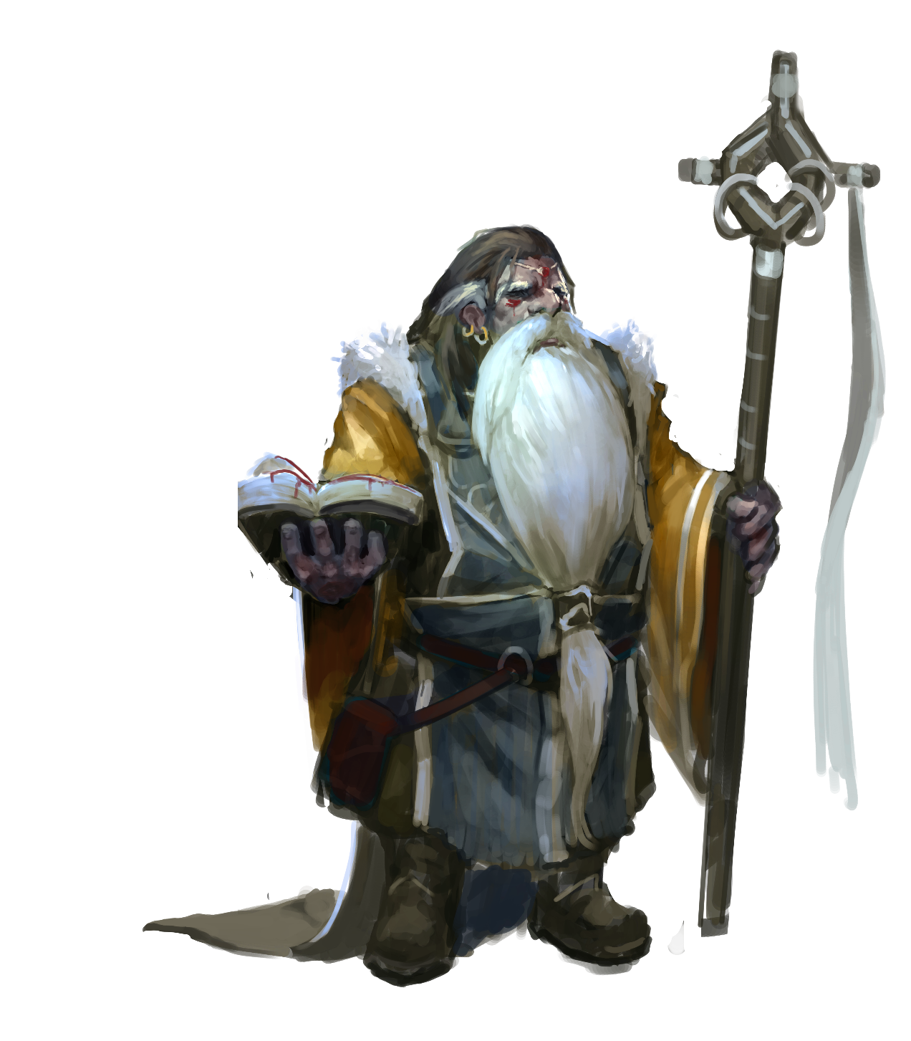

Fiction: Gratitude

Yurin Silvenei sat on the top of the tower and greeted the morning by miming the ceremonial movements of his faith, sharpening his paring knives and cleaver with the city stretched out in its leagues beyond him. Waking now and just beginning to shake the dust of sleep out of the corners of its eyes (not that the city, nor the bounty at its heart, ever truly slept), its merchants hauled out their wares to their stalls—many ritually counting their stacks—to ask for blessings upon their day.
The gates of the fortress Salzinwuun below him opened to allow for the changing of shifts, granting admittance to the next crew of God-Butchers who chose to sleep in the city at large rather than their order’s barracks. The rich copper smell of blood filled Yurin’s nostrils; he mused that they must have opened a vein. Idly he considered the dangers he might face before turning his mind to gratitude as was proper—he loved his city and said aloud the prayer of thankfulness for the bounty of god that had delivered so much to so many.
“Flea!” came the cry from below, echoing from near the beast’s flesh and ending several stories below Yurin. A two hundred pound insect landed on the ground. God-Butchers drew their weapons and approached cautiously while lesser laborers and a handful of merchants fled, scattering.
From atop his tower Yurin raised the implements of his faith to the sky, calling on Macinfex to bless the mortal butchers below. He knew from long experience—from a hundred battles with the unclean carrion feeders that first and foremost he’d need to keep the men and women alive—only after securing them would he move to calling down aggressive, disruptive magic.
Besides, the day was only just beginning and he’d need to conserve his strength.

The Church of the Monad

The Church of the Monad is a religion favored by many of the intellectuals, alchemists, and monks of Salt in Wounds—while adherents can be found the world over, the city is the seat of its power. Adherents to the Monad believe in, worship, and seek to better understand and commune with the one thing central to their creed: the subtle Aether (also known as the Monad) from which all phenomena is but an aspect.
The church of Monad has never found the acceptance it preaches because of its fantastical, often unpopular views on the mortal and supernal realm. Monadists are dismissed by other religions for their claims that the Aether is responsible for all creation. Their teachings are scorned by much of the aristocracy, believing the message of a single unifying force are a challenge to their social status. In addition, most lower class individuals feel that the church’s interests and teachings are too academic or effete to be of much use.
To those that embrace the church, the followers of Monad find a religion that isn’t faith-based, but a collection of virtues, research, and ideals. Sermons are replaced by powerful polemics. Hymns to an immortal deity give way to familial pledges to mortal companions. Though church-wide organized events and celebrations are rare, periodic congregations are held to discuss newly discovered or refuted research—as well as partake in new recreational panaceas.
Monad – The One, The Subtle Aether, The All-including
Symbol A single black dot
Alignment True Neutral
Portfolio Alchemy, Truth, Unity, The Unknown
Domains Community, Knowledge, Protection, Void
Favored Weapon Cestus (gauntlet)

Worshippers and Clergy. The Church of Monad has an eclectic member base divided into two main branches: hagiocratic (believing Monad is a physical entity) and geniocratic (believing Monad is a physical force). From visionary researchers to the proletariat, followers of Monad come from every walk of life with a common goal of improving self and community. Alchemists, clerics, and wizards of Monad have been known to offer secular guidance to communities as magisters of science and diplomacy. Followers with a martial lean often serve as magisters of the court but have been found in roles that range from midwife to shepherd.
Given the simplicity of Monad’s symbol, devotees have many ways of brandishing a holy symbol. Clerics receive The Black Bead, a philtrum piercing with a black stud as a holy symbol. Aetherist monks often paint or tattoo a large black dot in the center of their forehead. Those not wishing to display The One’s symbol permanently wear a ring of Monad in lieu of a traditional necklace. Members tithe or barter with their trade skills to receive the benefits of the church from housing and healing to accessing the order’s comprehensive library.

Temples and Shrines. The Temple of Reason in Sage’s Row is the most famous formal temple of the Church of the Monad, although small shrines (typified by a single black dot or globe) are located throughout the world, most especially in libraries.
Holy Texts. Given the heavy academic lean of the church, the title of “holy text” is awarded to research and textbooks that are deemed worthy but the individual branches do not always recognize one side’s certification of scripture. With new discoveries a thesis once deemed scripture can lose its status as research refutes its claims. This creates a competitive scholarly field the church deems necessary for steady progression. Titles of current holy texts include Continuity and Union Between The Cosmos and Man, Introduction to Absolute Space, Anamnesis Vitae, and Macrocosm and Microcosm.

Appearance. As the Monad has no physical description, it is pictorially depicted as a single black dot.
Dogma. Beyond the furthest star, Monad resides. All interposing space, be it the distance between worlds or the soul and the body, is filled with the presence of The One Thing. Therefore, any alteration to your physical constitution can lead to an alteration of morals. Purification and corruption are equally important to challenge and enact change in institutions of a depraved society. The Subtle Aether is the universal connecting medium, making all beings your brother and sisters with nature as your common mother. Education is a weapon used to attack the complications of classism, which disrupts the harmony of The All-Including.

Notable Members of the Church of the Monad
First Scholar Haverine Altaphy is a blind male human of advanced age who feigns senility and being hard of hearing to conceal his influence as a brilliant political operator.
Adjucator Ferinda Altaphy is Haverine’s granddaughter, known for her plain looks and understated style. She is fiercely competent and works as the bagman for her august grandfather—almost all who assume Ferinda gained her position through nepotism are sorely disappointed.

Macinfex, God of Butchers

Macinfex is the (demi-)god patron of butchers. For the world at large he is a minor figure, often considered to be barely a divinity or dismissed as an upjumped saint and honored only occasionally in an odd window of butcher's row. Salt in Wounds is not like the rest of the world however and here he is a if not the primary deity—worshiped by many, respected by all. Only the church of Septum Soletirmus the Coin Everlasting boasts as much influence in the city and its ranks are almost exclusively comprised of the rich. In Salt in Wounds, worship of Macinfex extends to all classes and all peoples.

Macinfex – Lord of Butchers, Grand Cutter, He Who Feeds
Symbol A cleaver crossed with a paring knife
Alignment Neutral Good
Portfolio Butchery, Animal Husbandry, Blood Letting
Domains Animal, Blood, Repose, Strength
Favored Weapon Handaxe (cleaver)

Worshippers and Clergy. Macinfex's clergy are very much entwined with the economy of Salt in Wounds and carefully monitor the selling of meat. Cleric inspectors survey the merchants, insisting that butchers and sellers throw away (or feed to the ghouls) old, potentially dangerous cuts of Tarrasque, and ensuring that portions and quality are carefully labeled all as part of their religious observances.
Devout worshipers of Macinfex are known to be obsessed with taking things apart to better understand their workings, extending an interest in the anatomy of all living (and even some nonliving) things.
The Tarrasque’s imprisonment is seen by Macinfex’s cleric devotees as the butcher god’s greatest gift to humanity: abundant, eternal food for all. It is no surprise that his worship is most fervent amidst the God-Butchers with devotion bordering on religious fundamentalism a practical requirement for aspirants reaching the rank of Master God-Butcher.
Temples and Shrines. Temples and shrines are found everywhere in Salt in Wounds with some doubling as the more prosperous Process Guild locations. The High Shrine to Macinfex is however located within the Fortress Salzinwuun proper and considered the church’s most holy location.
Of late, thanks to a compromise, numerous ghouls have joined the Church—much to the consternation of a traditionalist faction who believe undead creatures to be an abomination and disruption of the natural order of death their god represents. Rumors swirl about these ghoul converts (and other heretics) performing blasphemous rites that extend butchery to sentient creatures but nothing yet has been proven.

Holy Texts. To Cut, to Eat, To Live is a thousand page holy text of Macinfex’s church detailing how death—properly prepared—allows for eating and thus life, interspersed with parables and stories about the god alongside specific diagrams for butchering various creatures (including the Tarrasque). For most laypeople, a simple print showing the butchery diagram of a single animal rich in esoteric meaning serves as a distillation of the much larger corpus of learning.
Appearance Macinfex is usually is depicted as a thin, smiling, good-natured bearded human figure wearing a leather apron splattered with blood.
Dogma Flesh is for the eating, pain is for the lessening, and skill, knowledge, and craft pursued through hard work provide for all.

Notable Members of the Church of the God-Butcher
High Priestess Sendara Clevandastor is a middle-aged halfling that gained her position through unquestioning devotion to her god and consistent demonstrations of his favor.
Priest Davorine Krandow is a female ghoul who has become the de facto leader of her race within the church, often clashing with traditionalists (which Sendara seeks to respond to with compromise).

Septum Soletirmus and the Holy Writ of Coin Everlasting

One of the most popular religions in Salt in Wounds praises Septum Soletirmus, the Favor of Coins, worshiping wealth in all its forms (but most especially gold as the eternal, everlasting, perfect embodiment of wealth). Richness is next to godliness for the adherents to this sect, and many Binder-Lords and prosperous merchants count themselves as members. All adherents seek to court Gold-God believing that prosperity is a sentient being which flows towards its favored.

Septum Soletirmus – Coin everlasting, Gold-god, Holy riches
Symbol A single gold coin with a seven pointed star containing the same imagery.
Alignment Lawful Neutral
Portfolio Gold, Trade, Transfers of Wealth
Domain Greed, Nobility, Trade
Favored Weapon Light Crossbow

Worshippers and Clergy. The church is decentralized with any who follow its practices being able to call themselves devotees. Many paladins and clerics wander the city and the world, preaching the gospel of coin and expecting to receive heavy tithes for their blessings. Some scant few clerics and paladins gain power by their devotion of the principles of Septum Soletirmus and typically use these blessings to increase their own wealth (divining the mind of money by watching what sorts of activities generate profit). They preach a message of personal responsibility and the need to “turn away from the wickedness of poverty” to the lower classes, as well as lavishly praise the wealthy aristocrats and merchants which make them quite popular in the city. Most adherents tithe (via civic reinvestment) 15% or more to prove—by way of their generosity—that they are truly wealthy (and most holy books argue that any money spent this way will be returned ninefold to the faithful though other manuals argue that charity in all its form is a terrible sin and disrupts the true will of the coin.)

Temples and Shrines. Worship is conducted informally within banks and markets with the richest individual in attendance leading services as they see fit. Most services usually culminate with all in attendance counting the coin on their person or balancing their ledgers.

Holy Texts. Several texts are considered holy by Septumists although different adherents favor some books over others (even discounting others as heretical). These vary widely in the types of activities they praise and their proscriptions about how one should properly acquire wealth or attract the favor of coins—some espouse blessings of inherited wealth while others argue that wealth acquired in one’s own lifetime via entrepreneurial efforts are best. There is one indecent tome, The Walking Coin, that argues for theft, fraud, and even murder to acquire wealth (as gold should flow to the strong thus being able to keep it is proof of strength and the favor of coins). While very popular amongst criminals, the book is officially banned in Salt in Wounds and possession of a copy is a serious offense.

Appearance. The faithful usually depict Soletirmus on objects of worship such as a stack of coins, typically with vaguely humanoid features and a smile.

Dogma. Wealth is holy, acquiring gold in the right manner increases wealth for all and thus is pleasing to holy coin.

Notable Septumists
Bardo Givaltathrop is a gnome with crazed eyes usually bedecked in enough golden armor to make his movement difficult. He’s a powerful cleric and the unofficial leader of the Church of Septum Solitermus, deigning to create wealth through ever more elaborate schemes of derivatives and leveraged obligations.
Nataniel Hythian is often depicted but seldom seen. A cleric of Septum Solitermus, he authored The Walking Coin and preaches the glory of wealth obtained through crime. Rumor holds that he uses his magic to readily change appearance and plays dozens of parts in elaborate frauds to enrich himself and those who serve him.

The Cult of Renesec

To the world at large Renesec is the obscure, largely unknown God of Change said to have no fixed appearance, house, or location of worship. The enigmatic deity’s few devotees meditate on their god’s presence in the growth of crops, the aging of a face, the overthrow of a government—Renesec’s most ecstatic worshipers adopt radically different mannerisms, behaviors, and even personalities at an irregular schedule and hence are despised as outcasts, individuals who are not able to function in society. However the Ever-Changing has a thriving cult in Salt in Wounds who seek to understand and grow close to their god, and the Lord of Mutation’s power and majesty can best be experienced in the endlessly varied twisted forms of Tarrasque-fed mutations.
Every curl of flesh beyond its original form is deemed holy by the cult and the church of the Lord of Mutations preaches endlessly as to the need for the city to fully embrace these divine gifts Renesec pours out for the blessed.
While officially tolerated, the cult is large despised and mocked. Even so the church’s numbers continue to swell as more and more individuals feel the “touch of Renesec”, the scorn of the city only serving to deepen their bonds to one another and their faith.

Renesec – Lord of Mutation, the Ever-Changing, the Twist of Flesh
Symbol A curving forward arrow or (more commonly in Salt in Wounds) Mutated flesh/a pictograph of a mutated man.
Alignment Chaotic Neutral
Portfolio Mutation, Change
Domains Chaos, Healing, Liberation, Madness
Favored Weapon Sickle

Worshippers and Clergy. The cult provides food, housing, and even water for any so long as they bare the mark of Renesec (any manner of mutation) and if they do not, the organization’s clerics can induce one upon request. Especially with the uptick in mutation rates, canny political observers believe the cult could become a major political force in years to come even though in modern day it is dismissed as a refuge for the poor, the desperate, and the mad. Rumors hold that the cult has plans to spread the mutation throughout the city via the application of divine magic or specially crafted alchemy, but nothing has ever been proven.
Clerics of Renesec have been known to confer mutations unto any who ask, to utilize magic to alleviate suffering related to a specific mutation (while not curing it), and other abjuration and or metamagic effects.

Temples and Shrines. The Shifting Place is the only true temple in the city—what began as a single apartment in the Tail Stones has accrued bizarre layers by the endless stream of followers adhering odd ornamentations cast from powdered Tarrasque scale gradually increasing the building's size.

Holy Texts. The Neverending Stream of Change is the official holy text of Renesec’s church the world over.

Notable Renesec Cultists
High Priestess Quinay Mendij is a woman with a beautiful face jutting out of a bloated, massive, horrendously mutated body and she is rumored to be the most mutated creature in the world. Three mouths split open her back, looping spikes sprout seemingly at random and twine together to form intricate loops, and despite having ten arms and legs she must be carried on a litter by the church’s faithful (who see this duty as a great honor).
Champion of the Blessed Thracine Orange-Eye is a hulking copper dragonborn with extra eyes and bulging muscles who regularly acts as protector of the faithful—or mutated individuals generally—managing to intimidate (or worse) any who threaten the church or its devotees while maintaining cordial (if tense) relationships with the House Militias.

Other Religions

In addition to the four mentioned above, Salt in Wounds serves as home or place of business for adherents to dozens (possibly hundreds) of other religions and faiths from across the world. It is likely that a small congregation worshiping just about every major (and most minor) divinity can be found within the city. Shrines to dozens of gods and goddesses are found in the Traveler’s Temple within the Throat which—despite its name—serves countless local and native worshipers to other deities.

5. HISTORY
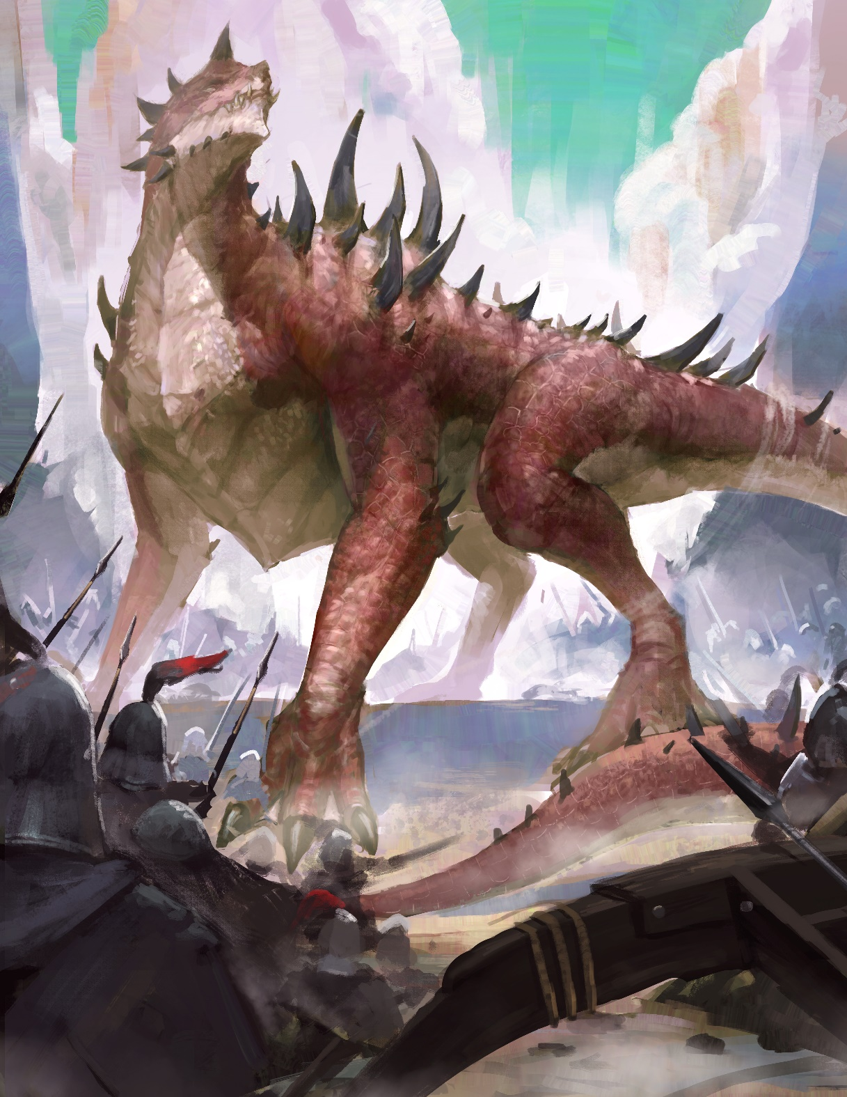

Fiction: Binding
I hear you, talking that release pig filth about how the city is a curse, about how it’d be better if we freed the beast. I spit on your words and if it comes to it I’ll spit in your face, then crack your skull if you don’t care for it. You weren’t there, for the War of Binding. I was. I lost friends, lovers, who are worth a score and more each versus the lot of you. Yes, I know I don’t look my age, it’s the elf blood ya see but I was there all the same.
Piss on the stories you heard, we got lucky. We bound the beast only by the grace of The Thirteen, by the bravery of those few who kept their wits even as the rest of pissed ourselves and ran—useless.
We had a plan you see, one we’d drilled for. All orderly lines—archers and siege placed just so—all with signals to fall back at their appointed hour even as they supported their fellows. Till finally we’d led it to this canyon where we’d fall upon it in earnest, slaying it so the thirteen harpoons would hold it fast.
We’d tried to goad it into such a battle half a dozen times. Each time it had turned aside, or we’d arrived too late, or otherwise missed our chance. We all had a good feeling as we’d led it into the mountains, went to be hoping the morrow would bring the proper battle.
I can still hear the sounds of bedlam as we retreated and died like dogs, crushed like vermin.
It had outrun our own scouts ya see, caught us before dawn with our pants down and our fruits in our hands. I swear it didn’t make a sound until it was already upon us, and then the cold quiet of predawn amongst the peaks was filled with its roar. And the avalanche—stones and ice the size of houses tumbling down slaying man and beast alike.
Men, hard men, old salt of those that hadn’t been slain by the rockfall…most of them soiled themselves and fled.
Throughout the camp was madness punctuated by the sounds of men dead and dying as the other troops struggled to get armed and armored. Those who fought naked or near enough—southern barbarians, monks, some sorcerers and other wielders of magic—engaged and bought us scant minutes and The Thirteen managed to get the rest of us moving, fighting in retreat.
We near routed, but did so at a pace and shaped in a direction that put the beast in the crosshairs.
It was because our captains’ whipped and guided us to where we’d placed the ballistas, solid and secured, and we couldn’t pin the beast down unless we were sure. So rather than fall back orderly in lines blunting its forward momentum, instead of fighting the battle we’d trained and scemed for, we died in our hundreds, our thousands, trampled underfoot and gored and bit, but we died in the right direction at least, leading the monster to the spot where we’ve held it fast these last centuries—Thirteen be praised.

Prehistory–50,000 BB (Before Binding)

The rough area which would become the Ronine Valley is home to numerous strata littered from the various conflicts and expansionist eras that left buildings, ruins, and more in their wake. These events include the Elder Elemental’s war-mate, the slave gods’ revolt against the Primordials, the extraplanar invasion, the dethronement of the gods, and finally the elf-dwergo war (and notably the valley has access to numerous dwergo ruins as it is formed over their city of Cardouf by geo-scale war druid magic).

50,000–100 BB: History of the Ronine Valley

For thousands of years tribes of stone giants and orcs make their homes (at least seasonally) in the high mountain Ronine Valley that would one day be the Tarrasque’s territory, finding it excellent forage for their herds. This valley exists on the borders of several major kingdoms (of changing names and territories) but due to its relative geographical isolation it is unclaimed by any power.

77 BB: Tarrasque Reemerges

After several centuries of seeming hibernation the Tarrasque reemerges on the world stage. For one hundred years various schemes to slay the beast are attempted (all of which fail) and the nations of men and demihumans alike resort to a strategy of attempting to guide the creature away from what they hold dear. It is during this period where a large number of magic items and weapons are embedded in the creature as various states and adventurers’ plots fail to stop the beast.

8 BB: The Thirteen Gather
Thirteen exceptional individuals—driven by impulses ranging from prophecy to greed, the quest for glory, legitimate selflessness—come together with a plan to bind the Tarrasque in place in order to determine the best way to slay it. For the next several years they travel extensively to determine the best location, develop and acquire the supplies required (including enchanting thirteen magical harpoons), and convince the various kingdoms to lend material support for their mission.

0 AB (After Binding): Tarrasque Bound & Construction of Fortress Salzinwuun Begins
After a tremendous battle (and enormous loss of life) the Tarrasque is successfully bound. The surviving heroes cheer, bury their dead, and begin devising the most efficient ways to slay the beast as various scholars can closely study the creature in hopes of finding a permanent solution. The binding army settles into a pattern of killing the creature twice a day which is difficult—even when it is bound.
Soon after the Tarrasque is restrained the binding forces begin construction of the fortress Salzinwuun to provide more permanent shelter than tents and a better way to defend themselves against raids by the Ten Talon orc tribe.

1 AB: Loss of the Armies

With no end in sight for the slaying of the Tarrasque, in order to deal with domestic matters most nations recall forces dispatched as part of the binding of the Army of the Thirteen. The Salzinwuun forces left are only a fraction of the most dedicated (and individually powerful) individuals.

11 AB–26 AB: Granite Shard War & The Harvest Begins

Around 11 AB the binders of Salzinwuun come into conflict with the Mammoth Wardens tribe of indigenous stone giants native to the area in and around Salt in Wounds. The Granite Shard War is what most refer to when speaking of the battles between the stone giant natives and the defenders of Fortress Salzinwuun.
Since the binding of the Tarrasque and a decade prior to the onset of hostilities, tensions rose between the stone giants and the polyglot of adventurers, military forces, and merchants encamped around the beast. The continuing presence of the enormous monstrosity scare away most big game including the titular mammoths on which the giants are especially dependent and there are several incidents of jumpy humans who attack giants on sight without provocation yet miraculously no one on either side is killed. Salzinwuun residents do not take part but a merchant slave caravan attempts to abduct several juvenile stone giants before being slaughtered by the Mammoth Warden tribe. In the rising tensions of the aftermath both Salzinwuun’s defenders and the stone giants send diplomatic envoys; none meet with success.
Meanwhile a well respected bardic stone giant has a vision of the valley soaked in blood and filled with mutated creatures while humans carry each of granite kin to toss into the maw of the Tarrasque. After discussing it for a month the elders decide that they have no choice but to drive off the “little ones” who have invaded the area—knowing full well that this means loosing the Tarrasque back on the world (and that they will finally be free of it).
The Granite Shard War opens with a siege-like bombardment of Salzinwuun, its walls barraged by huge hurled stones that catch the fortress wholly off guard. After much of the wooden fortifications are destroyed the Mammoth Warden warriors charge in to slay and drive off the defenders. This first battle is especially bloody with tremendous acts of heroism, brutality, and loss on both sides. Still it had been exceptional individuals who had originally bound the Tarrasque and while some of these heroes had wandered off in the long, frustrating years following the imprisonment of the monster, the stone giants of the Mammoth Wardens tribe discovered a garrison of martially and magically skilled defenders proved too much for them.
It was around this time that the Ten Talon tribe of orcs, sensing weakness, step up their intermittent raids. Their eventual extermination is usually lumped into the campaign of the Granite Shard War despite any evidence that the two groups coordinated. However as for the Mammoth Wardens, after their first, best push is repulsed and most of their warriors slain, the stone giants know they have lost the war even if it takes much time for defeat to finally, fully claim them.
No longer with the force necessary to attempt another direct assault the Mammoth Wardens alter their tactics to asymmetric warfare—they abandon their traditional encampments in the valley lowlands and drift up the mountainsides where the “little people” have problems reaching them. The tribal war council also shifts to targeting vulnerable caravans coming into and out of Salzinwuun, hoping that through prolonged isolation they might sap the fortress of its morale and fighting strength. While Tarrasque flesh had previously been eaten by a good portion of the fort's occupants, the effectiveness of the stone giant caravan raids ensure that meat butchered from the beast becomes the mainstay of every being garrisoned there (in addition to bone and horn becoming the preferred material for the crafting of tools and weapons). For their part the “little people” send countless missions to root out and kill or capture the remaining Mammoth Wardens, taking hostages to cow the rest of the tribe into peace. Utilizing their captives to begin rebuilding the fortress Salzinwuun creates the demand and legal framework for the mass enslavement which persists in the present day.
The hostilities of the Granite Shard War continue for years as the more militant giants are slain while those without the will or capacity to fight are captured and enslaved. When Salzinwuun rangers estimate that there are less than 10 free giants remaining in the nearby mountains, they claim victory and move on.

27–49 AB: Trade & Population Bloom

Now harvesting the Tarrasque for food and later raw materials, the period directly after the Granite Shard War is marked by a massive increase in commerce as various merchants establish and master trade routes. Also at this time, the population of Salzinwuun massively increases as various craft people and refugees immigrate to the location for promises of ready work and a limitless food supply. Many scholars who had persisted to find a permanent death for the Tarrasque despair and leave (or merely die of old age or other misadventure), or else turn their attention to making use of the beast as an exciting field for new focuses of study. Canny observers notice at this point that the weather and biome of the valley begins to change and shift towards tropical humidity.
It is also during this period that the first Tarrasque-Fed mutation is catalogued.

48 AB: Enders Founded

The Enders are created by several scholars who believe that the binders at large have forgotten their original mission—and that the only way forward is to further research a permanent solution to kill the Tarrasque, in opposition to the swelling population that have embraced the blessings it brings. Persecution and changes in the law drive the organization underground or force it into extinction, depending on whom one asks.

50 AB: Sovereign City Charter

Though it had effectively been functioning as one for quite some time, to commemorate half a century of binding the fortress Salzinwuun rededicates itself as a city. A central charter lays out the basic political structure with authority residing in the “Binder-Lords and Ladies”: all the original Thirteen, their descendants, or their inheritors.

59 AB: Creation of the Clear Water Accords

With groundwater increasingly poisoned the city creates the Clear Water Accords and officially forms the Water Haulers Guild. In the years to come this sets precedent for establishing the other professional associations that grow in power—the God-Butchers (which is the formalization of an existing order who had already begun to establish their own traditions and history), Blood Merchants, Process Guild, Sage’s Council, and finally Marrow Miners.

67 AB: Defeat of the Wyvern Siege & All Consumption Established

Mercenary warlord Segund the Wyvern King (a human so called for his command of two dozen of the creatures) set his eyes to conquer the then booming town of Salt in Wounds. Leading an army of 10,000 bolstered by the aforementioned monsters and other magical support, the brilliant logician manages to scale the steep track to Salt in Wounds with only a minimal loss of life. He faces hastily conscripted forces of around 2,000 militia, mercenaries, and irregulars and so—confident of an easy victory—the general plots how to best leverage this conquest for further gains and is ultimately lax in the assault.
The Wyvern King is turned back by Beutex the 9th House Binder-Lady, who threatens to release the Tarrasque. When Segund fails to heed her warning he is slain by his own men who don’t wish to risk the unstoppable beast being freed again to wreak havoc.
With the Wyvern Siege lifted before it even begins, what becomes the All Consumption is established where any military threat to sovereignty of the Binder-Lords is met by an unbinding of the Tarrasque. Scholars also argue that this encounter is the earliest conflict of the ongoing series of skirmishes which are known as the Synoma’s Artifact Wars wherein conventional military forces are blunted or made irrelevant by the deployment of epic magic, dangerous creatures, artifacts, and (ultimately) adventurers.

71 AB: Heartsblood Marsh Identified

Explorers first noted the beginning of the Heartsblood Marsh as a distinct (and hazardous) biome.

77AB–246 AB: Artifact Wars Rage

Much of the world is engulfed in a series of conflicts that see empires topple or bloom and ultimately culminate in the present day balance of power. Salt in Wounds—geographically isolated and able to maintain its independence—grows massively in power and wealth (by dealing as a broker, banker, and neutral power for warring states) and population (absorbing several refugee waves).

223 AB: Circle of Release Founded

The Circle of Release is founded by Errya, a druid deeply concerned that the imprisonment of the Tarrasque is fouling the ecology not only of the local environment but also that of the entire planet. As evidence he points to the explosion in the population of magical megafauna (with the resultant death and food web disruption) in addition to the increase and severity of the so-called Savagekind Wars (the interrelated incursions, skirmishes, and wars waged by the often technologically or magically inferior but quick-breeding goblinoid and orcine races). Finally Errya notes the prevalence of disease, mutation, and violent crime within the city as proof that—destructive though it may be—allowing the Tarrasque to range and roam where it will is the preferred option for all.
Errya is largely dismissed as a kook, no more than a diversion for the poor and desperate with no chance of effecting large scale change. However as his number of converts swells rumors circulate that he's managed to bring several influential merchants and even a Binder-Lord around to his way of thinking. Finally the God-Butchers—who believe it is their holy duty to continually slaughter the Tarrasque until the end of time—deem it is time to act.

238 AB: Night of Cleavers

On the Night of Cleavers the God-Butchers (acting unilaterally) slay Errya, the dozens of rangers and druids that live with him in the circle's commune, and hundreds of men, women, and children with acknowledged or suspected ties to the Circle of Release. Those killed in the purge include some well connected cousins of the aristocratic Meridian Houses, suggesting to canny observers that the God-Butchers are not controlled by the Binder-Lords to the degree that is commonly assumed.

256 AB: 12th Meridian Crisis

The 12th Meridian Crisis—the largest scale disaster to befall Salt in Wounds in its history—rocks the city. For reasons that are still unclear the Tarrasque is able to free its tail and it takes several chaotic hours for the God-Butchers to regain control and containment of the creature. In its thrashing and flailing approximately 2,500 people lose their lives from debris or the monster’s thrashing. Numerous pieces of God-Butcher equipment are destroyed and house-sized boulders are flung into the Hind Quarter smashing homes and businesses. While this is happening panic grips the city and—fearing that the end has finally come—swarms of people try to flee. In addition to the thousands or so who die in the wake of the Tarrasque’s direct actions, an additional 4,000 or so are trampled and killed in the madcap attempts to evacuate Salt in Wounds.
Master God-Butcher Helenie illegally uses her knowledge of the 12th Meridian Harpoon command word—very likely the most influential act in saving the city and keeping the Tarrasque in captivity.
Eventually the Tarrasque is brought back under control but with numerous lasting consequences.
The God-Butchers suffer a massive setback in public perception and internal shock with as many as one in five of its ranks leaving the organization (although much of this is influenced by the post-crisis treatment of Helenie). The Hind Quarter is transformed into what is now commonly referred to as the Tail Stones, an area of the city yet to be fully rebuilt and practically given over to lawlessness and grinding poverty.

257 AB: 12th House Coup & Creation of the Marrow Miners

Following the 12th Meridian Crisis, Autoxia Marcellun (then Binder-Lord of 12th House) is usurped by Tolviko Marcellun (then a lesser cousin of his). Moreover the newly confirmed Binder-Lord of 12th House shocks the city several months after the crisis by granting the extraction contract for the 12th Meridian to the newly created Marrow Miners, an organization led by former God-Butchers and staffed mostly by the so-called monstrous races.
As no official answer is ever been offered as to how the Tarrasque was able to free itself, numerous theories abound (see Circle of Release on page @@). The most widely accepted theory is that Autoxia has lost his divine mandate and so his charge was “unloosed”.

277 AB: Present Day

6. SECRETS & INTRIGUE
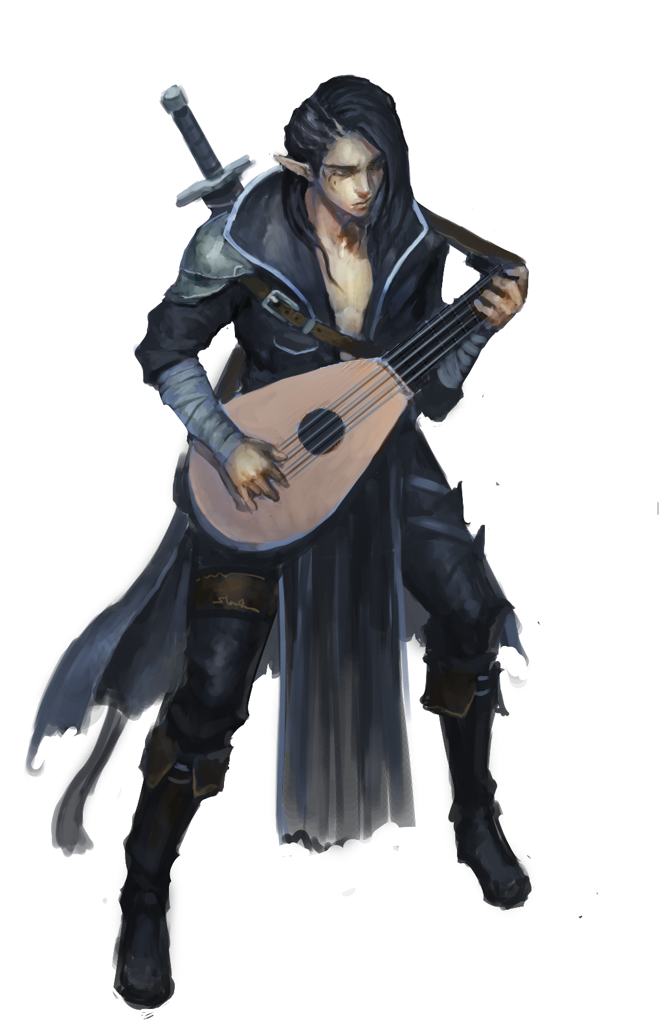

Relevant Fiction: Drums
Dinnai Eckert glared into the black of the tunnel beyond and saw nothing more than rocks. He licks his lips and crawls further, hoping that the guide’srumor monger’s information is good, that he had been sold a true map and—even had the dealer been honest—that the quakes haven’t shifted the passageway enough to twist the instructions into falsehoods.
Up ahead he hears drums. That’s promising.
Slowly his eyes shift from shades of contrasting grays to hues of color as torchlight dances at the end of the tunnel. Going carefully slow now he crawls until he can see out across the edge.
Harpies, three of them and perhaps two dozen zombies ringed around them. The undead bang at drums while the feathered witches work on a corpse on an altar—its middle open and various organs splayed across the table. Without thinking about it Dinnai starts playing with a spot of lyric about, “oh the silly birds, fly below the stones, pecking out the hearts, of good men.” He peers at the dead man on the altar, not wanting to disrupt any old ritual unless this was the right one. Green eyes, thatch-colored hair, and a tattoo of an ankheg on his arm—yup, this was the merchant’s son, and yes he was quite dead.
Time to collect his ransom. After he’d work to discover if these creatures worked for the unknown entity whose handiwork Dinnai had been tracking for some time, hoping to learn another secret he might be able to sell.
With a slight whoosh of air Dinnai flips from the tunnel overlooking the scene, landing easy and strumming his lute. The harpies turn, cocking their heads like quizzical chickens. Dinnai often found that starting with a song bought him more time than opening with an arrow or spell. He began to sing.
The witches gesture and the zombies drop their drums, turning to lurch at Dinnai—too late. When Dinnai strikes the last chord—just so—they stop in their tracks, and now it is Dinnai’s turn to gesture towards the harpies. The undead stumble that way, intent on bashing the bird fiends to death.
Necromancers always get so mad when you take away their toys; it really is quite funny. Dinnai added a bit to his song about it, dodging out of thrown dagger’s way.

Note: The following information is generally unknown to Player Characters and the population of Salt in Wounds at large.

Mammoth Wardens (Secret Faction)

The stone giants of Salt in Wounds seldom speak and seem extremely obedient leading many citizens to conclude that they are simple creatures and natural born slaves. What limited numbers escape to join their freeborn tribesmen outside the city walls are considered aberrations and indeed, a minority of their kind gave up long ago on any dreams of an end to their kindred’s enslavement—instead they labor to improve their lot in servitude or more rarely win their freedom and make their own place in the economy.
Whatever their status the vast majority of stone giants consider themselves full members of the Mammoth Warden clan, loyal to hidden elders that those born in captivity have never met—what they know is from covert communication between giants within and without the city. Leaders on both sides of the wall never accepted an end to the Granite Shard War, deciding instead to unleash their most terrible weapon to finally win the conflict: patience. They wait for their opportunity to win freedom for all (including the Tarrasque) and destroy Salt in Wounds so they can finally reclaim the valley that is theirs by birthright, a goal they move ever closer to realizing as they seemingly fade into the background while grasping at greater power and access coupled with ever diminishing supervision.
The Circle of Release has made contact with the hidden, moving village of free Mammoth Wardens and is currently negotiating an alliance as the aims of the groups seem to dovetail nicely.

Secrets of the Tarrasque

Since its imprisonment the Tarrasque has been growing larger and stronger, something known to a small number of highly placed individuals. Knowledgeable Binder-Lords and Blood Merchants see this as a positive development allowing them to increase their harvest but keep word of the anomalous development suppressed lest it panic the populace.
Eating a diet too high in Tarrasque meat, drinking red water tainted by the creature’s viscera, and other utilizations of harvesting the monster lead to side effects: some slow, some fast, some beneficial, and some not. This is general knowledge though not commonly discussed. Many seek to control these mutations with the Cult of Renesec and the ancient alchemist Zandon Ras making the most progress—Ras is funded and secretly supported by Dakragg Kelline (12th House Guard Captain) who hopes to raise an army of mutants to seize control of 12th House and possibly carve an empire for herself.
What is unknown at the current time to all is that the Tarrasque is pregnant, its unlaid eggs ready to hatch and burst out of the deep part of its belly within two years.

Secrets of the Heartsblood Marsh

Most don’t wonder about the origins of the Heartsblood Marsh and assume that like mutations it is an emergent property of harvesting the Tarrasque. Few know that it is the artificial creation of Afrindi Gunterhix, a mad gnome druid that crafted the artificial ecosystem and still guides its development after his “death” forty years ago (merging with the fungal sieve where he spun his body into endless knots of fungus).
What remains of his druidic impulse to stop the Tarrasque’s corruption wars with his baser fungal nature—suppressing the urge to spore and spread and claim ever more to sate his insatiable need to grow. Most grippli of Heartsblood Marsh worship Afrindi while their high priests (in addition to half a dozen adventurers and investigators) are infested with his spores, transformed into servitors through which he can more directly pursue his goals.
The Fungal Sieve is now a castle-sized knot of fungus, greedily sucking in the outflowing red river to grow ever larger. The sieve is riddled with tubules large enough for a human-sized creature to crawl or a child to walk through. It is also full of room size bladders and empty organs in which a variety of strange creatures seek shelter (including spore infectees). These are used by the sieve to force air, water, and other important matter throughout its body.
Near its core are its filter-grinders—thick, web-like strands of fungus coated with alternating rows of bony growths. Bloody water and food is shot through this area and matter is digested or sorted and squeezed out to the rest of the sieve’s body. These filter-grinders can also be reached more easily by following the stream’s path directly into the core of the sieve; but the fast rushing flow of water over innumerable rapids make such entry perilous.
Above the filter-grinders looms the face of Afrindi, thick strands of fungus rooted into his eyes and translating the olfactory senses of the sieve into something approaching vision.
The sieve is slowly crawling upstream towards Salt in Wounds at the rate of about a tenth of a mile each day.

3rd House Secrets

As part of their cornering of the spice and various food markets, 3rd House (known to eschew magic) maintains vast extra-dimensional spaces full of water and food stores large enough to sustain their members and those who serve “vital relationships” for several years. However none but Binder-Lord Gerard, Sergeant-at-Arms Drummond, and foreign wizards paid for the construction know of their existence.

5th House Secrets

Binder-Lady Kuolemita and her consort Merrin of 5th House are both deeply in love, completely loyal and honest with one another (if no one else), and non-monogamous by prior agreement. Merrin has assumed the role of drunken fool and Kuolemita that of the long-suffering wife in order to play both sides, implying a division and weakness where none exists, and otherwise create maneuverability to advance their political aims. They both often weave elaborate (and utterly false) tales about their own mistreatment by their spouse, sometimes hinting that they intend to leave the marriage. This is usually done with the intent to entrap the unwary, greedy, and romantic in their schemes.
Besides continuing to grow the influence and wealth of 5th House, Kuolemita and Merrin are most interested in securing their own power beyond any contest. Hence one of their primary goals is to eliminate Dofen: former 5th House Binder-Lord, Kuolemita's grandfather, and powerful wizard currently in hibernation as he transforms himself into a lich. Their current plan is to enlist a group of adventurers to destroy Dofen’s body and phylactery—once that has been accomplished they’ll condemn these actions and slay the ignorant heroes to pacify the Dofen loyalist faction within their own household.

6th House Secrets

6th House Founder Dradeth Bolgath is still existing as a ghoul (a situation brought about thanks to the manipulations of 5th House Binder-Lord founder Dofen) and runs the house through his son Duradin Bolgath. On his orders craftspeople and smiths have been abducted to help create engines of war, arms, and armor in the thousands. Numerous secret passages connect the various rooms of 6th House Manor-Tower, including the hidden sub-basement where the insane Dradeth Bolgath lords over and oversees workers driven to labor to death. Duradin is loyal to his father while his son Thuramin seeks to take over and fix the problems of the house (although the younger Bolgath is largely distracted from this goal due to innumerable debts racked up from personal vices.)

10th House Secrets

Even more secret than the narcotics production is House Impertabo's prized creation: a drug called veri. Distilled from a mixture of yet unidentified fluids extracted from deep within the Tarrasque hindquarters, the narcotic is the resource upon which the entire House is built—in its purest form it is a viscous blood red wine consumed via injection to the throat. A veri user is gifted with a supernatural ability to determine the truth of a statement. It allows a precisi to cut through layers of context, self-denial, and outright deception to firmly grasp what is true. This drug is why the House is so valued as advisors and consultants. While on veri the user cannot speak untruth themselves without suffering intense pain and even bodily damage. This side effect explains the necessity of having both the fuori and the precisi.
After a violent intra-house battle of succession house elders made it a requirement that all members of standing be dosed with veri at all times. The inability to speak untruths to each other has solidified the unity of 10th House—it is quite difficult to betray one’s mother and steal her position when completely incapable of lying to her (although this makes internal intrigues all the more complex and creative). Through generations of this tradition the governance of its members is incredibly loyal and unified, almost to the point of cult-like devotion.
To minimize pain from speaking untruth the precisi whisper their words to their retinue who then transmit them to clients. The lesser, younger members of House Impertabo, the fuori, exist to interact with the public at large; to be the liars, the faces, and the voice of their precisi masters. All fuori aspire to join the ranks of the precisi in time which is why most of the fuori are loud and boisterous bon vivants. These assistants know that their destiny is to eventually travel into a life of opulent silence so they seek to make as much noise as possible until that glorious reward is bestowed. The exorbitant parties House Impertabo often throws are as much nostalgia on louder times for the precisi as well as an outlet for the fuori.
There is another, darker, side effect of veri usage. After mere weeks of consistently consuming the wine, physical deformity starts to manifest from the injection point at the throat and spreads outwards to the face and chest. The disfiguring caused by this long-term use is why the precisi wear masks—10th House’s vain and arrogant top clientele would most likely recoil at the true visage of a precisi elder. As per tradition the more beautiful and intricate the mask, the more horrid and vile the disfigurement hidden beneath.
With veri as their tool the Impertabo earn additional revenue through blackmail and interrogation. Analyzing the small talk of aristocrats for truth at one of their many banquets and balls is profitable on its own without forcing secrets out of any guest, but uncovering information and prying thoughts out of prisoners is quite easy when dosed with a small amount of veri. There is no need for red hot pokers or rusty pliers when a person’s body tears itself apart from uttering dishonesty.

12th House Secrets

Founder Binder-Lord Spenser had early ties to organized crime with his cohorts creating the arrangement of the criminal underworld as they saw fit—pacts and guilds, favors earned and owed.
Two Marcellun families have coexisted ever since with one becoming the elder line and heading the family militia, managing the public affairs of 12th House, and protecting the word. The other are the branch line responsible for underworld affairs and ensuring that no other house is able to gain enough power to overthrow the Marcellun family. The coup of Tolviko blurred these divisions between public and underworld ventures.
Unbeknownst to Tolviko, Autoxia's alchemists were also working on a viable Tarrasque-mutation alternative with the end goal being to free 12th House from the necessity of the God-Butchers, the other houses, and even the Tarrasque itself. With the mutations controllable, the 12th House under Autoxia would have unsurpassed influence in and over the city—when Tolviko killed him, Dakragg Kelline (one of his bastard children) took over the program where she continues to run it in secret.

13th House Secrets

Binder-Lord Voth Ikarian claims to be a Salt in Wounds outsider but when pressed, he brushes off questions of his biological lineage and states that he had parents like anyone else who struggled to make ends meet, drawn by tales of the great city of Salt in Wounds where anyone could make their fortune. In truth he was born a slave of the House of the 1st Meridian. As a child growing up he was slow to learn his place in the social hierarchy, constantly challenging his betters and questioning the status quo. His altruism was ridiculed and beaten out of him though in fact this only tempered the steel of his desire. While barely an adolescent, Voth snuck out of Salt in Wounds in the back of a merchant caravan determined to find somewhere to do good in the world. He rambled from city to city, staying long enough to become more disillusioned with his fruitless efforts until adopting a different approach, cutting down those who were high instead of lifting those who were low. Voth began to see results—he didn't mind that his hands were bloody so long as someone else could smile. His own status increased as well as he realized he could be a champion of the common man while pocketing a fair bit along the way.
Returning to Salt in Wounds he set about killing any who might know his identity (save for his parents, who now live a comfortable life in the Throat). Afterward he ingratiated himself with the aging Binder-Lady of 13th House, using a combination of charm, enchantment, and politicking to succeed her. Once he is able, Voth plans on using his new power to bring total ruination to the aristocracy.

Secrets of Myrida, the Enders, and the Marrow Miners

In order to understand the Marrow Miners and the modern Enders, it is important to first understand the character and motivations of Mirayda of the Five Cask Clan—her philosophy and goals shape everything about the organizations that she founded and now runs.
The Marrow Miners were created two decades ago after the former journeywoman God-Butcher failed (spectacularly) during the Rite of Mutual Recognition. When she faced off against the Tarrasque and saw the spark of destruction there, Mirayda flew into a berserk rage, stabbing at its eye over and over again trying to end its life in contradiction of all sense and all her training as a God-Butcher. She had to be restrained by half a dozen others. Before any could debrief her she launched into a tirade about how the beast must be permanently slain and that all of the God-Butchers’ considerable resources should be reassigned to discovering, inventing, or otherwise implementing a plan to end the threat once and for all.
None of the Masters would listen to her plea, each attempting (with increasing sternness) to remind her of the importance of the Tarrasque to the city, assuring her that they had matters well in hand and commenting that the original founders (in addition to two centuries of harvest) had already proven that it would be impossible to kill the monster. Facing this response, Mirayda resigned from her position as journeywoman God-Butcher and began a quest to discover some manner to finally end the threat of the Tarrasque once and for all.
She spent decades traveling to libraries all around the world visiting any civilization that had come into contact with the Tarrasque, searching for some clue as to how it might ultimately be slain. Unfortunately she found only confusion and frustration for years as nearly every account of the creature was at best wildly speculative or at worst a virtual font of misinformation. Mirayda despaired when she realized that the best information about the beast was available in the God-Butcher archives—to which she no longer had access.
Still she managed to discover some early correspondence from the first generation of God-Butchers complete with what appeared to be detailed anatomical records. With a flash of inspiration Mirayda comprehended that the Tarrasque has changed massively since its imprisonment began. At this point she knew her answers couldn’t be found in the past but that they would need to be invented through directly working on the monstrosity as it exists today.
During the long journey back to Salt in Wounds she agonized over how she’d once again rejoin the God-Butchers after her disgrace, all while attempting to keep her aims and motivations secret—but she arrived home during the 12th Meridian Crisis and was provided a different path. Mirayda threw herself into Tail Stones relief efforts, reintroducing herself to much of the city (most especially its poor). When Tolviko Marcellun staged his coup and seized control of 12th House she approached the young Binder-Lord with an offer worthy of his brashness: she would found a new organization that would take over the 12th Meridian extraction contract from the God-Butchers who had were re-contracted every year as a matter of course, an outcome so expected that many had forgotten that this was a privilege that could be changed. In exchange for this unprecedented move the ‘Marrow Miners’ would pay fees far in excess of any usually paid by the God-Butchers in addition to providing smuggled reagents which had previously been unavailable to 12th House.
Tolviko took the deal, and Mirayda of the Five Cask Clan founded the Marrow Miners.
Unbeknownst to most the Marrow Miners possess advanced techniques to temporarily overwhelm the Tarrasque’s regenerative abilities and are able to quickly cut deep tunnels into the beast. With these secret (and extremely temporary) channels (usually dug at night when God-Butcher activity is lessened) the Marrow Miners both gain access to rare glandular and organ cuts, and they produce more accurate information regarding the Tarrasque’s shifting physiology. It is this vital research that Mirayda believes will one day allow her to finally slay the beast.
Mirayda is one of five individuals who suspect that the Tarrasque is pregnant and will give live birth soon, an event she is actively anticipating as she hopes to capture a young Tarrasquelet and experiment on it to gain a better understanding of its progenitor.
The Marrow Miners (and their 12th House sponsors) regularly deal with the various gangs, criminal organizations, and corrupt Blood-Merchants when selling off their illegally harvested Tarrasque viscera. Mirayda and her trusted lieutenants are also huge importers of rare and custom poisons which they test in bulk against the Tarrasque, always searching for any substance that will improve their efforts at ever greater extraction or show potential for taking the Tarrasque’s life (although if Tolviko Marcellum or most of the organization knew that was Mirayda’s ultimate goal they would expose her, see her tried by the stage-courts, and reorganize the leadership of the Marrow Miners.)
Mirayda meets secretly (and in disguise) with a dozen like-minded individuals to discuss what she’s learned and is the current unofficial leader of the nearly extinct and almost wholly disorganized Enders.

Secrets of the Capcaps
Mirayda meets secretly (and in disguise) with a dozen like-minded individuals to discuss what she’s learned and is the current unofficial leader of the nearly extinct and almost wholly disorganized Enders.

Secrets of the Capcaps
Other than the exploratory wells dug by the God-Butchers into the Capcaps, entrances to the subterranean realm can be found in the basements of gang headquarters, in nearby cave systems, and other secret sites throughout the city. Once the Capcaps have been entered there is a path to almost anywhere in the settlement although even well-traveled guides know very little about the total shifting geography, usually sticking to five or six favorite routes to navigate the maze-like environs.
Derro have colonized the deepest parts of Cardouf—the cavernous royal tombs—where they conduct alchemical experiments on captured humans and demihumans. Most notably they have recently begun to transform ordinary humans into worm-like Alchemical Oblates capable of producing high quality imitations of controlled or otherwise unavailable Tarrasque extracts. This technology has begun to be exported to the city at large—a process they’ve started to share with the alchemists they deal with.
A cabal of Blood-Merchants has sent down engineers protected by mercenaries to assess the feasibility of opening up and retrofitting the Capcaps to make it suitable for housing of the poor who don’t mind (or will be forced to accept) underground lodgings. The engineers have set up shop in the former feast hall of Cardouf, though it has been weeks and following the collapse of some tunnels after a Tarrasquequake they no longer know how to find their way back to the exploratory well that leads to the surface. Growing increasingly paranoid these groups of scouts assume everyone they encounter are dangerous criminals sent to rob them or rival operative seeking to undermine their claim.
There is an entrance a possibly global network or caverns and passages in Cardouf, which is currently controlled by the derro. Several factions native to the realm of constant darkness suspect this and have been drafting plans to seize this point of access (and the unknown area above it).

Tuska and the Quest for Divinity

There are places throughout the planes where torture beyond mortal comprehension takes place. Devils and demons have their hells and stranger, more twisted creatures have odd pits where cruelties are inflicted eternally. Yet there are pockets in the Material Plane where incredible evil and torment exist: the labyrinthine dungeons of a mad king perhaps, or upon the sacrificial altars of a heartless summoner. But pain on the planes of mortals is always limited by the lifespan of and resiliency of the creature suffering—and the hundreds of years of torturing the immortal and regenerating Tarrasque has created something new.
Something unique.
Something dangerous.
The agony of the Tarrasque has created Tuska.
Tuska is the sentient, disembodied, psychic distillation of the Tarrasque’s pain. When Tuska first achieved consciousness they were barely stronger than a half-formed mortal ghost able only to (with great effort) move small objects or whisper suggestions. In the centuries since as the monstrosity’s agonies continue they’ve increased Tuska's power, growing in stature until now they are akin to a demigod, able to grant powers to witches and warlocks who claim them as patron.
It is important to note that Tuska is not the Tarrasque: Tuska is a new spiritual being that uses the agony of the creature as a food source. While the city at large may feast upon the monster’s flesh, Tuska (and—to a lesser degree—their servants) feed upon its agony.
Tuska is served as a patron by a tribe of harpies as well as a dozen or so witches and warlocks in the city of Salt in Wounds. Through skillful political manipulation, assassination, and magical rites performed with the assistance of their subservient witches, Tuska has blocked or thwarted any change in procedure that would lessen the Tarrasque’s pain (and the Tarrasque harvest of today is more excruciating for the creature than it’s ever been).
At present time Tuska is drawing together the final elements for a decades old plan to ascend to true godhood—a deification that will first require the Tarrasque to briefly be freed so it can experience its own bestial equivalent to hope and freedom before Tuska cinches tight the final, eternal noose that will extend its agonies into time without end.
Tuska’s notable allies include the Coven of Three comprised of the powerful witches Fina (a harpy who takes multiple shapes, including a beautiful woman and a rag washer), Funa (a horrendously mutated enforcer who leads a group of fierce assassins and regularly contracts out mercenaries currently often pregnant with a tarrasqueling which—after birth—is ritually slaughtered as part of worship for Tuska), and Fex (also known as Trundle Ginderhold, Binder-Lord of 4th House, who wields incredible influence). Fex specifically was drawn to Tuska not because of a fetishization of pain but rather curious ambition as to what it would be like to be on the ground floor of the birth of a new god. Since his affiliation with Tuska began house fortunes have suffered somewhat but only a little, delaying the risk that 4th House might break from their orbit.

The Command Words & Releasing the Tarrasque

Each of the thirteen immoveable harpoons that have been sunk into the Tarrasque and binding it in place is controlled by a command word. Knowledge of each of these command words is a closely guarded secret not only due to the practical dangers of someone unbinding the creature (as the Circle of Release intends) but also due to the fact the knowledge of a command word is woven into the formal notions of power within the City of Salt in Wounds.
Command Word Possessors
In theory each Binder-Lord or Lady is in possession of the command word that corresponds to their house's meridian. As possessor they are the only individual legally entitled to ever make use of the command word and it is in this quality that their formal authority rests. None save the respective Binder-Lord possessor may ever use the command word to unmoor or remoor their respective harpoon under penalty of truncation. The last individual to do so (and suffer the penalty) was Ex-Master God-Butcher Helenie.

In theory each Binder-Lord or Lady is in possession of the command word that corresponds to their house's meridian. As possessor they are the only individual legally entitled to ever make use of the command word and it is in this quality that their formal authority rests. None save the respective Binder-Lord possessor may ever use the command word to unmoor or remoor their respective harpoon under penalty of truncation. The last individual to do so (and suffer the penalty) was Ex-Master God-Butcher Helenie.
Command Word Confirmers and Safeguards

Each meridian command word also features a minimum of four others (Master God-Butchers,(Master God-Butchers, well-connected merchants, and other Binder-Lords) who act as confirmers, individuals who are aware of the command word but charged with using that knowledge to check the that of a Binder-Lord or teach it to a new Binder-Lord (and so are integral to managing house successions). Binder-Lords and -Ladies usually pass on their command words to their successors well before they themselves step down as part of the process of establishing their heir apparent. Most commonly this honor is bestowed upon the first born of either sex but sometimes it is granted to a different relative or—even more rarely—an unrelated individual who has been adopted into the Meridian House usually as the result of some great service.
While uncommon, coups are possible—the first step of which is to discover the respective meridian command word. After this the original Binder-Lord or -Lady has to be deposed, and then the would be successor needs approval from 3 out of the 4 confirmers (known as a confirmation). Any individual who is able to gain a (secret) command word, overthrow a Binder-Lord or -Lady, and politically secure a confirmation quorum is generally accepted as possessing all the necessary skills to excel as one of the new oligarchs of Salt in Wounds.
Extensive use of memory magic (like modify memory) or compulsion magic (like geas) is used to prevent leaks and limit knowledge or use of command words.

Other Sources for Command Words
In addition to residing in the minds of their respective confirmers and possessors, command words can be found in the following places:
- The command words are magically woven into the immoveable harpoons themselves. In addition, they also are embedded into and act as the command words for a number of secondary magical items unique to a few of the Meridian houses (crowns, scepters, weapons, and the like). There is a rumor that an otherwise unremarkable halfling wizard named Patrega Thatchthumb operating in the Throat bazaarThere is a rumor that an otherwise unremarkable halfling wizard named Patrega Thatchthumb operating in the Throat bazaar has created a device that can extract a magical command word from the item it controls.
- Command words are sometimes possessed by disgraced or otherwise replaced confirmers or possessors. Some of these individuals are vagrants in distant cities, prisoners, or half-insane hermits living in the wildlands. Many of them have had their memories magically altered or are under a compulsion to reveal their command words only under very specific circumstances. Learning the identity, whereabouts, and communication conditions of such individuals represents a massive magical or academic undertaking.
- In the rarest of cases command words are written down (generally only for volatile Meridian Houses which have experienced succession crises or by Binder-Lords who wish to flaunt security conventions). Such instances are under heavy guard, usually secreted in a vault complete with magical and mundane countermeasures to oppose would be thieves.
- Certain command words can be obtained (for an exorbitant fee) from one of the half dozen information brokers operating within the city.
Releasing the Tarrasque
While sometimes their ritualized political use obscures this fact; the harpoon command words are the true keys that could unlock the destruction of Salt in Wounds and the reshaping of the world. All major factions and power blocks have an incredible interest in controlling knowledge of the command words. Only the Master God-Butchers (in their role as confirmers and only collectively as a group) possess all thirteen. In addition they also control physical access to each of the harpoons (save the 12th, which is currently controlled by the Marrow Miners) and could therefore release the Tarrasque immediately with little trouble if they so desired.
The Thirteen Command Words are as follows.
1. Glory
2. Finality
3. Marisol
4. Peace
5. Martyr
6. Home
7. Apropos
8. Talon
9. Desolation
10. Thrice
11. King’s Guard
12. Aftan
13. Incarnadine
Note: if you wish to pronounce the words in their original language for fantasy flavor they are as follows.
1) Uzuko
2) Gqibela
3) Ulwandle Nelanga
4) Uxolo
5) Oyingcwele
6) Ekhaya
7) Niselo
8) Ukuphosa
9) Ukoxotshwa
10) Kathathu
11) Umlindi Wenkosi
12) Emba
13) Igazi

Secrets of the Circle of Release

Secrets of the Circle of Release
Since seizing the reigns of power and reforming the Circle of Release, Grovask—a half-orc who regularly works as a merchant guard—has led the group to the ascendancy of its power and to within a stone's throw of accomplishing its goal. The fact that she has done so while facing violent opposition from nearly every other influential faction in the city is a testament to her unrepentant ruthlessness and strategic brilliance.
Where under founder Errya's leadership the circle attracted the poor, malcontents, theorists, and academics, the modern circle's recruiting efforts are nearly entirely focused on those with the magical or martial capacity necessary for direct, covert action. Hard-edged rangers, druids capable of channeling the naked ferocity of nature, and even sympathetic rogues, fighters, and wizards of the green faith now comprise the various rings of the Circle of Release.
The Circle of Release is organized as half a dozen semi-independent rings (or cells) each having only tentative communication with and knowledge of the membership or activities of other rings. When possible, these rings carry out missions of intimidation or sabotage aimed at making the continued butchery of the Tarrasque untenable. Large scale coordination is utilized on efforts to discover or steal the command words that release the magical, immoveable harpoons that bind the Tarrasque.
To date Grovask has learned 9 of the harpoon command words. When the group has gathered all 13, Grovask will enact her plan to overwhelm and confound the God-Butchers and House Militias long enough to unmoor all the meridian harpoons—finally unleashing the Tarrasque.

Alchemist War

The Alchemist War is an unspoken conflict—now entering its second decade—between alchemists and others loosely aligned into two camps: those allied or under the direction of 5th House (which seeks to establish an effective monopoly upon the alchemical trade in Salt in Wounds) and the independents unofficially led by Bakal Fillagreen who resist these machinations. The primary mechanism for the conflict is 5th House using its position as supplier of the vast majority of alchemical reagents to fix prices and direct supply towards its favored, subservient alchemists, a practice reinforced by a litany of crimes like theft, blackmail, sabotage, framing various individuals, extortion, and threats. So far the independents have focused their efforts on securing non-house sources for the reagents they need (beyond the limited quantities they have access to by working with other meridian houses and smugglers) with the emergence and discovery of alchemical oblates (actually a derro innovation) providing a huge push. Anonymously employed criminals are the major forces employed in this war as both sides prefer not to get their hands dirty with adventurers regularly employed for offense, defense, or the collection of some vital piece.
The war has yet to feature confirmed assassinations though both sides suspect the other’s involvement in several suspicious accidental deaths. In preparation of the conflict getting more heated Bakal Fillagreen has been producing and storing Tarrasque Flesh golems—loyal only to him and his associates—in anticipation of needing martial forces to resist 5th House’s might.

Secrets of the Oni

Oni are quite common in and around Salt in Wounds. While the spirits' origins are unknown to most their preponderance is due to the schemes of Gurilda, a now deceased oni prince that traveled the world disguised as a merchant. When he happened upon Salt in Wounds a century after its founding he decided that due to the multiplicity of its sins the city would be a perfect place for formless, wandering oni spirits to physically embody themselves. Aiming to become king of such beings, Gurilda performed an intricate ritual to create a magical anchor to attract and bind other oni. His personal plans for glory were foiled when he was slain by a group of adventurers but his magic (as well as the inherent evil of the city) has nonetheless led to incredible numbers of masterless oni incarnating in and around Salt in Wounds. It is suggested that if Gurilda's essence could ever be reconstituted into physical form all the oni would be compelled to follow his commands—or the commands of the one who controlled Gurilda.

7. MONSTERS & HAZARDS
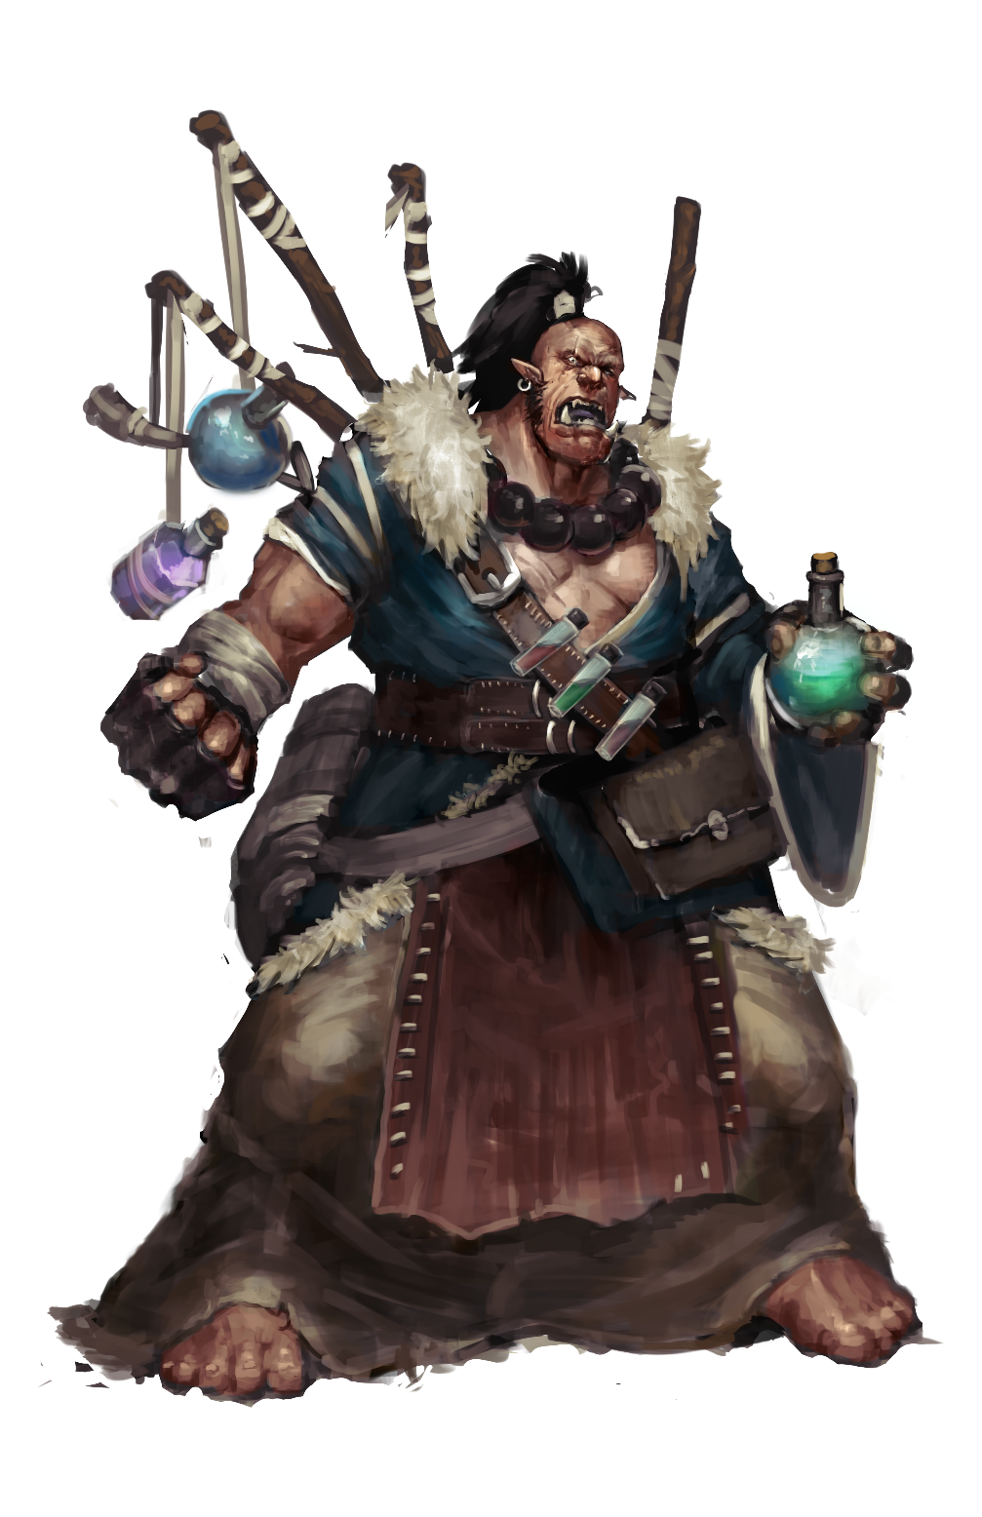

Fiction: The Arena
Ry stood, marking his breath.
All around, the crowd murmured but Ry gave them no mind.
In the center of the sand some foppish talker yelled through some manner of amplification cone, working up the onlookers. This was a part of the fights here, in the arena; the money changing hands, the gambling, the big talk-talk, the anticipation and the lust for blood. Ry’s blood he assumed they preferred...though he supposed they’d settle for the reigning champion’s after the half-orc broke him apart.
Ry tried not to smile at the thought—it was unbecoming to the life of contemplation he’d devoted himself to—but his face flashed a brief smile all the same.
They’d taken Ry’s potions and meager gear leaving him only with his small clothes, but such trivialities hardly mattered. He had little need of the magic stored in his clanking phials and glass bottles, in his enchanted weapons, not when he knew and commanded the paths of aether within and how each could be unlocked, shifted to fill himself with power. Intuiting that the time for bluster and talk was drawing to a close he began to move, assuming the correct postures: crane takes fish, contented lion, lizard climbs. He held each pose for a breath all the while seeing the flows inside change, glow, and he felt his flesh charge in response. He grew stronger, faster, his mouth filling with steam.
Finally the announcer finished and bowed, the crowd roaring in response. The thousands of spectators began shouting one word like a mantra, the name of their champion: “CHANGA! CHANGA! CHANGA!”
The portcullis opposite Ry opened and through the ten foot tall arch a gray-skinned rune-inscribed humanoid crouched to get through. In answer to the crowds sounds of appreciation the stone giant bellowed, raising his arm in anticipation of triumph.
Then he charged flat out towards Ry.
As Ry finished the last process he idly thought that the creature was bigger than he’d expected. Not for the first time he wondered how a seeker of knowledge like himself ended up in situations like this—and, despite countless hours of meditation to banish such base dross—he felt that flicker of a smile return larger than before to split his lips and reveal his sharp teeth. As a young half-orc he’d loved nothing more than fisticuffs and even now, decades later, after all his master’s lessons to empty his heart of desire he still loved a good fight, to test and push in the thrill of battle on scales the child he had been could only dream. Perhaps he always would love it. He allowed himself the grin for another breath, suppressed his desire to scream in joy-rage, and returned his face to a mask of calm.
Empowered by his final process, Ry leapt fifteen feet into the air to catch the charging stone giant right in the chin with a punch that would have done his master proud.

Salt in Wounds is host to many monsters and hazards beyond rampant crime, corruption, and political infighting. Some are found all over the world while others are virtually unknown beyond the city’s limits but all are twisted and made unique by the city’s influence.

Animated Objects
Animated Objects
Animated Objects are used as inexpensive sentries and guards, a common hazard to thieves or “explorers” in Salt in Wounds. Sometimes the magical instructions placed to guide these objects decay with time or were inexpertly applied in the first place leading to more than one incident of an unwarranted assault about town.

Ankheg

Ankhegs are a native apex predator to the region around Salt in Wounds although they are now far more common than ever before binding. They emerge seemingly at random from the ground outside the city and sometimes even within the walls themselves—thousands have been glimpsed feasting below the bound Tarrasque, growing bloated and huge as they dig into the monster's belly. God-Butchers and Marrow Miners purge them once a season but they always return. Most often the terrifying individual ankhegs encountered as hazards are the weakest specimens of the city’s population, pushed out by stronger creatures that continue to eat their fill of enormous monstrosity’s flesh as they grow ever larger.

Axe-Beak

These dangerous, large birds are native to the steppes around Salt in Wounds and work as the city’s primary beasts of burden and mounts (their meat being cheaper than the feed required for horses). Feral and aggressive axe-beaks can still be found in the surrounding area, though occasionally even the domesticated beasts can present a hazard to passerby inside the city walls.

Ghouls & Ghasts

While ghouls and ghasts can be citizens of Salt in Wounds with the same ethical responsibilities of any other humanoid it is not unheard of for individuals to revert to a bestial, mindless state and attack on sight.

Ghouls and Ghasts
While ghouls and ghasts can be citizens of Salt in Wounds with the same ethical responsibilities of any other humanoid it is not unheard of for individuals to revert to a bestial, mindless state and attack on sight.

Harpy
Numerous flocks of harpies roost in the mountains around Salt in Wounds harassing travelers and traders. Uniquely these monsters include a large number of witches empowered by a bargain with an unknown entity. These harpy witches (and the flocks they lead) are assassins and operatives working to further hidden schemes (for the right price or prize).

Oni

While not historically present to the area several decades after its founding the city of Salt in Wounds and surrounding lands have became populated with numerous oni of various types—some haunt the wilderness and slums to prey on the weak, others operate in secret and disguise their true nature in service of larger plans, and a few operate openly in the city hiring out their labor or selling magic and accepted as citizens that can keep a bargain.

Otyugh

Before the legalization of ghouls in Salt in Wounds hundreds of imported otyughs were used to help dispose of the masses of rotting meat. After 5th House and its sanctioned undead picked up the contract for waste disposal, the monsters—many mutated and made more terrible by their constant diet of Tarrasque flesh—were slated to be executed. Led by their emergent sorcerous blood-shaman leader the unexpectedly intelligent creatures anticipated the crisis and staged a mass escape, fleeing to CapCaps and Heartsblood Marsh where they’ve since thrived.

Stirge

Millions of stirges feed upon the bound Tarrasque and even with dedicated purge efforts swarms of these creatures represent a serious hazard in Salt in Wounds. Most of the time they are content to grow fat and bloated drinking the tremendous beast's blood, but when multiple swarms are disturbed and take flight the sky is darkened by their incredible locust-like numbers. During these so called Black-Sun days residents bar their doors and windows against the stirges until they can burned out of the air en masse—the unlucky or unwary individuals caught outdoors are often discovered later as nothing more than desiccated husks.

Yeti

These primates reside in the nearby mountains though they have recently been spreading down into the lowlands, discovering good hunting in the sanguine, fecund, and flesh-choked environs around Salt in Wounds. Those that no longer live amidst the snow continually rub their fur in the viscera of their kills to better blend in with the red tinted landscape—creatures generally referred to as blood yetis.

Unique Monsters

Alchemist Testing Apparatus
This small, hand-sized construct is an odd assortment of brass clockwork, bone, and machined sinew. Typically constructed by an alchemist trying to discover medical data, the devices have six copper legs that end in hooked talons and a mosquito like ”face” comprised of a thick syringe. Small clear vials of brightly colored, viscous liquid cover its back.

Small, Vicious Automaton. Powered by an improbable arrangement of tightly-wound springs, alchemical reactions, and more distressing techniques, the apparatus is also a deadly and easily-hidden sentinel for its maker. Since the device is not fully sapient it sometimes fails to recognize its creator and attacks. Most owners keep them set to inactive until moments before releasing them into a contained environment, such as a guard post they don't plan to enter again. Alchemist testing apparatuses can recognize constructs and undead, and do not attempt to "test" them.

Alchemist Testing Apparatus
Tiny construct, unaligned
Armor Class 13
Hit Points 77 (22d4+22)
Speed 25 ft., climb 25 ft.
STR DEX CON INT WIS CHA
6 (-2) 16 (+3) 12 (+1) 6 (-2) 10 (+0) 8 (-1)
Damage Immunities poison, psychic
Condition Immunities charmed, exhaustion, frightened, paralyzed, poisoned
Senses blindsight 30 ft.
Languages —
Challenge 3 (700 XP)
Control Panel. An alchemist testing apparatus has a control panel hidden on its body. A creature can access the control panel while the alchemist testing apparatus is incapacitated without difficulty. While it is grappled or restrained, a creature can use an action to make an Intelligence (thieves' tools) check (DC equal to AC), opening the panel and changing the setting on a success. The three settings are Inactive Mode, Experiment Mode, and Defend Mode.
- While in Inactive Mode, the alchemical testing apparatus is incapacitated.
- While in Experiment Mode, it uses its Primary Syringe.
- While in Defend Mode, it uses its Secondary Syringe.
Latch On. While latched on to a creature the apparatus has advantage on attack rolls against it. When the apparatus suffers damage, the creature it is latched onto suffers half that amount of damage. The apparatus can end the latch as a free action.
ACTIONS
Primary Syringe. Melee Weapon Attack: +5 to hit, reach 5 ft., one target. Hit: 5 (1d4+3) damage, the apparatus latches on to its target (escape DC 13, or if wearing medium or heavy armor escape DC 18), and roll 1d4:
1—The target makes a DC 12 Constitution saving throw. On a failed save, the target takes 18 (4d8) poison damage and is poisoned until the end of its next turn. On a success, the target takes half as much damage and is not poisoned.
2—The target makes a DC 12 Constitution saving throw. On a failed save, the target mutates horrifically, taking 13 (3d8) necrotic damage and gaining vulnerability to piercing damage for 1 minute. On a success, the target takes half as much damage with no further effect.
3—The target makes a DC 12 Constitution saving throw. On a failed save, the target is paralyzed until the end of the apparatus' next turn.
4—The target's skin hardens, granting it 15 temporary hit points that last until the end of the apparatus' next turn. If any temporary hit points remain when this effect expires, the target is petrified for 1 minute. The target can make a DC 12 Strength saving throw at the end of each of its turns, ending the petrification on a success.
Secondary Syringe. Melee Weapon Attack: +5 to hit, reach 5 ft., one target. Hit: 5 (1d4+3) damage, the apparatus latches on to its target (escape DC 13, or if wearing medium or heavy armor escape DC 18), and the target makes a DC 12 Wisdom saving throw. On a failed save, the target is charmed. As long as the apparatus remains latched on and the creature remains charmed, the apparatus takes no actions and the target makes its most effective melee weapon attacks against one of the apparatus's enemies, moving if necessary. The target receives a new saving throw at the end of each of its turns, ending the charmed condition on a success.

Goblin Wormtongue
Goblin Wormtongue
Goblin wormtongues are goblins transformed by their exposure to Worm Brew and colonized by parasites. They are able to command loyalty from other goblins, are tied to the worms, and have been awakened to mystical power by the Worm Brew and their wriggling communion. Most serve Gothmork but some few have left the Grub House to found their own organizations, a few having left Salt in Wounds entirely. Where their tongue would normally be is instead a tangle of worms. When a goblin wormtongue speaks it is actually a chorus of small-mouthed worm voices speaking in unison with the goblin host—goblin wormtongues keep their mouth as closed as possible when they speak but their condition becomes especially apparent when they cast a spell.

Goblin Wormtongue
Small humanoid (goblinoid), neutral evil
Armor Class 14 (leather armor)
Hit Points 14 (4d6)
Speed 30 ft.
STR DEX CON INT WIS CHA
8 (-1) 14 (+2) 10 (+0) 12 (+1) 12 (+1) 12 (+1)
Skills Stealth +6
Senses darkvision 60 ft., passive Perception 11
Languages Common, Goblin
Challenge 1/2 (100 XP)
Nimble Escape. The goblin can take the Disengage or Hide actions as a bonus action on each of its turns.
Inspirational Figure. All goblinoid allies within 50 feet of the goblin wormtongue who can hear its voice gain a +2 bonus to attack and damage rolls.
Innate Spellcasting. The goblin’s spellcasting ability is Charisma (spell save DC 11). It can innately cast the following spells, requiring only verbal components.
At will: friends, minor illusion
3/day: command
1/day: charm person, hideous laughter
ACTIONS
Dagger: Melee Weapon Attack: +4 to hit, reach 5 ft., one target. Hit: 4 (1d4+2) piercing damage and the target makes a DC 10 Constitution saving throw or takes an additional 7 (2d6) poison damage.
Sling. Ranged Weapon Attack: +4 hit, range 30/120 ft., one target. Hit: 4 (1d4+2) bludgeoning damage.

Kolo Birds
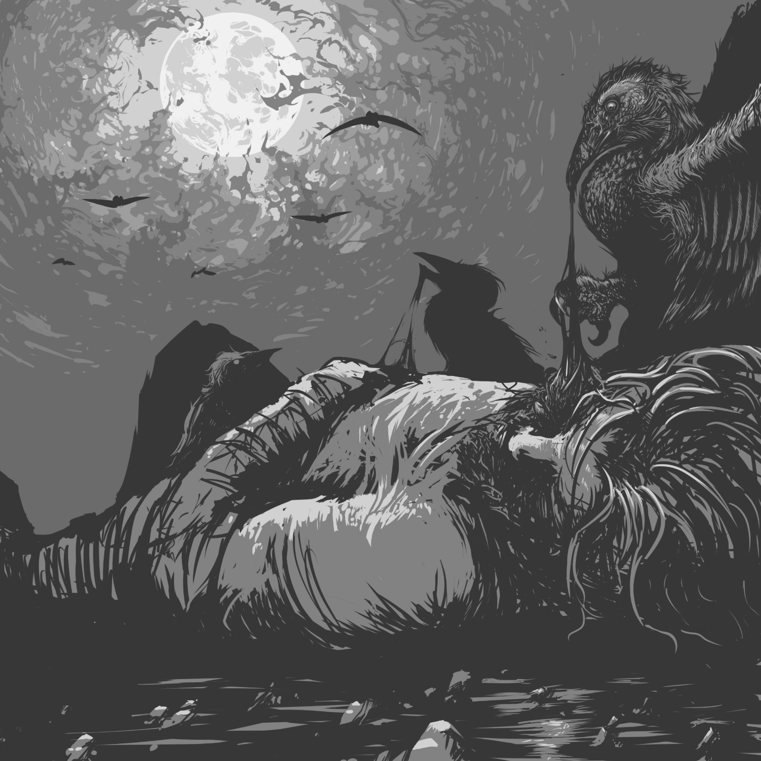
This dark-feathered avian has a red undertail, intense yellow eyes, and its hooked beak is congealed with dried blood and viscera. Kolo birds are micropredators that use their incredibly sharp beaks to create nesting cavities and grievous wounds. Although they do not typically hunt, kolo bird flocks (knows as wakes) seek out wounded creatures with their keen carrion sense, preferring to deliver a swift coup de grace rather than engaging in drawn out conflicts.

Kolo Bird
Tiny beast, unaligned
Armor Class 13 (natural armor)
Hit Points 14 (3d4+6)
Speed 10 ft., fly 40 ft.
STR DEX CON INT WIS CHA
7 (-2) 15 (+2) 14 (+2) 2 (-4) 15 (+2) 7 (-2)
Skills Survival +6
Senses passive Perception 12
Languages —
Challenge 1/8 (25 XP)
Blood Frenzy. The kolo bird has advantage on melee attack rolls against any creature that doesn't have all its hit points.
Keen Carrion Smell. The kolo bird has advantage on Wisdom (Perception) and tracking checks that rely on smell against creatures who are either missing at least half (50% or fewer) of their hit points or undead.
ACTIONS
Bloody Beak. Melee Weapon Attack: +0 to hit, reach 5 ft., one creature. Hit: 1 (1d4-2) piercing damage. At the start of each of the target's turns, it takes 1 piercing damage from blood loss for each time it has been hit by this attack. At the end of each of its turns, a wounded target makes a DC 13 Constitution saving throw, ending the effect of all such wounds on itself on a success.

Mottled and sporting minor vestigial mutations, watchers are kolo birds that have mutated due to a steady diet of Tarrasque. They are larger, hardier, and more resistant to virulent damage than their smaller cousins. Warlocks that have selected the Pact of the Chain can select a watcher as a familiar.

Watcher (Dire Kolo Bird)
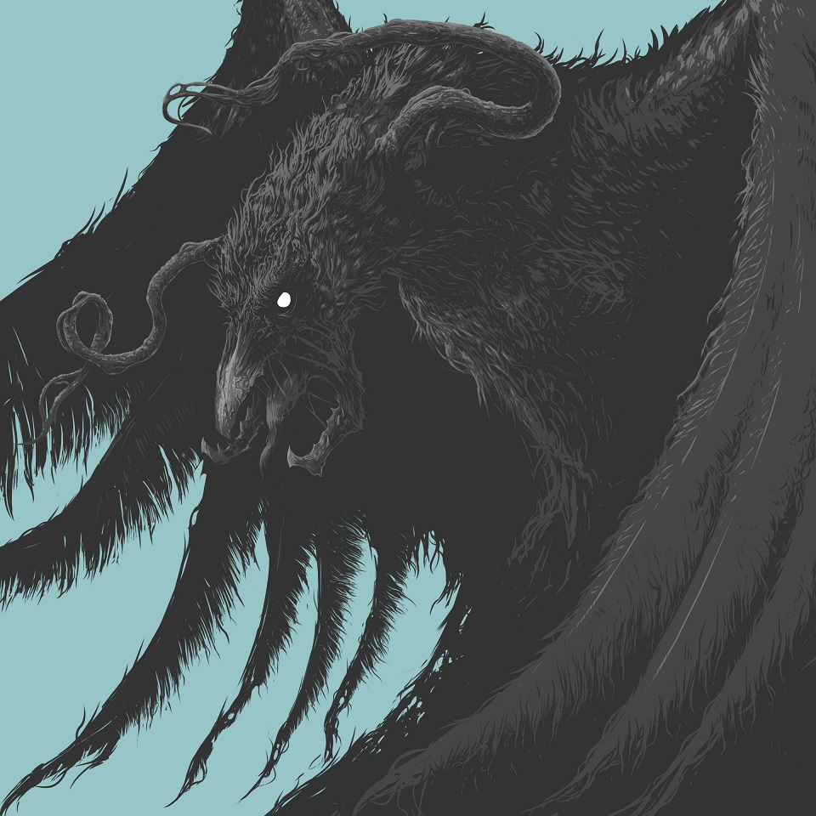
Small beast, unaligned
Armor Class 14 (natural armor)
Hit Points 19 (3d6+9)
Speed 10 ft., fly 50 ft.
STR DEX CON INT WIS CHA
9 (-1) 13 (+1) 17 (+3) 2 (-4) 15 (+2) 7 (-2)
Skills Survival +6
Damage Resistances necrotic
Damage Immunities poison
Condition Immunities poisoned
Senses passive Perception 12
Languages —
Challenge 1 (200 XP)
Blood Frenzy. The watcher has advantage on melee attack rolls against any creature that doesn't have all its hit points.
Keen Carrion Smell. The watcher has advantage on Wisdom (Perception) and tracking checks that rely on smell against creatures who are either missing at least half (50% or fewer) of their hit points or undead.
ACTIONS
Bloody Beak. Melee Weapon Attack: +3 to hit, reach 5 ft., one creature. Hit: 4 (1d6+1) piercing damage. At the start of each of the target's turns, it takes 1 piercing damage from blood loss for each time it has been hit by this attack. At the end of each of its turns, a wounded target makes a DC 15 Constitution saving throw, ending the effect of all such wounds on itself on a success.

Ledgerman
This figure takes the shape of any common sentient race that has a concept of debt, its form a translucent dark blue or purple. It appears to be clothed in sober, professional attire, bearing a ledger-book, abacus, or anything else that current or previous local cultures used to manage financial matters. Often appearing in groups, ledgermen ruthlessly seek out debtors (real or imagined) and extract wealth from them.
Astral Thoughtforms. Though they look ghostly and indeed are often believed to be undead, ledgermen are instead the reified thought-form of a populace's fear of unpaid debts. When destroyed a ledgerman disperses back to the psychic winds of the Astral Plane but it is never long before a new one takes its place. They are especially likely to manifest when someone dies while desperately in debt.
Hunger for Wealth. The ledgerman's nature drives it to destroy physical wealth in the form of coins, gemstones, precious metals (though not ore still in a vein), art objects, or magic items. When given wealth in any of these forms, it takes time to note the payment in its ledgers—leaving it distracted and vulnerable. If left in the presence of unattended wealth and not threatened with violence, it disintegrates large quantities of treasure at a time. The ledgerman has no special capacity to locate vaults or counting-houses, but if it finds one by chance, it could wipe out vast fortunes in minutes.

Ledgerman
Small or Medium construct, lawful evil
Armor Class 11
Hit Points 176 (32d8+32)
Speed 30 ft., fly 30 ft.
STR DEX CON INT WIS CHA
10 (+0) 12 (+1) 13 (+1) 16 (+3) 12 (+1) 13 (+1)
Skills Insight +4, Intimidation +4
Damage Resistances bludgeoning, piercing, and slashing from nonmagical weapons that aren't silvered
Damage Immunities poison
Condition Immunities exhaustion, frightened, grappled, paralyzed, petrified, poisoned, restrained
Senses darkvision 60 ft., passive Perception 11
Languages Common
Challenge 7 (2,900 XP)
Debts to Pay. When a willing creature gives a ledgerman coins, precious metals, gemstones, art objects, or magic items worth at least 50 gold pieces, the ledgerman takes no actions and becomes vulnerable to all damage types except poison until the end of that creature's next turn.
Incorporeal Movement. The ledgerman can move through other creatures and objects as if they were difficult terrain. It takes 5 (1d10) force damage if it ends its turn inside an object.
Stocked. The ledgerman uses d8s for hit dice regardless of size.
ACTIONS
Multiattack. The ledgerman attacks twice.
Tarnishing Touch. The ledgerman chooses one creature it can see within 5 feet. The target makes a DC 15 Charisma saving throw, taking 16 (3d10) acid damage on a failed save, or half as much damage on a success as the ledgerman's touch corrodes everything of value. It can also target unattended inanimate objects; one Tarnishing Touch destroys up to 300 gp in value.
REACTIONS
Balance the Scales. When a creature within 10 feet deals damage to it, the ledgerman can use its reaction to cause its attacker to take 10 (3d6) psychic damage.

Ramora Fleas
These bloodsucking parasites are like huge ticks or fleas and the creatures are common throughout Salt in Wounds.

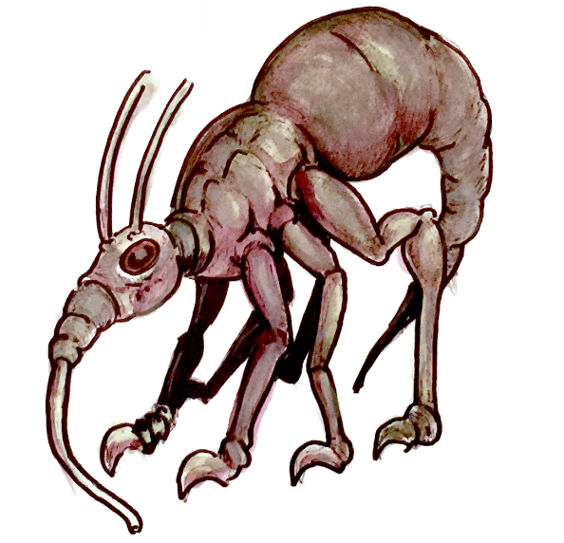

Ramora Flea (Lesser)
Small beast, unaligned
Armor Class 15 (natural armor)
Hit Points 22 (4d6+8)
Speed 30 ft.
STR DEX CON INT WIS CHA
14 (+2) 12 (+1) 15 (+2) 2 (-4) 11 (+0) 4 (-3)
Skills Stealth +6
Senses blindsight 10 ft., darkvision 60 ft., passive Perception 10
Languages —
Challenge 1/2 (100 XP)
Standing Leap. The flea’s long jump is up to 30 feet and its high jump is up to 15 feet, with or without a running start.
ACTIONS
Blood Sucking. Melee Weapon Attack: +4 to hit, reach 5 ft., one target. Hit: 5 (1d6+2) piercing damage and if the target is Medium or smaller it is grappled (escape DC 12). While the target is grappled, the flea doesn’t attack. Instead, at the start of each of the flea’s turns, the target takes 5 (1d6+2) untyped damage from blood loss.

Dire Ramora Flea
Large beast, unaligned
Armor Class 12
Hit Points 52 (7d10+14)
Speed 40 ft.
STR DEX CON INT WIS CHA
18 (+4) 14 (+2) 15 (+2) 3 (-4) 12 (+1) 8 (-1)
Skills Perception +3, Stealth +6
Senses blindsight 10 ft., darkvision 60 ft., passive Perception 13
Languages —
Challenge 2 (450 XP)
Bounding Off. Once per round while grappling a Medium or smaller creature, the flea can make an opposed Strength check. On a success, the flea jumps off of the creature, dealing 5 (2d4) bludgeoning damage.
Pounce. If the flea jumps towards a creature and then hits with Blood Sucking on the same turn, the creature must succeed on a DC 14 Strength saving throw or be knocked prone.
Standing Leap. The flea’s long jump is up to 60 feet and its high jump is up to 30 feet, with or without a running start.
ACTIONS
Blood Sucking. Melee Weapon Attack: +8 to hit, reach 5 ft., one target. Hit: 11 (2d6+4) piercing damage and if the target is Large or smaller it is grappled (escape DC 15). While the target is grappled, the flea doesn’t attack. Instead, at the start of each of the flea’s turns, the target takes 11 (2d6+4) untyped damage from blood loss.

Red Leech Tide
Even the leeches of Salt-in-Wounds are changed by the city's effluvium. Red leech tides are swarms of red leeches connected by a hivemind that grants them lethal cunning when in large groups. As predators they engage in ambush tactics against far greater prey than common leeches would dare pursue.
Predator & Parasite. Red leech tides sometimes gain strange powers when they drink the blood of sorcerers or monsters. They favor targets that show signs of innate power that the red leech tides can absorb (particularly when their intellect is enhanced by proximity to additional red leech tide swarms).

Red Leech Tide
Medium swarm of Tiny beasts, unaligned
Armor Class 12
Hit Points 77 (14d8+14)
Speed 20 ft., swim 30 ft.
STR DEX CON INT WIS CHA
10 (+0) 14 (+2) 12 (+1) 6 (-2) 12 (+1) 3 (-4)
Damage Resistances bludgeoning, piercing, slashing
Condition Immunities charmed, frightened, paralyzed, petrified, prone, restrained, stunned
Senses blindsight 10 ft., passive Perception 11
Languages —
Challenge 2 (450 XP)
Blood Drain. A creature that starts its turn grappled by a red leech tide takes 10 (3d6) necrotic damage from blood drain.
Hivemind. If one other Medium red leech tide is within 60 feet, both have Int 8 (-1) and Cha 5 (-3). If two other Medium red leech tides are within 60 feet, all three have Int 10 (+0), Cha 7 (-2), and proficiency in Intelligence saving throws (total modifier +2). If three or more other Medium red leech tides are within 60 feet, all have Int 12 (+1), Cha 9 (-1), proficiency in Intelligence saving throws (total modifier +3), telepathy with a range of 60 feet, and resistance to psychic damage.
Swarm. The swarm can occupy another creature's space and vice versa, and the swarm can move through any opening large enough for a Tiny red leech. The swarm can't regain hit points or gain temporary hit points.
ACTIONS
Bites. Melee Weapon Attack: +2 to hit, reach 0 ft., one creature in the swarm's space. Hit: 9 (2d6+2) piercing damage, or 5 (1d6+2) if the red leech tide has half its hit points or fewer. In addition, the target is grappled (escape DC 10).

************BEGIN SIDEBAR
Blood is Power
Red leech tides often retain a fraction of the power of previous victims. Increase a red leech tide to CR 3 by adding any of the following features (roll 1d4 to randomly determine which).
1—The red leech tide fed off of something poisonous. A creature that starts its turn within 5 feet of the red leech tide makes a DC 10 Constitution saving throw. On a failed save, the creature is poisoned until the beginning of its next turn.
2—The red leech tide fed off an aquatic aberration. A creature that takes damage from the red leech tide's Blood Drain makes a DC 10 Constitution saving throw. On a failed save, tentacles grow from the wound, writhing and hampering coordinated movement. The creature has disadvantage on all attacks and ability checks using Strength or Dexterity until the tentacles are removed. Removing the tentacles requires an action that inflicts 5 (1d10) slashing damage on the target, or half that if the creature removing them uses a bonus action to make a successful DC 15 Wisdom (Medicine) check.
3—The red leech tide fed off a humanoid with a magically-potent bloodline. The red leech tide and all creatures of its choice within 10 feet have advantage on saving throws against spells. When a creature casts a spell within 10 feet of the red leech tide, the red leech tide can spend its reaction to deal its Blood Drain damage to that creature.
4—The red leech tide fed off of a fiend. When a creature starts its turn within 10 feet of the red leech tide, it must make a DC 10 Wisdom saving throw, becoming frightened until the beginning of its next turn on a failure.
*****************END SIDEBAR

Tarrasque Flesh Golem
Tarrasque flesh golems are terrifying constructs utilized in and around Salt in Wounds while being virtually unknown beyond city limits. Crafted primarily from the freshly extracted flesh, carved bone, and neural tissue of the enormous monster—pulsating, oozing figures which seem to pulse with life even as their creators insist that they are merely constructs. As a result of the material used in their creation, these automatons move faster and are stronger than those composed of other bodies. Even worse for would-be opponents, they can regenerate from wounds and damage. Notably, Tarrasque flesh golems have two (usually mismatched) humanoid eyes, most often formerly belonging to a criminal punished by the Stage Courts before being purchased and incorporated by an enterprising alchemist.
While most of these constructs hew to a classic man-like shape forms as varied as centaur, spider, or even serpentine have been utilized. However crafting a Tarrasque flesh golem to resemble the Tarrasque itself is considered extremely bad luck and an invitation to the runaway regeneration and berserk state that sometimes takes hold of these abominations. Several of the Meridian Houses have begun actively exploring the military applications of the constructs and currently Tarrasque flesh golems are utilized extensively by alchemists, with Bakal Filligreen in particular considered a master maker.

Tarrasque Flesh Golem
Medium construct, neutral
Armor Class 9
Hit Points 93 (11d8+44)
Speed 35 ft.
STR DEX CON INT WIS CHA
20 (+5) 9 (-1) 18 (+4) 6 (-2) 10 (+0) 5 (-3)
Damage Immunities fire, poison; bludgeoning, piercing, and slashing from nonmagical attacks that aren't adamantine
Condition Immunities charmed, exhaustion, frightened, paralyzed, petrified, poisoned
Senses blindsight 60 ft., passive Perception 10
Languages understands the languages of its creator but can't speak
Challenge 7 (2,700 XP)
Berserk. Whenever the Tarrasque flesh golem starts its turn with 40 hit points or fewer, roll a d6. On a 6, the golem goes berserk. On each of its turns while berserk, the golem attacks the nearest creature it can see. If no creature is near enough to move to and attack, the golem attacks an object, with preference for an object smaller than itself. Once the golem goes berserk, it continues to do so until it is destroyed or regains all its hit points. The golem's creator, if within 60 feet of the berserk golem, can try to calm it by speaking firmly and persuasively. The golem must be able to hear its creator, who must take an action to make a DC 15 Charisma (Persuasion) check. If the check succeeds, the golem ceases being berserk. If it takes damage while still at 40 hit points or fewer, the golem might go berserk again.
Immutable Form. The golem is immune to any spell or effect that would alter its form.
Magic Resistance. The golem has advantage on saving throws against spells and other magical effects.
Magic Weapons. The golem's weapon attacks are magical.
Regeneration. The golem regains 5 hit points at the start of its turn if it has at least 1 hit point and is not incapacitated.
ACTIONS
Multiattack. The golem makes three attacks: one with its bite and two with its claws.
Bite. Melee Weapon Attack: +7 to hit, reach 5 ft., one target. Hit: 9 (1d8+5) piercing damage.
Claws. Melee Weapon Attack: +7 to hit, reach 5 ft., one target. Hit: 10 (2d4+5) slashing damage.

The Worm Mother
Huge, blind, and largely mindless, the worm mother seeks only food and the creation of more giant worms. It lives on offal, worshiped by worm savants and its cult of goblin servants. It can be calmed by trained tenders but if not controlled it leaves its feeding pit to seek living food. Though apparently mindless worm mothers are prized for the unique ability that when slain they sometimes telepathically issue a single true prophecy. For this reason some occultists grow the creatures, looking to predict the future though they often escape (creating another worm cult to tend to its offspring away from captivity).
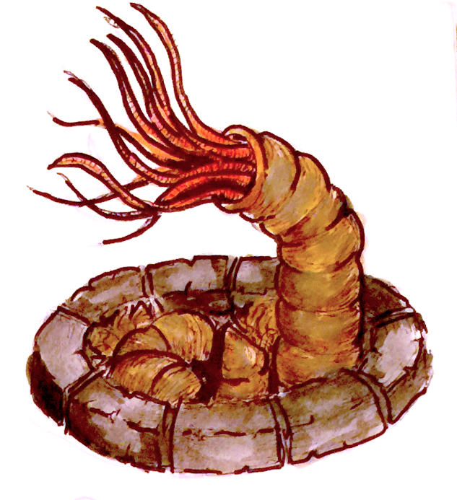

Worm Mother
Huge monstrosity, unaligned
Armor Class 15 (natural armor)
Hit Points 95 (10d12+30)
Speed 40 ft.
STR DEX CON INT WIS CHA
20 (+5) 8 (-1) 17 (+3) 2 (-4) 11 (+0) 6 (-3)
Senses blindsight 30 ft., tremorsense 60 ft., passive Perception 10
Languages all (tongues); telepathy 120 ft.
Challenge 3 (700 XP)
Death Throes. Upon death worm mothers telepathically issue a single true prophecy to all sentient beings within 300 feet though it is intermingled with gibberish, images of gore, and worm-perspective strangeness. Note that it is up to the GM as to whether or not a worm mother will issue this sort of prophecy.
ACTIONS
Paralyzing Tentacles. Melee Weapon Attack: +9 to hit, reach 10 ft., one target. Hit: 10 (2d4+5) bludgeoning damage, the target is grappled (escape DC 17), and the target must make a DC 15 Constitution saving throw or be poisoned for 1 hour. While it is poisoned, the target is also paralyzed. The target can make a saving throw at the end of each of its turns, ending the effect on a success.
Devouring Maw. Melee Weapon Attack: +9 to hit, reach 5 ft., one grappled target. Hit: 15 (3d6+5) slashing damage.

Worm Savant
The impossible, even paradoxical existence of worm savants imbues them with sentience and magical power. Fat, orange-brown, arm-sized grubs with smooth, vaguely humanoid faces that issue a constant stream of unintelligible whispers, these creatures communicate in riddles and puzzles, seeking only power and the advancement of themselves and their worm mother—if they lack a worm mother they find allies to help them grow a new one.
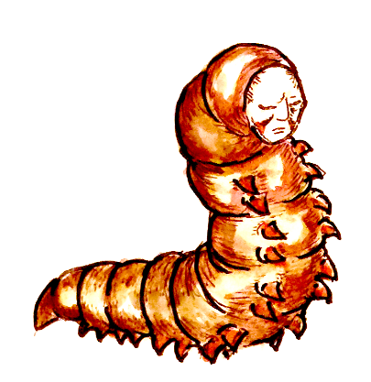

Worm Savant
Small monstrosity, neutral evil
Armor Class 15 (natural armor)
Hit Points 22 (4d6+8)
Speed 20 ft.
STR DEX CON INT WIS CHA
6 (-2) 12 (+1) 12 (+1) 16 (+3) 15 (+2) 8 (-1)
Skills Arcana +5, History +5, Insight +4, Perception +4
Senses darkvision 60 ft., passive Perception 14
Languages all (tongues); telepathy 120 ft.
Challenge 1/2 (100 XP)
Innate Spellcasting. The worm savant’s spellcasting ability is Intelligence (spell save DC 13). It can innately cast the following spells, requiring only verbal components.
At will: mage hand, message, poison spray, prestidigitation
1/day: fog cloud, hideous laughter, ray of sickness
ACTIONS
Poison Sting. Melee Weapon Attack: +3 to hit, reach 5 ft., one target. Hit: 3 (1d4+1) piercing damage and target must make a DC 11 Constitution saving throw or be poisoned for 1 hour. If the target fails its save by 5 or more, the target is also paralyzed. The target can make a saving throw at the end of each of its turns, ending the effect on a success.

Appendix 1: Intro Adventure - Gothmork’s Grub House

Introduction
Gothmork’s Grub House is perhaps the worst eatery in the Tail Stones. Run and staffed by Gothmork and a crew of scruffy goblin cooks, servers, and servants, the Grub House serves lousy food and worse ale in dirty and crowded conditions to anyone desperate enough to come in for a meal and a terrible drink. The regular customers here are goblins, half-orcs, criminals, and the abject poor. In addition this is often used as a place for brigands, gangsters, ne’er-do-wells, and more to meet up where they know no one cares what they are doing and nobody is likely to call on the law to interfere.
The Grub House sells two regular items: a huge bowl of grub stew for 1 copper piece and a giant tankard (about a half liter) of ale for 1 copper piece. No one asks about the source of the food, and the cuisine and drink are both blandly unpleasant. Both are made from the bodies of grubs that Gothmork has been growing in his basement for years, parasites harvested from the skin and feces of the Tarrasque.

The House Stew: Worm Stew
Worm stew is bland, filling, rich, and tastes vaguely like a mix of chicken, onions, porridge, and a pinch of dirt. It would be generous to say that it isn’t unpleasant to eat but it doesn’t taste good by any stretch of the imagination. Worm stew is a filling meal though and works as food—it is not at all dangerous to eat.

The House Ale: Worm Brew
Worm brew is a strong alcoholic beverage with mild hallucinogenic properties for goblinoids that lead to delusions of grandeur and feelings of divine inspiration. To non-goblinoids it an ingested poison. An hour after drinking worm brew, a non-goblinoid creature must make a DC 12 Constitution saving throw. If the creature imbibed only one ale, the save is made with advantage. If the creature imbibed more than two, the creature has disadvantage on its saving throw. On a failure, the creature is poisoned for one hour. While poisoned, the creature becomes euphoric and highly suggestible—Intelligence, Wisdom, and Charisma ability checks are made with advantage against a creature poisoned by worm brew.

Reasons the PCs might get involved
Gothmork’s Grub House is a low-level encounter, a minor criminal conspiracy, and a background threat that lurks around the edges of the campaign. This could be used to introduce investigation, intrigue, and a sense of danger as a background story arc as the adventurers begin to explore the city to make more sense of its players and endless schemes.
- The Grub House is the center of criminal activity led by Gothmork. He not only hosts criminal meetings in the Grub House, he also acts as a fence for stolen goods. More importantly the goblin gets minor crime lords drunk on worm brew to turn them into loyal agents. This means that the Grub House can be a place where PCs can meet criminal contacts, learn rumors, hire henchmen, or spy on illegal activities. In the process they can overhear criminal dealings by Gothmork, see his supernatural hold on others, and witness his goblin employees’ fanatical loyalty.
- The party could be hired to find a young man or woman from a poor family who has suddenly fallen into low-level criminal behavior after frequenting the Grub House and drinking worm brew. The drink made the missing person susceptible to influence and led them into working for one of Gothmork’s illegal enterprises. The adventurers need to find the missing person, uncover the conspiracy, and free the victim from the brew’s influence.
- The PCs find a growing gang war among the lower-levels of crime in the Throat. Several small-time hoods seem to be consolidating operations, leading more powerful criminals to ask the party to investigate. Clues reveals strangely compliant and compulsive behavior among the criminals the adventurers encounter, and the investigation leads the PCs to Gothmork’s Grub House and a goblin conspiracy.

Background
Gothmork was a simple goblin that escaped from his tribe driven by a uniquely developed sense of self-preservation—he wanted independence, wealth, and the kind of eased life he saw among the human merchants his people often raided and harassed. Traveling to Salt in Wounds seeking his fortune he worked his way from beggar to thief, smuggler, and finally dealer in various forms of Tarrasque-derived narcotics. After several run-ins with House Militias the goblin decided there had to be an easier way to get rich; he would start a business. Figuring everyone needed to eat, Gothmork opened a restaurant—even though he had no cooking skills (or anything like them).
Unwilling to let go of any wealth Gothmork searched for ways to find free food: catching singing water lizards, stealing supplies, even seeing if he could raise his own meat, but eventually as is so often the case in Salt in Wounds, he turned to thinking about the Tarrasque. Harvesting the flesh of the beast was out of the question—it was hard and dangerous work, not to mention exclusive—yet maybe the monster could still provide.
Searching his neighborhood he noted that the worms growing from rotting heaps of meat cast off by the various Process Guild render shops. Gothmork began to harvest the creatures and became fascinated with their potential as a free resource. First he realized he had an affinity for training the lesser ramora fleas whose eggs he bartered from the Marrow Miners, raising a small number as useful pets, guarding his humble hovel and helping him eliminate rivals. Second he learned that the worms he’d collected could be grown in vats of offal—some into meaty grubs that he could make into steaks and stews that he and other goblins found delicious, and humans found oddly palatable. Others were smaller, and with time and experimentation he found he could pull, ferment, and brew them into a milky liquor that pleased his palate and (more importantly) got him drunk. When he was intoxicated by this worm brew he saw visions of the ascendancy of goblins under the rule of a great worm mother, rising from the gutters to overcome humankind, seize control of the Tarrasque, and drive all other races to submission.
Once he discovered the worm brew, Gothmork’s experiments expanded. He fed the drink to the types of grubs he used to make it and they began to change, becoming arm-sized worms with humanoid faces and intellect. They started speaking to him, whispering to about his visions and their ascendancy, teaching him the ways of magic and how to choose one of the grubs in his vat, feed it, and nurture it into their worm mother. They also helped him to gather a following of goblins to serve as a loyal cult—all under the influence of the worm brew—to breed worms, feed the mother, and prepare for the rise of goblinkind.

The Tavern and Basement
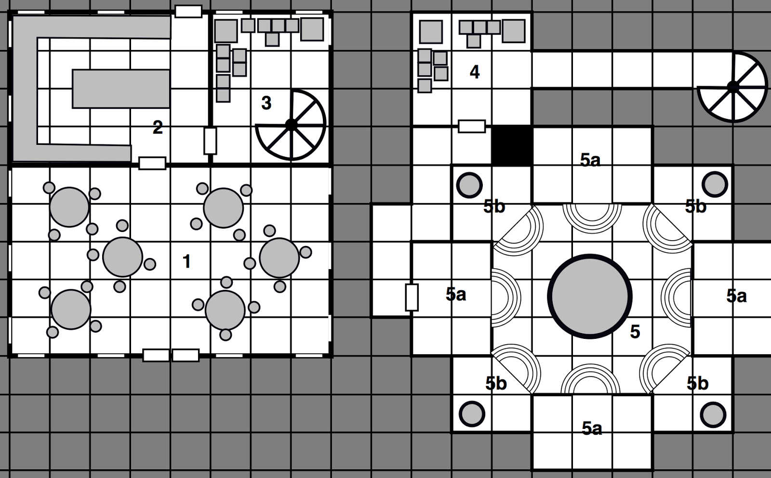
Gothmork’s Grub House is a nondescript, dirty, one-story building. Filthy and dingy yet crowded, the tavern itself is not particularly notable but the basement below the tavern is heavily excavated to hide Gothmork’s farming and other cult activity.

1. The Dining Room
Crowded whenever the Grub House is open, the dining room is filled with goblinoids, criminals, and paupers. Goblins serve the tables—they are quick, surly, and try to clear out customers as quickly as possible. Typically one or more patrons are playing a version of mummbly-peg, laughing whenever someone is stabbed, and Gothmork (a goblin wormtongue) is often here during business hours circulating among the regulars and visitors taking the chance to make criminal and business deals.

2. The Kitchen
A team of goblin cooks work in the hot kitchens, making the stew and dishing out meals. The prep area and the pots are disgusting as the goblins break down worms into the soup.

3. The Storeroom
Filled with boxes of potatoes and onions alongside barrels of water, worm brew, and salt, the storeroom isn’t particularly exciting aside from the spiral staircase that descends into the basements.

4. Basement
This appears to be further storage including yeast, salt, and water barrels, but some of the boxes also include cultic robes, hooked goads, leather armor, and other gear for the cultists. The basement is regularly watched by a goblin wormtender and a lesser ramora flea.

5. The Worm Chamber
The worm chamber is home to the worm mother, overseen by a bevy of goblin wormtenders. The room uses a complicated but roughly hewn goblin style of architecture with a crudely arched ceiling. Short, circular steps descend to the central chamber, the middle of which is a large pool filled with murky liquid—home to the worm mother. Three captives are gagged and bound here slowly being bled into various fermenting pools. The worm mother is tended by three goblin wormtenders led by a goblin wormtongue.

A. Wormtenders
Each landing holds wormtenders watching over the scene—one goblin wormtender and a lesser ramora flea. Challenging the first goblin wormtender sparks a call out to the others in the room and spurs a large-scale fight.

B. Fermenting Pools
The fermenting pools are filled with a thick, yeasty brew of chopped up worms on top of which floats a sizable mat of lichen, yeast, and bacteria. A large wooden spoon hangs over the large stone pools. Two goblins work over each pool under the supervision of a worm savant.

Ending the Adventure & Foreshadowing
After defeating Gothmork and the worm mother, the GM can use its Death Throes trait to provide hints and clues about the next stage of the adventure. Alternatively the party can discover that the captives are connected and have offers of thanks to the party, useful information, and opportunities for employment.

Appendix 2: Salt in Wounds, the Wider World, and Synoma
The following pages outline the basics of the world of Synoma and Salt in Wound’s place in it. More information about Synoma is available in the Synoma Campaign Setting from Pangolin Press.

Synoma: The Fantasy Cold War
In the seventh age of Synoma new kingdoms rose upon the ruins of dead or moribund empires. These fledgling powers quickly realized that power was not measured by the size of armies, but by the amount of magic dug up from the ground or developed by one’s peoples. Massive research and exploration efforts began in earnest three hundred years ago and every easily located ruin or dungeon was secured by a state and plumbed for its power. A series of conflicts which would come to be known as the Artifact Wars rocked the world as the various national powers, each with their own specialties and unique relics, fought on a titanic scale. After years of escalating war they reached a stalemate as each possessed magics capable of utterly obliterating their enemies—and possibly themselves. With open war too costly to conceive of (or at least that’s the hope of ordinary citizens) conflict has transferred to proxy wars fought over satellite states and spheres of influence, relentless crusades to push back monstrous, demonic, or undead forces, and finally the so called “great game” of adventurers.
Magic items are extremely rare and high level magic is virtually nonexistent. Only those most rare savant-like individuals are capable enacting high level magical workings or to craft permanent enchantments. The primary resource the various states compete over is high level wizards, clerics, sorcerers, and creators of magic items. Abundant alchemical goods have replaced most low level magic items and these are often derived from the special properties of magical creatures (most especially the Tarrasque of Salt in Wounds).

The Great Game: The Role of Adventurers in the Geopolitics of Synoma
Most adventurers in Synoma are loyalists pledged to one of the five great powers although occasionally they are mercenaries happy to take the pay of whoever offers the most coin. More paranoid states control their adventurers via leveraging threats to their loved ones, rune-bound exploding slave collars to enforce compliance, or mind-affecting magic. These nation-states have have identified twenty-two “Paths to Power” (what in other settings are character classes) and rigorously screen their population for any individuals who show aptitude for one of the paths (there is also regular abduction and recruitment of exceptional citizens of other empires). Such persons are then conscripted (or at least strongly encouraged) to pursue developing their abilities whereupon they are incorporated into traditional armies or sent to join state-sponsored adventurer agencies. These organizations are utilized for intrigue, covert dungeon delves (often behind enemy lines), or a swift militaristic response to emergent and quick moving threats for which the army is ill-equipped to handle.
Most adventurers in Synoma do not attain epic heights (capping out at 6th level) and to push past this ceiling is to generally become something more than human (or greatly divergent) and in so doing wind up in the crosshairs of enemy powers. After reaching this point they figure greatly into politics and plots of the greater world as their enemies begin developing exhaustive dossiers on their strengths and weaknesses (all while facing regular assassination and recruitment efforts). As such the maximizing of potential (“min-maxing”) is something states regularly do for their squads of adventurers, attempting to put together the most effective and versatile teams of possibly insane, inhuman, and largely amoral irregulars to regularly face down threats “far above their level.”
However even as they arm themselves to take down demigods, adventurers must regularly move throughout the paranoid world of Synoma without attracting notice. Some rare few manage to keep their abilities secret and become independent operators but these are the exception rather than the rule. Adventurers are amongst the only segment of the population with regular knowledge of magical items and the incredible value of any make the owner especially tempting targets.
In Synoma adventurers function as something between secret agents, special forces, and an armored tank division or living weapons of mass destruction—with their sponsor states ready to disavow or betray them following a failure, or even if they seem to have grown too powerful. This is of particular import as one of the current five great powers was founded by a group of adventurers who recovered an artifact that put them on equal footing with the other empires, allowing them to carve out a kingdom of their own.

Salt in Wounds in Synoma
Salt in Wounds is one of a handful of impossible cities in Synoma—settlements that can only exist because of some supernatural quality that supports their otherwise untenable existence. It has managed to maintain its independence due to its isolation, self-sufficiency, and the established policy of the Binder-Lords that they will release the Tarrasque if their rule is threatened by an outside force. As such, Salt in Wounds often serves as a meeting place for rival factions and powers, a base to scheme and launch plots and intrigues, and one of the central locations wherein an interested party can find neutral, mercenary adventurers. It is also one of the only places in the world where most commoners have witnessed high level magic at some point in their lives.
Another unique feature is that due to the incredible value of its alchemical exports in a world largely void of magic, Salt in Wounds runs a huge trade deficit with most of its regular trade partners. Hence large quantities of magic items flow into the city to pay for all the alchemical goods and Tarrasque-derived wondrous items flowing out of the city. It is one of the few places in the world where magical items can often be procured...though higher end pieces can usually only be obtained by providing favors or going into debt with one of its aristocratic or merchant powers.

Appendix 3: Random Encounters

D6 Encounters for Sage's Row
- The party encounters a half-elven street peddler named Tianti Tani who offers a variety of odd jury-rigged magical items of dubious utility.
- A Tarrasque flesh golem has gone berserk and is attacking at random. Depending on party level, a low powered wizard is already engaging the construct with hastily summoned monsters and other distracting magic (though he will probably lose without the adventurers’ intercession).
- A stooped man heavily laden with magical supplies trudges down the street as a cherubim hovers above him raining down curses and the occasional blow. Any attempt to speak to the man or the apparent angel causes the cherubim to respond, “pike off, mind your own thrice-damned business.”
- A street cryer calls out, “Anyone looking for work? Anyone looking for work?” When queried she reveals her employers are looking for anyone interested in being the subject of (perfectly safe!) medical experimentation. The deal is, if any PC is willing to wear an alchemist testing apparatus (set to Experiment Mode) for a month they will be paid 200 gold pieces.
- An alchemist’s shop has a series of exhaust pipes emanating puffs of odd-colored smoke. A giggling trio of teens inhale some of the vapors and if the party shows any interest they are invited to partake. Upon inhalation there is a 50% chance that the PC is poisoned for 24 hours. Otherwise the vapors produce an intense euphoria and vivid hallucinations that amidst nonsensical imagery contain portentous truths about the party’s upcoming adventures. Up to three turns with the vapors can be taken before the shopkeeper comes out to chase away the assembled by threatening to summon the militia.
- A small procession of individuals move past a shrine to Macinfex, God of Butchers. Each genuflect with a bow and a pantomime of sharpening knives before taking a small piece of raw meat (held in a bowl in the statue’s hands) into their mouths. Any PC who imitates is blessed with advantage on a single attack roll or ability check made in the next 24 hours. This blessing must be selected for use before dice are rolled.

D6 Encounters for the Throat Merchant District
- The party is confused for a group of exotic slaves (with one of the PCs assumed to be the owner) by Quine Calafax, a foppish gnome slave monger. Quine makes ludicrous offers to buy the individual party members and if told one is not a slave, he simply moves onto bargaining over one of the others. He mentions that due to the PC’s race or distinguishing features that they would “complete his collection.”
- An overladen hand cart has tipped over and casks filled with water have spilled out into the street. Various people are darting in and out, absconding with the barrels while a woman bellows for help to stop the thieves.
- On a roll of 3, roll again. While otherwise engaged with the results of the second roll, the adventurers are targeted by a pickpocket (use the statistics of a spy).
- One of the party is mistaken for Brown Sutto by a gang of 4 thugs who insist that they pay their debt (500 gp) before something bad happens. The ruffians back down if the adventurers call for authorities but will follow them in the days to come (looking for an opportunity to strike when the PCs are either isolated or vulnerable).
- Recognizing the party as adventurers (or having heard of their exploits) a grippli bard named Xuzay offers to spend a week comprising an epic poem praising the party—for the nominal fee of 100 gp. If they turn her down she instead immediately produces a dirty sing-song limerick mocking one or more of the party members, a melody the party will hear randomly while in the city for months to come.
- An axebeak has bucked its rider and is viciously attacking the man, perhaps mortally tearing at him with its wicked beak. A crowd has gathered to laugh at the proceedings.

D6 Random Encounters for the Tail Stones
- Stegen Oarlock—cleric of the god of wine—has been miraculously producing “wine” (actually, clean water with only a hint of grape) out of thin air to freely provide for the thirsty poor who can't afford to purchase their own. He is currently being harrassed by House Militiamen demanding that he pay a fine for unauthorized distribution of water. Stegen however is refusing and a crowd of sympathetic rowdies is gathering.
- A blood-fat ankheg has burst out of the ground and people are fleeing in terror. Depending on the party's level, a badly-equipped group of local shopkeepers may be engaging the creature (though they risk being overwhelmed without help from the adventurers).
- A 5th House courtier named Haren Harenson is handing out pamphlets and answering questions about the benefits of indentured ghoulification. If any of the party seems interested, he speaks at length about the procedure saying whatever they want to hear (highly motivated by the possibility of a potential commission).
- An oni sits in a lotus pose, eyes closed with a small sign that reads “Hire Me” in elegant calligraphy. Everyone other than the party either is unable to see the spirit or is ignoring him (and would also lie if asked if they see the creature). It does not respond to the party until they’ve reached 7th level at which point it offers any service it is conceivably capable of (though at the cost of a single favor).
- In the center of a cheering crowd hastily placing bets, a female human apprentice God-Butcher and a male half-orc Marrow Miner are about to have a bare knuckled brawl (both are berserkers). The winner (determined with a coin flip) calls out to the crowd (including the party) that none are tough enough to face their fists.
- A dwarf dumps a heap of rotting meat into the street outside a Process Guild render shop and it is immediately set upon by a trio of ghouls dressed in tatters. One of the undead breaks from its gorging to hiss and point to one of the party members before returning to glut its hunger.

D6 Encounters for the Beast Crown District
- A wounded man in plate mail stands over the stilled corpse of a ghoul, brandishing his glowing sword towards a cadre of 5th House Militiamen. Whether the man is a paladin who couldn't resist cutting down an “undead monster” that was taunting him or an innocent warrior who was defending himself is up to the GM (but the militia believes it to be the former).
- A trio of bored, fashionably androgynous 7th House courtiers speak clearly about their sexual appraisal of the PCs. The GM should instead have them in a discussion of who would win in a fight if the group prefers to avoid issues of sexuality in game.
- A cursing half-orc commands a scantily-clad, sobbing woman to hold still while he holds a syringe full of green liquid next to her arm. He asks, “do you want to get paid or not?” to which the woman responds, “yes, yes I'm sorry.” Around them stand multiple figures that look like hyper-realistic statues but close inspection reveals them to be paralyzed humanoids in various poses. When the half-orc (and artist named Vinkelheim) spots the party, he requests their help, “holding this damn fool model still so he can settle the pose.” If the party assists he gives them a dose of sculptor's paralytic poison as thanks. Use crawler mucus with application via syringe only.
- A half-elven cleric decked with gold chains stands behind a lectern preaching that wealth is godliness. He curses at any PC carrying less than 2,000 gold, referring to anyone carrying more than that as “gods favored” and blessing them. This blessing grants advantage on a single ability check involving the exchange of currency, decided before the check is made. At the GM’s discretion, the blessing is secretly a curse that causes the ability check to made with disadvantage.
- At the sentencing platform for the stage courts a hard-eyed man gazes out at the crowd. A sign around his neck reads “Crime - Burglary | Punishment - Vivisection”. Various alchemists, anatomists, and ghouls dressed in finery bid for his body parts (with particular interest in procuring his eyes) in response to a suave auctioneer shouting from the criminal's right.
- A quartet of House Militiamen featuring the livery of 3rd House demand to see the party’s “district passes” (which don’t exist). When the PCs fail to produce any (or provide forgeries) they demands 5 gp in “fines.”

About the Author
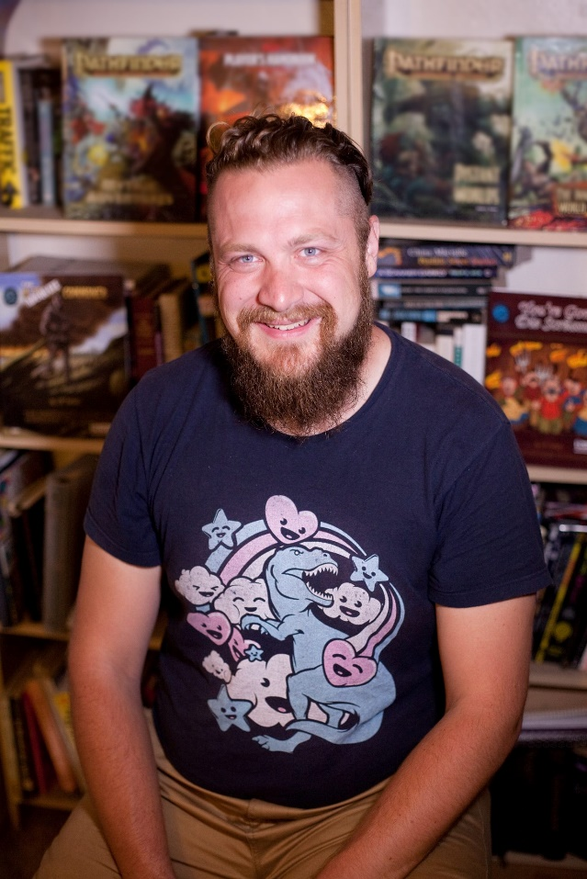
J.M. Perkins writes stories, designs games, and spends far too much time thinking about monsters.
You can learn more about him and his work at www.jmperkins.com or send him an email john@jmperkins.com

Special Thanks to all the Kickstarter Backers: your patience, early support, and incredible ideas helped make this work what it is.
Paul Wynns
Clint Smith
Erich L.
Patrick Harris
Adam Dagna
Mike Myler
Jim McClure
Jack Gulick
JohnnyBravo
Brian Southworth
Richard Orr
Robert J. Peterson
Z Aab
Corinna Clanton
Elizabeth Schueman
Rob Doss
Liam D Hughes
Clayton Thompson
SS
Dylan Verden
Kevin
Duncan Watson
Ryan Longair
Johannes Hovland
Kiernan Angley
John Hendricks
ARCH DIXON
Sleet
sbarrie
Andreas
Trevor Head
Austin Nickell
Robert Mull
Blake Ryan
Matthew Tarpley
Marvin Langenberg
Andrew Wilson
Anton Koncan
James Hunter
John Lamulle
Rich Howard
Jason Broadley
Andrew Piseck
AndrÃ© Roy
Constantinos Frantzis
Nacmac
Stephen Brady
Alexander J Skrabut
Jared Tatman
Benjamin Provencal-AubÃ©
Grant
Peter Smallridge
ziv plotnik (TheHero?)
John Unverferth
William Barnhart
Alex Austin
Greg Lang
calitfin
J Michael Lanaghan
Brian Whitby
Steven Prins
Erik Saltwell
Henrik Lemos
Cordell Jacques
Adam Miller
Eric Lange
Adrian Colbert
Alan Walters
Tracy Landrum
Marc Margelli
Roman
Doomedpaladin
Jonathan Pio
Ross Thompson
James Lawson
Greg
Michael Egan
Nicholas Kerr
The High Frontier
Jacob Hogan
Ben McFarland
Bryan
Erik
garblargh
Zzasikar
Michael J. Benensky
Colin McLaughlin
Martin PapsÃ¸e
Derek
Joseph Scott
Edward O'Bryan
Alex Thompson
Taiga Brenerman
Max McHardy
Ben Laurence
Jonathan Chiaravalle
Aaron C. Adler
B'omarr Punk
Stephen Coffey
Kenton Watson
Malakai
Alex Myers
Bryce Fraser
Luis Juarez
Brandon Elliott
Scott Reichelt
Kari
Tyler Blair
Stuart Lange
Robert Lyons
chyros
Terry Gilbert
Doug Grimes
Akrura Gordillo
Chris Garber
Richard Baldwin
Brandon Mariana
Fred Yost
Ethan Fardoux
Oath Brothers
Scott Hughes
Snakeeyz99
Frankie
Braden
Bobby Taylor
M'sMenagerie
Matthew
IrishBandit
Robin Farnsworth
Corey Tess
Pete James Godbey
Elventremere
Jeffrey Doiron
Chris McMahon
Carey Newhouse
Michael Andrews
David Garibaldi
Zane C Weber
Louis Coombs
Chris Hartmann
Shawn Boudreau
Nathan Howell
Nathan Pierce
C.S. McFarland
Ed Kowalczewski
Stefanos
Kirsten Meek
Paul Kensler
David Finch
Matty
Josh Medin
Spenser
Jeremy Frazier
Erik Ashby
Michael Seghi
Scott Corum
Trip the Space Parasite
Shimodesign
mutericator
themozh
Erik Martin
Nathan
Josh Steadmon
Nicholas Watkins
Limboman
Christian J M West
Matthew Batten
Max Glasner
Matt Elder
Chris Marshall
Kevin O
Mark Sable
Juston Crawford
Jacob Tripp
xrabohrok
Alex
Joshua Goodrich
Brett Volz
Simen L Stangeland
Emmanouil Tragakis
Ross Lemp
Allard Hoeve
Joe Davidson
Augur
Michael Miranda
Lyner
Jonathan Green
Griffin D. Morgan
Chris Nortcliffe
DivNull Productions
Aaron Fox
Richard Fryer
Brandon Barnes
Soerian Lieve
David Starner
Jonathan Smith
Bryan R Miller
Donald A. Turner
Jim Hart
Jens Kristian Nielsen
Alexander Huyer
Robert Winkel
Devroy Queen
Steven Collins
Robert Keys
Johnny Tabales
John Chamness
Brandon Reef
Paul Hazen
Dominic Davies
Ben Fowler
Greg Horsfall
Stewart Perkins
Kaine Beaumont
Joshua Nach
Corey Giesemann
pw3ner
Felix
josh
Brayton Reed
Kevin Meeks
Greg Stock
Elgin Scott
Daniel Ferrer
Adam Thompson
Robert McNeal
Will Brezinski
Miles K
Gabriel Zenon Wach
Stephan Wegener
Eriq R
Mitchell Struck
Jay Wright
Salvatore Puma
dradeth
Morgan heinemann
Nicolas Desjardins
pyrelite
rawb
Jacob Fifield
Thalji
Chris Phillips
Shawn
Ross Richards
MarkCef
Jacob Clift
JH
Robert Jadczak
Corby Kennard
Bryan Humble
Austin Matteson
Alchimous
Shane Liila-Fogarty
Philip Ezickson
RiffingTheVerse
Praxidicae: Vindicator of Phoenix Rising
Hugues Dubedout
adrian ridley
Oldest One
Marc Cardwell
Jarrod
Kurt Olson
Dan Cozma
David South
Robert Chalford
Jhon Adams
jengagne
Gabriel Schive
Gianluca Percovich
Justin Kugler
Aaron Askam
Stuart Turner
Benjamin Tutko
Nicholas Yaeger
Danyon Greatorex
Brian Fitzpatrick
Eric Anderson
Shawn Polka
James Van Doren
quinn
Michael Lepchenske
Joe
Adam Fishback
michael ficklin
QuidEst
Kyle Goodrich
Jesse Jones
Nimander
Samuel Conway
Doug Connelly
Michael Telford
Matthew Moyer
Henry McDonald
Dustin
Brandon Dees
Mark Alexander
louis chang
Mark Havenner
Steve Reinhart
John Brown
Jeffrey Levine
Michael Bucher
Derek Guder
Matt Hills
Joshua Straub
GeekGamer
bwschroyer
Grier3d
Francisco Martinez
Tom Lamb
Russell Liley
Michel
George Cook
CrocCreator07
Mathew Reller
Jeremiah VanderMark
John Callander
epcifalcono
Matt
Phillip Bailey
Kyle Capps
Sean
Darian
Jay Tallsquall
Jeff Tillotson
xidle2
Impact! Miniatures
Eddie
Paul L.
Carlos Huertos
Christopher Sulat
Bruce Meyer
Keith Catalano
Nessalantha
Adrian Knight
Brad
Michael G Townsend
Emmett Morris
Francois Mersch
Tim Hall
anonymous1453
Lawrence Keogh
Alex Wayman
Robert Hillard
Kisa A
Benjamin
Dark Naga Adventures (Kevin Watson)
Brandon â€œFFTGeistâ€œ Miller
Alex Jackson
Joshua Starbuck
Mean Eyed Cat
Michael Titchen
Ian
Patrick Thomas
Al Bear
NezduQ
callithrix
John Filipek
Metaldracolich
Tadd Layton
Clayton Thomson
Nicholas R. Dysard
Jon Buran
Stephen Kelley
Aaron Jones
Olav MÃ¼ller
Andrew Cowie
Daniel Youngren
Tyler Mascia
Cerxi
Yagami Chris
Dudley Birch
Dakota Graves
Joshua Starkey
Dave Lambrecht
Matthew
Adam Pecar
Stephen Morris
codepage9
Saajan 9000
Neal Powell
Lim Seng Kok
Nicholas Toepp
Michael Tree
joe lagle
Grant Richardson
WuseMajor
Thomas Hindle
Joseph Geenty
Pablo DomÃ­nguez Castro
Max Gorenberg
Zakkeh
Leo Schultz
Ari Heitler-Klevans
Nathan Verrilli
Jeremiah Safford
Patrick Burgess
badger1stclass
James Ferguson
Garret
Andrew Lotton
Sean Riedinger
Derek Heim
Twindry
Torger083
James Bullock
Steven VanDyk
James White
Louise Tindel
Max Thomas
Connor Scott
Oliver Cadena
Eldric IV
Chase Reasoner
Jason Bross
Shane Walden
stephen scott
Adam Green
Charlie Williams
Kyrie
Karen Lockwood
Robb
Steven Petruzzellis
Peter Olfelt
Charles Blackwell
Kendall
Wesley Kehs
Kalanyr
Garrett Jensen
Brian Scott Walker
Tom
Tim Russell
Joshua Percy
Dirk Martens
George Gordon
Kevin Gill
jared.kincaid
Michael Zautner
Eternal
Chris Winchell
Cally harper
Aaron Pothecary
Randy Tootell
Samuel Klingensmith
Hasneen Karbalai
Ian Harriman
Andrew James Princep
William Walters
Lo Skana
Mr_Teach
Kenny Beecher
John Stock
muttonchop
Erik Muise
Jeff Iverson
Michael Gourd
Robert
gatherer818
Evan Sala
Jim Kalfas
Jorden Varjassy
David Heckman
Christopher Gargani
London 'Iccus' Young
Paul S.
Lawrence Wang
Andreas Graef
robert
Christopher McMahan
Bez Bezson
Dan Layman-Kennedy
Gary Lester
Francois Lapikas
Darren Aldredge
Matt
Todd K. Otto
Warren
Nekrul
John Arcadian
Joshua Dahlberg
Andrew Caldwell
Robert Morehead
BZ
Russell Petree
Cody
Alex Wallace
Kai Ottesen
Widmer
BloodAndSalt
Andrew
John Hare
waldo the banjo player
Santtu KÃ¤rkkÃ¤inen
Seith Keough
Jeff Foy
Brad Knipper
Bethany Wang
Anthony Kapolka
Michael C Burgess
Jay Watson
Paul Goodwin
Erebus
Patrik
Patrick Schweicher
Stephen Eric Johnson
Wright Johnson
Elisabeth Fields
Silas Byrne
Brian Tetirick
Noah
Justin Nieusma
Craig Cormier
Rusted Portal Games
kyle jones
Austin Rode
Ben iverson
Matthew Stanton
oldstevo
Brian Summers
Russell Ventimeglia
QuillHound Studios
Jason Vines
Michael Stankov
Phillip Schlicher
William
Michael Smith
Chuck Dee
Travis Bonnough
Wolfgang Troth
Jeremy Herrera
Andrew
Katherine Provance
Daniel Neally
Filthy Monkey
C. Rasmussen
Micah Burkey
Dan Suptic
KovÃ¡cs RÃ³bert DÃ¡niel
Justin Boncher
Oliver
Seth Klein
Jason Dallinga
Kevin Cartee
Iain Gillett
James Introcaso
Richard Zerafa
Robert Vandevanter
sammorbai
Nick Overfield
Brian Suskind
Matthew Dodson
Akil Hooper
Oran Ken Hirsch
Dinnsdale Piranha
Paul Poppleton
Tietar
Ahmed OKeeffe
M.R.
William Tan
Silas McDermott
RAM-Kay
Kelroy Was Here
Stephen J Holodinsky
Ben Madden
Troy
Adam Toulmin
Sean Hagen
Robert Bersch
Sulynn
Nathaniel Deml
Duncan Kight
Ian Weldon
william moreland
Andrew Goode
imredave
Josh Singleton
Kevin Davis
Eric
Imban
kade
Jerome Devie
Justin Sallie
Doug Atkinson
Petteri Turtiainen
Morgan O'Brien
Shawn Stephens
Michael Lee
Fenrir Lupara
william albee
Jesse Goldberg
FIGMENTIA(Daniel)
Frey James
Avery Bonner
Sean Aliff
Hazirawn
Edgeland Games
James Holdener
William Meagher
TheOneRok
ANDREW BOX
Dustin Anderson
Joseph Jay-Dixon
Evan Srnka
AJ Kovacs
Drew Calderone
Richard Henning
Satellite92
esserin
Ted
Ben Boyd
Nicole Gent
Richard Mundy
Jonathan Perrotto
Scott Frega
Abraham Swingle
alcethenecromancer
Shikkarasu
Robert
BurnToTheGround
Jim Ryan
Kaleton Martinson
Steven Nordhauser
Joseph
Charles Minars
George White
Guillaume Lavoie
Cameron Fina
Christopher Blackwell
rodney gordon
Ilfar
Adam Ralston
Oliver von Spreckelsen
William Dobbins
Tommy Frost
Patrick Akey
Scott Chambers
James Robertson
Heidi Roberts
Kieran McGee
Ian Coghlan
Carl Holzboog
Steven
Alex
Jason Glen Clark
Churchill
Hans Chung-Otterson
William Buchanan
Brian
Robert Trnka
Chuddernaut
Ross geach
Christian Suppan
Cirk R. Bejnar
James Maloney
Jack Ulrich
DefinatlyLegit
Steven Nicholson
Owlglass
Kane Gartrell
Chris McManus
sean dearden
DarkWhite
Michael Munn
Alan Smithee
Andrew Moreton
James Straight
fiend
Jono Everson
Nicholas Trettel
Ovidiu Tudose
Yu Tsai Su
Shane Hebert
Gregory A. Lusak
Noah McCoy
thompgc
Aidan Thomas Raphael Allcock
Micah Krietemeyer
Daniel Danielson
Andrew McWilliams
Erik Talvola
Malcolm Wilson
EmbersDS
Sarah
Cody Swatek
John W. Oliver
Zack
Charles Evans
Ryan
Anthony
Tim Langen
Phillip Dawson
Sam Hing
Jeffrey Hersh
Herko Coomans
Todd Cumbow
Sheikhsaddiqi
Thierry Lechler
Josh Wilkins
Dennis Rush
Glaurung
Ryan Young
Philippe Daigneault
Marsgreekgod
cowpewter
Brian Wright
Sean Kelly
Jona Littler
David Leber
john mcshane
Vincent Mellon
Cole Thompson
Lucas Ray
Alex Parker
Breon Halling
Jordan Richer
Donald Nicholson
Jason Scott
R Marshall
Adam Jenner
Mathieu Girard-Reydet
Tim Baker
Matthew Karabache
Stephanie Turner
Andrew Lock
Jan Artoos
Ferrell Riley III
Dan
Amy (Other Amy)
Patrick
Shawn Flickinger
ivan
Bitwise Constructs
Bradley Wills
Jordi Rabionet Hernandez
Eric Anton
Kevin
Randy Smith
Allen Odden
Paul Telfer
Samuel Doepken
Martin Vlk
Ryan Sandbo
Russell Hoyle
Matt Greenwell
Russell James Matthews
Geoffrey Wertman
papa goob
Matthew Roberts
Matt
Tyler Beckett
Wade R Bland
Joshua Townsend
Aeon Cor
Ken Marable
Donald Ferris
Josh Olsen
JasterMereel
Matthew J Weidman
Sam Eaton
Matt DiBernardo
Greg McWhirter
Admortis
Kevin
Hayden Hart
Gantt Nicholson
Marc Reamer
Algernon Busby
Chimi
John Michael Hess
Charlie A. Arreola
Gordon Nelson
Shrimpness
KICK in a BOX
Zach Pritchard
Justin D. Short
Prickly Pear
Mister Numbers
Eli Davis
Bryan
Bulldozers
Benjamin Whistler
Daniel Morales
Dan
Richard Greene
Robert Smith
Frances Watson
Doug Ford
Kohuded
rbailey952
MItchell Diamond
Cavan Cardile
Jon T Nay
Kris Gauthier
John Melton
Travis
Dropped
Patrick Kelley
Richard Bannon
Terry Helman
John
Eric
Jon Ryherd
James Palmer
John
Darklord
Tyler Spears
Geoffrey Lloyd
Ben Rosenbloom
Ryan Crowe
Jason Romero
Jonathan Paquette
Josh
Michael Howard
andrew brooks
Askorn
Alex Preisser
Jason Neff
Kevin Dill
Maxim Atkins
Cj Dusky
Buksey
Wrathamon
Dustin Hall
Drew Tillman
F Scott Nessler
David Jones
Josh B
FUNgineer
Andrew O'Leary
Jonathan Jordan
Maciej Murakowski
Emily Jackson
Kfir Mazuz
Mike P
mushrooomsamba
Jess Hunte
Chris LaCross
Michael W Kilduff
Jeremy Siemon
Kyle Meyer
Bill Redford
Jokey665
Andrew K
Biggoon
Charlie Day
Pierre Waldfried
John Townsend
Quinn Parrott
Bryan chamchoum
David Verne
Scott McCutcheon
Ed Bailey
Samuel Hair
Bernard Birnbaum
Ruth
Geoffrey Ford
Daniel Mastropieri
Michael
Mathis Hasle
Nick Vandewalle
James Conners
Sergio Silvio Herrera Gea
Jason flood
Sven Berger
Thomas
Kevin Klaus Thibault
Quincy Jackson
Thor Anderson
Puremagiclive
shawn meyer
Alex Foote
David Dalton
LAMBERT Jason
Steven Quinones
Andrew Hess
Alan Cohen
Jon Terry
David Shlafer
ChrisWainman
Brandon Walsh
Philippe Roby
Kennedy Boswell Jones
Henry Toohey
Nick
Jonathan Brock
Charonen
Lynn Reed
Drake Phillips
Johnathan Allen
Joshua Laudise
Leanna Bender
Aaron Benjamin Carter
Charles Haywood
Darren
Blarghedy
Nick Mendola
James Miller-Marquez
Kristopher Rodrigues
Austin Hoffman
Sean Donnelly
Nathan Beal
Proze
Harry John Shephard
Alvin Lee
Adrienne
CJ_Trachta
Blake Anthony Morgan
jtopian
Steven DeBirk
Jason Weigel
John Burchett
Erik Stratton
Thomas
Mark Fazzari
Addison Voldeng
Spencer Hobson
Tanner Houghton
Charlie Mehl
Samuel Kohner
John D.
Ryan Kent
Robert O'Neill
Nathan Marigoni
bejan paknia
Odin
Hananda
Pikey
Alex
Winthrop Wilcox
Kenneth Faulkner
Joshua Godfrey
Alexandra Collins
Matt Andrews
Chris Furness
Dan
Belltrap
Sorokin Boris
Javier MalÃ³n
Jared Robinson-Kam
Kyle Spens
Jay Muir
Luca
Kimberley Smith
Davae Breon Jaxon
Bryan Dotson
Jon Boylan
Jeffrey Schultz
Gamechild Studios
Shane Martin
Lewis Crown
josiah
Rick
Todd Kes
thomas schaeffer
Jared Boles
Hadschi Halef Omar
Mike Prokop
Jo-Herman Haugholt
Kristian Williams
Christian Barry
chris stewart
Paul Casagrande
Sam Hillaire
John Riegerix
Brendan Townsend
Warren Nelson
roshaun helsin
J Langenbacher
Ryan Woodroof
Baheru Mengistu
Delkaetre
Christopher Henry
Zac Zembo
Jordan Ferch
Ira Taraday
WL Tay
Benjamin Reece
Brandon Ulvenes
Chris Jordan
Joe Wilkinson
Daryl Boyer
Philippe Niederkorn
Stephen kline
Michael Anthony Hunt
Charles Hughes
Randal Estevez
Andrew Valentin
Riley Morrell
Rose Whitcomb
Mondo
Andrew Patton
Tom
Brandon Smith
Nick Roland
Matthew Means
Kenneth Watkins
Joshua N. Affrime
Michael Luipersbeck
Andrew Wright
Gregory Morris
Fecal Encephalopath
Sam Sarphatie
Dave J Diveley Jr.
hunter wiench
Andrew
Eliot Lee
Zachary Host
David Marino
Brian Kallay
Carl Lott
Andrew Drake
Johannah Keily
Sean Youngstone
Adrian Ridley
John Ameye
Robert Lesmeister
Jesse Brake
Lee Christoffers
Benjamin Hale
Jacob Whittington
Skander Ballard
Michael Evans
Anahta Langley
Brian Dale Clark
Scott Reichelt
Adam Thrash
Alexander T Gomez
Bryan McIntyre
Stewart MacLean
Wesley Kern
Toby Welch
Jim Heston
Brion Abel
Taylor Evans
Aaron L Funk
James Howard Jr
Patrick Walsh
Danielle Montanari
Evan Steiner
Karl Cutler
Allen White
Sam Clifton
Michele Jacobsen
Ronald Paul White
Riley Ruppert
francis cole
Mike Broduer
Raphael Bressel
Jason Karl-Wolfe Leisemann
John Ely
Nathaniel Winkler
Gordon Cranford
Jay Kint
Matthew Fridley
Brett Keizer
GEOFFREY PIEPER
Ryan Mitchell
Gabriel Miller
Kyle Moore
Devin R Whittington
Steve Bush
Devin R Whittington
Bryan K Strahm
Christine Watson
Christopher Van Fleet
Chantz Turner
Andrew Steven
Scott Isaac Reichelt
Colton Goodrich
Samuel Petto
Daniele CalÃ Campana
Daniele CalÃ Campana
John M. Portley
David Tyler
Samantha Greenall
Charles Richard Koeppel II
Alec Queen
David McMichael

OGL Information
The following text is the property of Wizards of the Coast, Inc. and is Copyright 2000 Wizards of the Coast, Inc ("Wizards"). All Rights Reserved.
1. Definitions: (a) "Contributors" means the copyright and/or trademark owners who have contributed Open Game Content; (b) "Derivative Material" means copyrighted material including derivative works and translations (including into other computer languages), potation, modification, correction, addition, extension, upgrade, improvement, compilation, abridgment or other form in which an existing work may be recast, transformed or adapted; (c) "Distribute" means to reproduce, license, rent, lease, sell, broadcast, publicly display, transmit or otherwise distribute; (d) "Open Game Content" means the game mechanic and includes the methods, procedures, processes and routines to the extent such content does not embody the Product Identity and is an enhancement over the prior art and any additional content clearly identified as Open Game Content by the Contributor, and means any work covered by this License, including translations and derivative works under copyright law, but specifically excludes Product Identity. (e) "Product Identity" means product and product line names, logos and identifying marks including trade dress; artifacts, creatures, characters, stories, storylines, plots, thematic elements, dialogue, incidents, language, artwork, symbols, designs, depictions, likenesses, formats, poses, concepts, themes and graphic, photographic and other visual or audio representations; names and descriptions of characters, spells, enchantments, personalities, teams, personas, likenesses and special abilities; places, locations, environments, creatures, equipment, magical or supernatural abilities or effects, logos, symbols, or graphic designs; and any other trademark or registered trademark clearly identified as Product identity by the owner of the Product Identity, and which specifically excludes the Open Game Content; (f) "Trademark" means the logos, names, mark, sign, motto, designs that are used by a Contributor to identify itself or its products or the associated products contributed to the Open Game License by the Contributor (g) "Use", "Used" or "Using" means to use, Distribute, copy, edit, format, modify, translate and otherwise create Derivative Material of Open Game Content. (h) "You" or "Your" means the licensee in terms of this agreement.
2. The License: This License applies to any Open Game Content that contains a notice indicating that the Open Game Content may only be Used under and in terms of this License. You must affix such a notice to any Open Game Content that you Use. No terms may be added to or subtracted from this License except as described by the License itself. No other terms or conditions may be applied to any Open Game Content distributed using this License.
3. Offer and Acceptance: By Using the Open Game Content You indicate Your acceptance of the terms of this License.
4. Grant and Consideration: In consideration for agreeing to use this License, the Contributors grant You a perpetual, worldwide, royalty-free, non-exclusive license with the exact terms of this License to Use, the Open Game Content.
5. Representation of Authority to Contribute: If You are contributing original material as Open Game Content, You represent that Your Contributions are Your original creation and/or You have sufficient rights to grant the rights conveyed by this License.
6. Notice of License Copyright: You must update the COPYRIGHT NOTICE portion of this License to include the exact text of the COPYRIGHT NOTICE of any Open Game Content You are copying, modifying or distributing, and You must add the title, the copyright date, and the copyright holder's name to the COPYRIGHT NOTICE of any original Open Game Content you Distribute.
7. Use of Product Identity: You agree not to Use any Product Identity, including as an indication as to compatibility, except as expressly licensed in another, independent Agreement with the owner of each element of that Product Identity. You agree not to indicate compatibility or co-adaptability with any Trademark or Registered Trademark in conjunction with a work containing Open Game Content except as expressly licensed in another, independent Agreement with the owner of such Trademark or Registered Trademark. The use of any Product Identity in Open Game Content does not constitute a challenge to the ownership of that Product Identity. The owner of any Product Identity used in Open Game Content shall retain all rights, title and interest in and to that Product Identity.
8. Identification: If you distribute Open Game Content You must clearly indicate which portions of the work that you are distributing are Open Game Content.
9. Updating the License: Wizards or its designated Agents may publish updated versions of this License. You may use any authorized version of this License to copy, modify and distribute any Open Game Content originally distributed under any version of this License.
10. Copy of this License: You MUST include a copy of this License with every copy of the Open Game Content You distribute.
11. Use of Contributor Credits: You may not market or advertise the Open Game Content using the name of any Contributor unless You have written permission from the Contributor to do so.
12. Inability to Comply: If it is impossible for You to comply with any of the terms of this License with respect to some or all of the Open Game Content due to statute, judicial order, or governmental regulation then You may not Use any Open Game Material so affected.
13. Termination: This License will terminate automatically if You fail to comply with all terms herein and fail to cure such breach within 30 days of becoming aware of the breach. All sublicenses shall survive the termination of this License.
14. Reformation: If any provision of this License is held to be unenforceable, such provision shall be reformed only to the extent necessary to make it enforceable.
15. COPYRIGHT NOTICE
Open Game License v 1.0a Copyright 2000, Wizards
of the Coast, Inc.
System Reference Document 5.0 Copyright 2016,
Wizards of the Coast, Inc.; Authors Mike Mearls,
Jeremy Crawford, Chris Perkins, Rodney Thompson,
Peter Lee, James Wyatt, Robert J. Schwalb, Bruce R.
Cordell, Chris Sims, and Steve Townshend, based on
original material by E. Gary Gygax and Dave Arneson.

